How to…
Line Items in SEM-BPS and BW-BPS
Logging the history of plan data

SEM-BPS/BW-BPS

Applicable Releases: SEM 3.1B - SEM-BPS 3.5, BW-BPS 3.5

1 Problem 2
2 Concept of the Solution 2
3 Practical Implementation 2
4 Result 4
5 Possible Problems and Solutions 4
6 Sample Coding 5

1 Problem
In the context of the delivered standard functions, it is not possible to reconstruct the history of a plan data record after the event in SEM-BPS/BW-BPS. For example, if a sales target is planned for a business area for a certain time frame, you can no longer see when and from whom this sales target was actually entered. It is also not possible to see whether this value was planned directly, or whether the value was formed from targets, changes and corrections in the context of a long process.
However, if such proof is desired/requested in particular cases, then it can be realized by proceeding as follows.

2 Concept of the Solution
The solution described here uses the technology of characteristic derivation, which has been a part of the standard functions of SEM-BPS since the SEM release 3.1A (and BW-BPS 3.5).
The “normal” application case of characteristic derivation consists of deriving the characteristic customer group from the characteristic group, or the company code currency from the company code.
In the present case, this interface is used to make a unique identification of the current data record. Since in SEM-BPS/BW-BPS a delta posting is carried out internally, this unique identification means that the complete history of a plan figure is logged to the current characteristic combination.
You can find more details on the topic of characteristic derivation in the SEM-BPS/BW-BPS documentation under the keyword Characteristic Derivation.

3 Practical Implementation
To provide every data record with a unique identification, the InfoCube in BW used for planning must contain a suitable InfoObject or if necessary be extended by one. A characteristic of the type Char with length 32 without a check table or text table (for example, 0BBP_OBGUID) is suitable for this, which can be filled with a GUID (globally unique identifier) during characteristic derivation. Alternatively, this unique identification can also be achieved by pulling a number from a number range or similar techniques. In each case, a suitable InfoObject must be available in the InfoCube. In addition to that, other fields can also be included in the InfoCube to save additional organizational data, for example, 0UNAME (created by), 0DATE (date) and 0TIME (time).
On the side of SEM-BPS/BW-BPS, the characteristic relationships must be maintained in the planning area used as shown below.
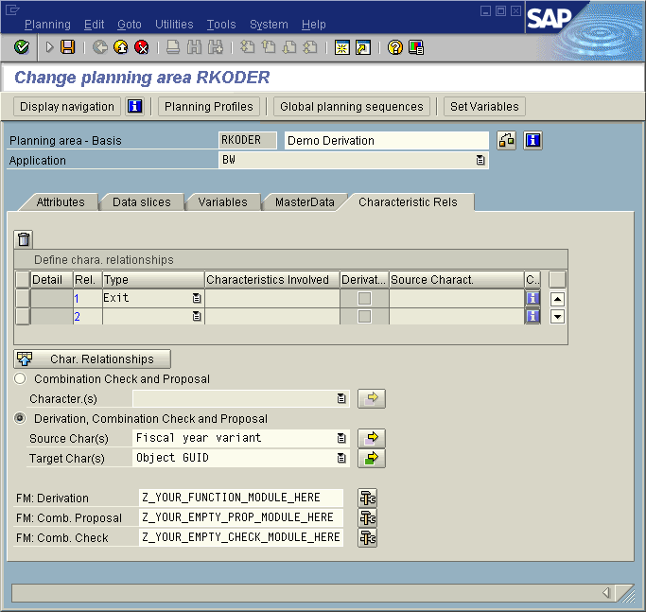
Here the source characteristic of the derivation can be any characteristic which is contained each of the planning levels used. All characteristics which are to be filled with control data are to be entered as target characteristics. In the example above, these are 0BBP_OBGUID, 0UNAME, 0DATE and 0TIME. These target characteristics are not to be included in any of the planning levels used, since they are automatically filled by the function module for characteristic derivation (here: Z_YOUR_FUNCTION_MODULE_HERE).
As a rule, you must implement the function module for characteristic derivation (here: Z_YOUR_FUNCTION_MODULE_HERE) in accordance with the data model used. In SEM-BPS the delivered module UPY_CDI_DERIVE_EXIT can be used as a copy template (for BW-BPS please copy the coding attached to this How to). If the fields used in the example (0BBP_OBGUID, 0UNAME, 0DATE and 0TIME) are used exactly, then this module can also be used directly.
Note: Modifying this module for the purposes of adjustment can reduce the stability of the entire system! Even if no static usage is displayed, a dynamic usage cannot be ruled out!
Both of the function modules (Z_YOUR_EMPTY_PROP_MODULE_HERE and Z_YOUR_EMPTY_CHECK_MODULE_HERE) can be any function modules without functionality which implement the required interfaces for exit modules for combination check or generate valid characteristic combinations. Implementing functionality is not necessary here, since these modules are normally never called up (the target characteristics of the characteristic relationships are not contained in any planning level).
After these preparations, you can plan as normal with the existing data model.

4 Result
With the technique described above, for example the history of data
can be presented in all single steps as below:

5 Possible Problems and Solutions
Using this technique avoids different postings being aggregated to one characteristic combination and thus being grouped together in one data record. This is also absolutely necessary for a complete log.
On the other hand, this of course results in a much larger data volume than normal. Therefore, possible performance problems must be taken into account with this approach.
If necessary, this effect can be reduced or even completely avoided with a suitable organizational task.

For example, it is imaginable that not the whole planning process is logged, but only certain steps. Recurring steps such as transferring old actual data as the basis for planning and changing it with automatic planning functions (revaluate: +10%) could be documented sufficiently, for example, in the process description of the planning cycle. During such “uncritical“ steps, the characteristic derivation can be removed from the characteristic relationships of the planning area. Only when, for example, a decentralized manual change of data is executed by the person responsible, can the described functionality be activated. Instead of changing the Customizing of the characteristic relationships, you can program a mechanism to activate and deactivate the functionality described and integrate it in the function module for characteristic derivation. Unfortunately, an automatic control is not possible here, since the module only receives the current data record, but not the call up context (manual planning or name of a planning function).
Alternatively to that a second InfoCube can be used without line item display in which the plan data is transferred aggregated before “uncritical“ steps of the planning cycle.
Another way to limit the number of records is to get the time stamp only once and buffer it. Thus all records changed within the same planning session will have the same time stamp and there will only be one delta record for a given characteristic combination for each planning session.

6 Sample Coding

FUNCTION UPY_CDI_DERIVE_EXIT.
*"----------------------------------------------------------------------
*"*"Lokale Schnittstelle:
*" IMPORTING
*" VALUE(I_AREA) TYPE UPC_Y_AREA
*" REFERENCE(ITO_CHA) TYPE UPC_YTO_CHA
*" CHANGING
*" REFERENCE(XS_CHAS) TYPE ANY
*" EXCEPTIONS
*" FAILED
*"----------------------------------------------------------------------
FIELD-SYMBOLS: <l_chavl> TYPE ANY.

* fill ID
ASSIGN COMPONENT '0BBP_OBGUID' OF STRUCTURE xs_chas
TO <l_chavl>.
CALL FUNCTION 'GUID_CREATE'
IMPORTING
ev_guid_32 = <l_chavl>.

* fill user
ASSIGN COMPONENT '0UNAME' OF STRUCTURE xs_chas
TO <l_chavl>.
<l_chavl> = sy-uname.

* fill date
ASSIGN COMPONENT '0DATE' OF STRUCTURE xs_chas
TO <l_chavl>.
<l_chavl> = sy-datlo.

* fill time
ASSIGN COMPONENT '0TIME' OF STRUCTURE xs_chas
TO <l_chavl>.
get time field <l_chavl>.

ENDFUNCTION.

Appendix (Sample ABAP Source code)

Function module Z_VARIABLE_GET_DETAIL

