How to…

Integrate BEx Web Applications into BPS Web Interfaces

Business information Warehouse
Applicable Releases:
SEM 3.1B – SEM3.5

December 5, 2004

Scenario
A Web Interface contains more or less a complete set of elements and information to perform a certain planning task. Typically there are also BEx Web Applications or BW Queries involved for e.g. display the plan data in a different context or to display more details - but how to integrate them?

This document describes options to incorporate a BEx Web Application in a visible manner and how to locate it in certain areas of the Web Interface. Additionally it is shown how BPS Variables can be linked to the filter values in order to automatically synchronize the plan and the reporting view.

A short overview of samples described:
- Adding a BEx Web Application to the page.
- The filter value is determined by a BPS variable shown in a drop down box.
- The filter value is determined by a planning layout with line selection.

Introduction
Since the Web Interface Builder supports the feature of adding HTML and JavaScript to the planning applications from the very beginning all examples given in this document will work from release SEM 3.1B to SEM 3.5 and BW 3.5.

There is no special HTML or JavaScript knowledge required to implement the solution – but very helpful to perform potential next steps of adjusting the examples and further evaluate the concepts described. When searching for more information about the IFRAME tag or which parameters could be used in the BEx Web Application context please check out standard documentations.

The idea behind the examples: As a first step an IFRAME definition is done where the source attribute contains a fixed URL (in the first example it is the URL of a BEx Web Application). Then depending on the properties and setting of variable selectors the URL is adjusted dynamically. The example shows how to add a filter value, but it can be extended to any URL property for BEx Web Application described in the online documentation.

There is a basic problem to be solved: how to get the current selection from a variable selector into the JavaScript environment? The first approach of accessing the generated HTML of the Web Interface leads to several complications. For example depending of the appearance of the selector (e.g. drop down, radio group or hidden!) different HTML is generated and hence different way of determining the values are required. In the case of a hidden variable it is almost impossible as there is no corresponding HTML.
The solution is to add Business Server Page (BSP) script statements in the custom HTML section. As an example the statement ’<%=descr(VarvlSel_Product/value)%>’ will be replaced by the BSP rendering with the value of the variable selector VarVlSel_Product. As this is feed by backend information an appearance independent access is given. For a complete sample please refer to the source code examples of chapter 3.3 and 3.4.

Note: When using compounded InfoObjects the parent values have to be added as well. Example: The fiscal year (0fiscyear) is compounded with the fiscal year variant (0fiscvarnt). Assuming the year 2004 and the variant K4 the filter value has to be K4/2004.

The Step By Step Solution
The chapter 3.1 is a short tutorial on how to add HTML and JavaScript to a Web Interface. If you are familiar with this go straight to one of the following chapters.

How to add JavaScript/HTML to a Web Interface

- Start the Web Interface Builder using transaction BPS_WB.
- Open the Web Interface to be enhanced. The application used for this example has the name Application. | 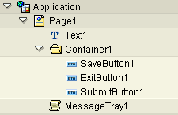
- Right click on the page node to add a new subcomponent. | 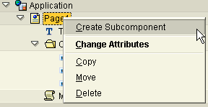
- Choose the text component. | 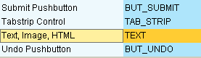
- Give the component a name. In the example we use HTMLContent. | 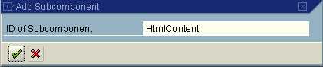
- Set the value for property HTML to True.  Press F4 on the value for the property Text. | 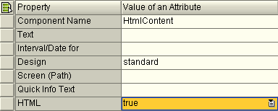
- Choose the option Edit Long Text. | 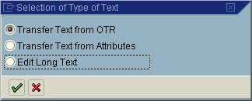
- Now you see a blank text edit field. Enter the HTML-fragments given in the following chapters. | 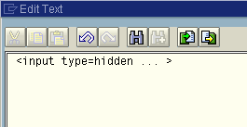

Simple Integration of a BEx Web Application

- Create a text component as shown in chapter 3.1 and move it to the position in the Web Interface where the BEx Web Application should be shown. | Customizing Sample:  The application will be shown below the container.  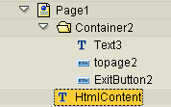
- Now copy the source code shown to the text component and replace the name MYWEBAPPL by your own BEx Web Application. | <iframe  id="BWReport01"  name="BWQUERY"  src="/sap/bw/BEx? cmd=ldoc&TEMPLATE_ID=MYWEBAPPL"  width="800"  height="600">  Frames are not supported.  </iframe>
- Save and (Re-) generate the planning application by pressing button.
- And this is how the result of the customizing should look like.  BEx Web Application | 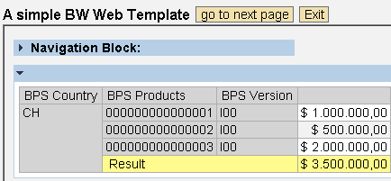

Filter value read from BPS Variable

Prerequisite: There is a BPS variable defined for the same InfoObject that should be used for filtering. In case of a compounded InfoObject please keep in mind to add the parent value to the filter as well.

- Create a text component as shown in chapter 3.1 and move it to the position in the Web Interface where the BEx Web Application should be shown.  In our example it has the name BWTemplate_with_filter. | 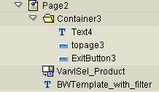
- Create a variable selector with the name VarvlSel_Product and set the properties for appearance and formatting as shown.  Change the name of the planning area and the variable to your own ones.  In the component tree it has to be placed above the text component. | 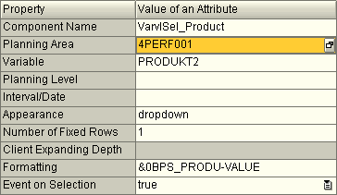
- Note: The formatting has to follow one of the patterns listed:
- Text (Key)
- (Key) Text
- Key
Text only is not supported, as the proposed solution requires the key information to set up the filter.
- Now copy the source code shown to the text component and set the values given to your needs:  BEx Web Application MYWEBAPPL  InfoObject 0BPS_PRODU  Variable selector VarvlSel_Product  When using a compounded InfoObject adjust the variable comp accordingly. | Note: More source code examples are available in the appendix of this document.
<iframe id="BWReport03" name="BWQUERY" src="/sap/bw/mime/bex/icons/pixel.gif" width="800" height="600"></iframe>

<script language="JavaScript" type="text/javascript">
var frame = document.getElementById( 'BWReport03' );
var url = '/sap/bw/BEx?cmd=ldoc&TEMPLATE_ID=';
var filter = '&FILTER_IOBJNM=0BPS_PRODU&FILTER_COLLAPS=&FILTER_VALUE_EXT=';

// Example using fiscal year 2004 and variant K4: K4/2004 => comp = ‘K4/’
var comp = '';
var appl = 'MYWEBAPPL';
var varvl = '<%=descr(VarvlSel_Product/value)%>';

// Option: Adjust the '--SELECT--' to your local language
if (varvl != "" && varvl != "-- SELECT --"){

// expected formatting of variable selector: Text(Key) or Key
var convert = /\((.*)\)/;
convert.exec(varvl);

// If there is value in brackets it is the key
if ( RegExp.$1 != "") varvl = RegExp.$1;

// create URL
url = url + appl + filter + comp + varvl;

// remove possible white spaces
url = url.replace(/ /,"");

// set source attribute of iframe to new URL
frame.src = url;
}
</script>
- Save and (Re-) generate the planning application by pressing button.
- And this is how the result of the customizing example could look like.  As you can see in the navigation block, the filter value for BPS Products is taken from the BPS variable selector. | 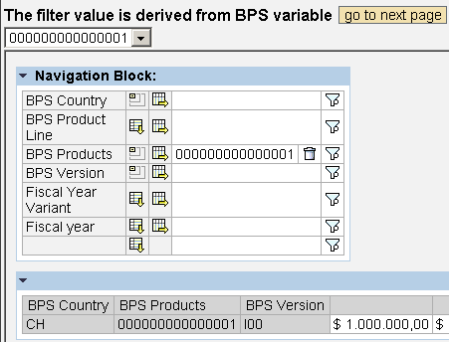

Filter value read from Line Selection of Planning Layout

Prerequisites:
- The example described in chapter 3.3 has been implemented.
- There is a manual planning layout defined using the InfoObject to be filtered in the lead columns.

- Navigate to the Page created in chapter 3.3 and choose Create Subcomponent from the context menu. | 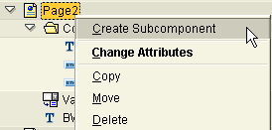
- Choose the tab strip control and accept the proposed name. | 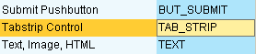  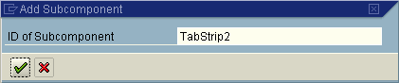
- Create two tabs by choosing the Create Tab option from the context menu and define a label for each tab.  In our example Manual Planning for TabPage2 and BEx Web Application for TabPage3 is used. | 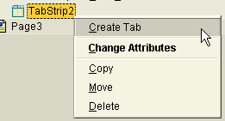  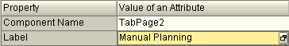  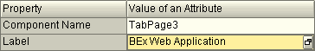
- Move the variable selector and the text component created to TabPage3. The result should look as shown on. | 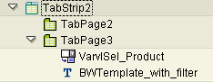
- Create a layout component and assign it to TabPage2. The screen shots show the intermediate steps. | 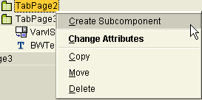  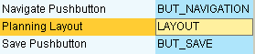  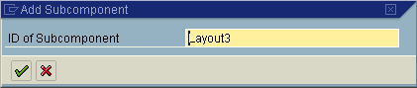
- Enter your planning area, level etc. and set the property Row/Cell Selection to line. | 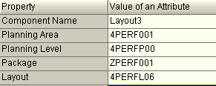  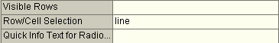
- Navigate to the property section to the variable selection VarSel_Produkt.  Choose as source for selection Layout3.  Note: the appearance is set hidden automatically. | 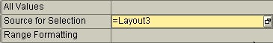
- Save and (Re-) generate the planning application by pressing button.
- The next steps describe a short test of the Web Interface created.  Start the Web Interface and this should be the result. | 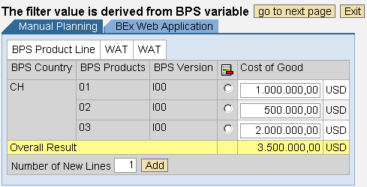
- Navigate to tab strip BEx Web Application. The BEx Web Application will remain blank, as there is no valid filter value available. | 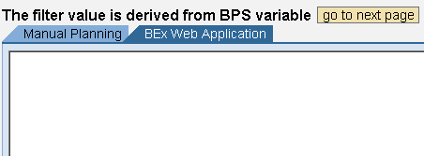
- Go back to tab strip Manual Planning and choose a line. | 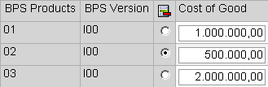
- Navigate again to tab strip BEx Web Application. The filter now contains the value of the selected line as shown in the navigation block. | 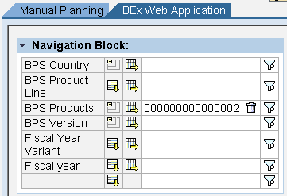

Appendix

Set variable values of BEx Web Template

This source code example shows, how you can set several variable values.

<iframe
id ="myWebAppl"
src="/sap/bw/BEx?cmd=ldoc&TEMPLATE_ID=MYTEMPLATE" style="width:800;height:150">>
</iframe>

<script language="JavaScript" type="text/javascript">

function varValueConvert(dispValue){
/* Expected formatting of variable selector: Text(Key) or Key
If there are more than one (...) expression the first is taken.
*/
var keySection = dispValue.match(/\(.*?\)/);
if (keySection){
var keyValue = keySection[0].replace(/\(|\)/g,"");
alert(dispValue + ' : ' + keySection + " : " +keyValue);
return keyValue;
} else {
alert(dispValue);
return dispValue;
}
}

var frame = document.getElementById( 'myWebAppl' );
var url = '/sap/bw/BEx?cmd=ldoc&TEMPLATE_ID=';
var queryVar1 = '&VAR_NAME_1=PRODUCT&VAR_VALUE_EXT_1=';
var queryVar2 = '&VAR_NAME_2=CUSTOMER&VAR_VALUE_EXT_2=';

var appl = 'MYTEMPLATE';
var bpsVarvl1 = '<%=descr(VarvlSel_Product/value)%>';
var bpsVarvl2 = '<%=descr(VarvlSel_Customer/value)%>';

bpsVarvl1 = varValueConvert(bpsVarvl1);
bpsVarvl2 = varValueConvert(bpsVarvl2);

// create URL
url = url + appl + queryVar1 + bpsVarvl1 + queryVar2 + bpsVarvl2 ;
// remove possible white spaces
url = url.replace(/ /,"");
// alert('Generated URL: ' + url);
// set source attribute of iframe to new URL
frame.src = url;

</script>

www.sap.com/netweaver

