How to…

Add a Logo into the MIME Repository
SEM-BPS / BW-BPS
ASAP “How to…” Paper
Applicable Releases: SEM 3.1 / BW 3.5 or greater
January 2004

Business Scenario
A logo needs to be added into the MIME repository for use in an SEM-BPS web page.

The Result
The logo will be available for use within SEM-BPS. The logo must be in a “gif” format. If it is a bitmap image, it must be converted into a “gif” format before it is brought into the attributes of the text within the web interface builder.

The Step By Step Solution

This example was developed in an SEM development client.
- Go to your Web Interface Builder Application.  SAP Menu path: Strategic Enterprise Management → Business Planning Simulation → Cross-Application Planning → Web Interface Builder → Customizing (transaction code: BPS_WB) | 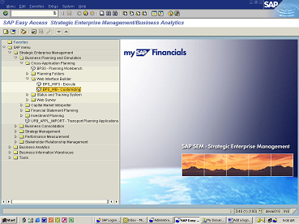
- Open a web application. Right mouse click on “Application” and click on <Open> | 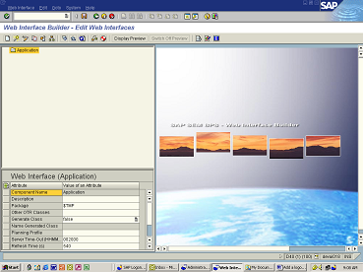
- Choose your web application by double clicking on it. | 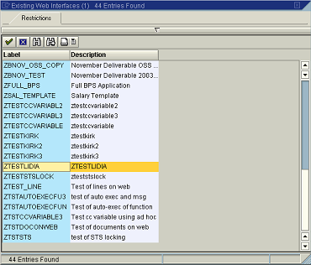
- Right mouse click on <Page 1> and choose <Create Subcomponent> | 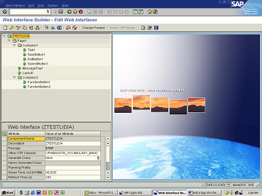
- Choose <TEXT> by double clicking on it. | 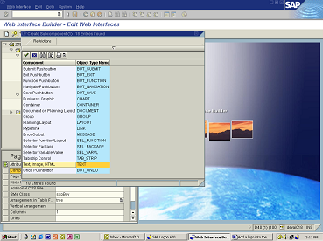
- Input the name of the text as “Text3” and click on<Green Check Mark> | 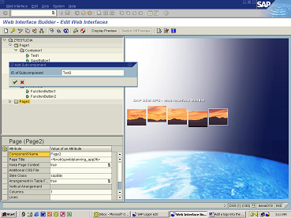
- Right mouse click on <Text 3> and click on <Change Attributes> Click on the field next to <Image (Path)> and “pull-down” on the right corner | 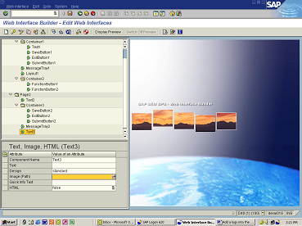
- Click on <Import MIME> | 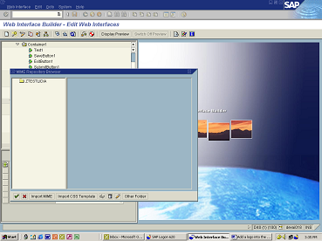
- Choose the logo from your local drive that should be added to the attributes (Note: file name should not contain any spaces). | 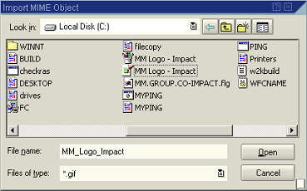
- Double click on the logo (Note: To display the logo, highlight it and click on <Display> | 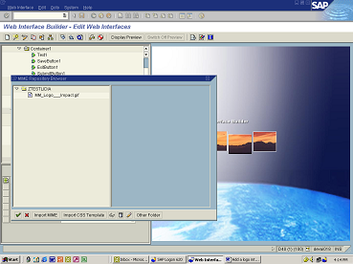
- The logo is added to the attributes of “Text3” | 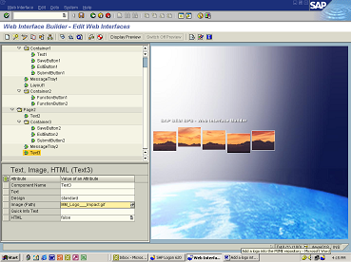
- Click on <SAVE> | 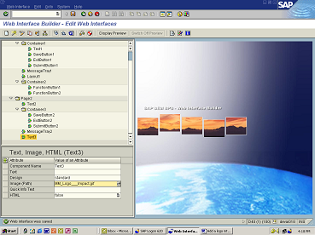

Appendix – How to convert a “bitmap image” into “gif” format
The following is a website that converts bitmap images” into “gif” format: http://www.develcor.com/utilities/bmptogifpro.htm
The BMPToGIF utility can be downloaded for free.

TIP: In SAP’s MIME repository, names cannot have any spaces in them. Use an underscore (‘_’) to separate words. A red X appears on the web page wherever there are spaces.

SAMPLE CONVERSION:

- Open the BMPToGIF utility and click on <File Open> Choose the bitmap that you want to convert and click on <Open> | 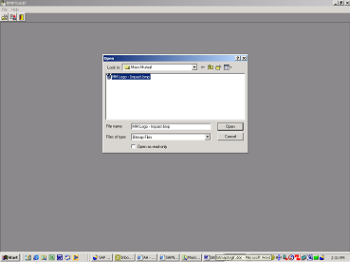
- Click on <File Save As…> rename if you wish and click on <Save> | 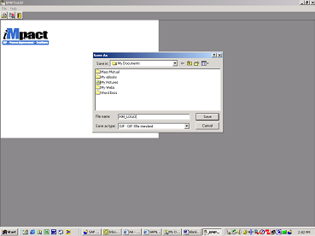
- Open your saved “gif” image. It needs to be resized to get rid of the extra white space around it. | 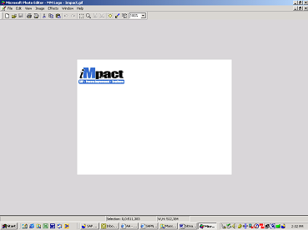
- Click on the <Select> icon (the dotted square next to the magnifying glass) and “paint” the logo without extra white space. | 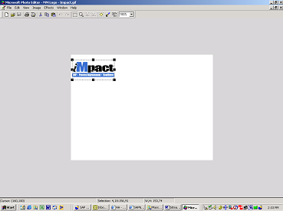
- From the menu bar, click on <Image> and <Resize> then click on <OK> (Note: at this point you can also change the size if needed.) | 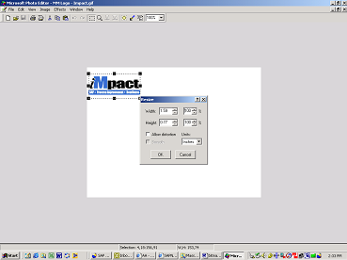
- Your logo/image is now ready for use. | 