How to…

Add a Cascading Style Sheet into the MIME Repository
SEM-BPS / BW-BPS
ASAP “How to…” Paper
Applicable Releases: SEM 3.1 / BW 3.5 or greater
January 2004

Business Scenario
A customized cascading style sheet (CSS) needs to be added into the MIME repository for use in an SEM-BPS web page. SAP delivers a standard CSS for use. It also provides the capability to customize a web page (change fonts, colors, sizes, etc… of objects).

The Result
The customized cascading style sheet (CSS) will be available for use.

The Step By Step Solution

This example was developed in an SEM development client.
- Go to your Web Interface Builder Application.  SAP Menu path: Strategic Enterprise Management → Business Planning Simulation → Cross-Application Planning → Web Interface Builder → Customizing (transaction code: BPS_WB) | 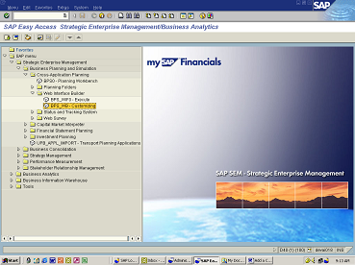
- Open a web application. Right mouse click on “Application” and click on <Open> | 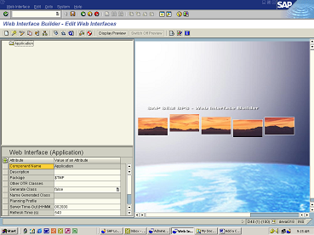
- Choose your web application by double clicking on it. | 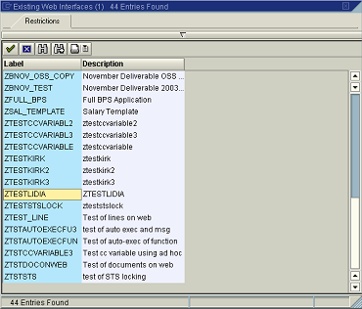
- Double click on the “Page” that you are modifying (Note: The field next to “Additional CSS File” is blank.) | 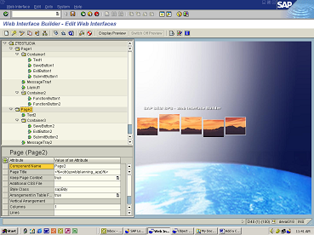
- Click on <Display Preview> (Note: the background color of the page is white.) | 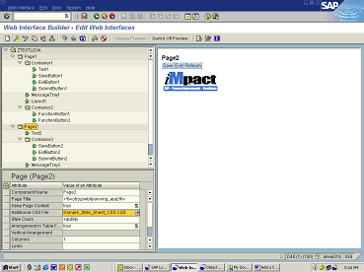
- Pull down on the right corner of the blank field of the “Additional CSS file” attribute. | 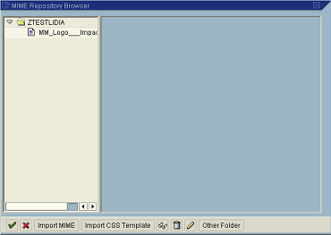
- Click on <Import CSS Template> (Note: “stylesheet000003.css” was added. This is a generic CSS template by SAP.) | 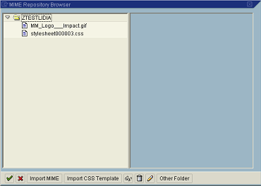
- Highlight <stylesheet000003.css> and click on <display> | 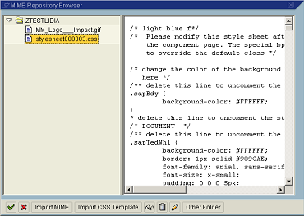
- To customize/edit the style sheet copy (cut and paste) the detail of the style sheet into a Word document. (Note: all text between /*……*/ is considered a comment and not code.) | 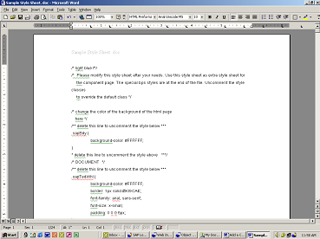
- Customize/edit the Word document. (Note: remember to remove comments in order to enable code. Also include your own comments to clarify/explain the customizing. Changed background color to green and documented with a comment.) | 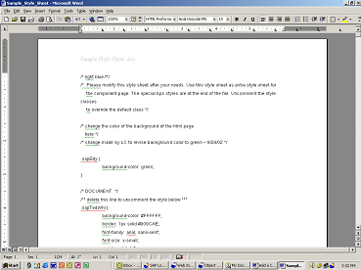
- Save the document as a “Text Only” and add “.css” to the file name. (Note: Do not include any spaces in the file name.) | 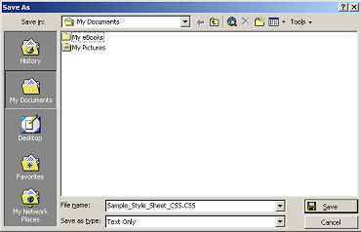
- Go to transaction SE80 (Object Navigator). | 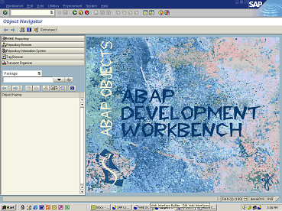
- Click on <MIME Repository> and find your web interface. | 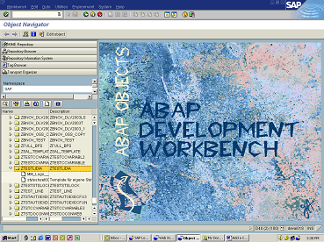
- Right mouse click on your web interface and choose <Import MIME Objects>. | 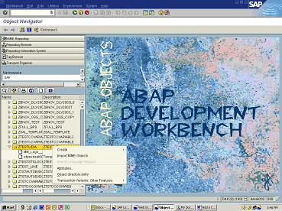
- Find and choose your modified/revised Cascading Style Sheet and click on <Open>. | 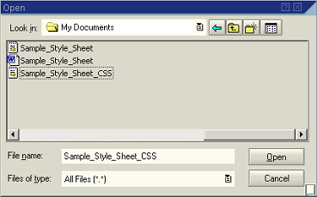
- Click on <Save> (Note: In the pop-up specify the package and transport request). | 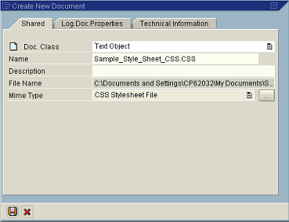
- Go back to your Web Interface (menu path in number 1 above). Double click on the page that you are modifying (same as in number 2 above). Pull down on the right hand corner of the blank field next to “Additional CSS File”. | 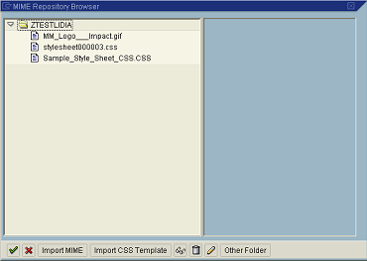
- Highlight your new CSS (in the example: Sample_Style_Sheet_CSS.CSS) and click on the <Green Check Mark> and then click on <Save>. | 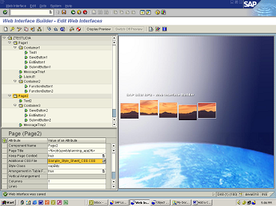
- Click on <Display Preview> and then highlight the page you modified. Right mouse click on click on <Change Attributes> the background on the page changed to green (as stated in number 8 above). | 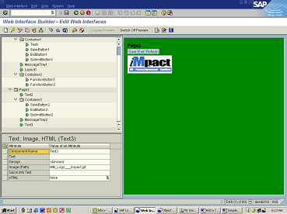

Appendix A – HTML colors
The website below includes a list of 216 colors that can be used in CSS. These HTML colors are recognized by most standard color monitors. Any other colors may display differently depending on the user's monitor.
http://mbweb.com/216code.html

Use the following website to preview HTML colors:
http://www.iwai-h.ed.jp/etc/color-check.html

