How to…

Archive in BW
ASAP “How to…” Paper
Applicable Releases: BW 3.0A
November 2001

Business Scenario
You have data in your system that you do not want to delete for good, instead, you want to move it away from your main data targets (InfoCubes and ODS Objects). You want to improve the load and query execution performance by decreasing the volume of data. In addition, you want to restrict system growth, and have decided to move some of the data onto a slower storage medium, which is also cheaper than the expensive, quickly accessible memory within your system. You may need to retrieve this data some time in the future and therefore, you think about archiving your data.
Note Remarks for the archiving of InfoCubes with Non-cummulative key figures are provided in Appendix.

Solution
BW Archiving in 3.0 is the process of selectively writing the data of a data target to a file and subsequently deleting this data from the respective data target. This process is split in two parts, one job for writing and one job for deleting the data. Hence, the consistency of the archived data is guaranteed. No data will be deleted before not all archive files of the write job are verified, that is, they are accessible and complete.
Archiving in BW uses the Archiving Development Kit (ADK). The ADK is well established in the R/3 environment. It has several beneficial features. Some of the BW relevant features of ADK are:

- Handling structural changes Since the ADK is storing metadata of the archived data as well as the data itself, it is capable of retrieving the archived data even after structural changes have been made. This data is not converted to the new structure, but simply displayed in the new structure.
- Platform independency The ADK can handle different code pages (ASCII, EBCDIC, UNICODE) and number formats.
- Data compression The archived data can be compressed up to 5 times of the original data volume.
- Archiving Information System (SAP-AS) The archived data can be displayed with the Archiving Information System. In BW, the customer has to define the InfoStructures for the respective archiving objects, and fill them manually within AS customizing.
- Administration via transaction SARA The scheduling, monitoring and management of the archiving session can be performed with the standard transaction SARA.

The Step-By-Step Solution

Description of the scenario

This scenario is based on a business content ODS object from the Accounts Receivables (AR) application. The following activities are described in this document:
- Creating an archiving object (including activation and generation of the archiving object and the necessary programs - write and delete program)
- Scheduling the archiving session
- Monitoring and statistics of the archiving session
- Reloading archived data to a data target
- Reporting or displaying archived data

Creating an archiving object

- Call the archiving object maintenance within the maintenance of a data target. | 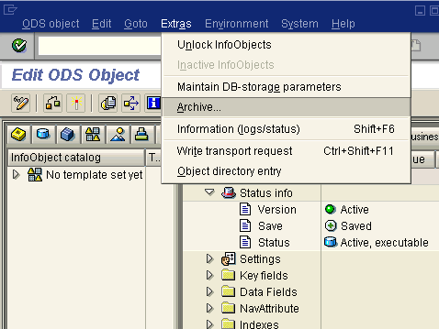

- The name of the archiving object consists of a prefix BW (for the application BW), followed by the character C or O (for InfoCube or ODS Object, respectively) and a 7-character encryption of the data target name.  On the first tab strip of the popup, you define the characteristics that are to be used as selection criteria. It is recommended to use at least one time characteristic to allow periodic scheduling of archiving sessions. When data has been archived, it is not possible to remove characteristics from the selection, yet additional characteristics can always be added to the selection. | 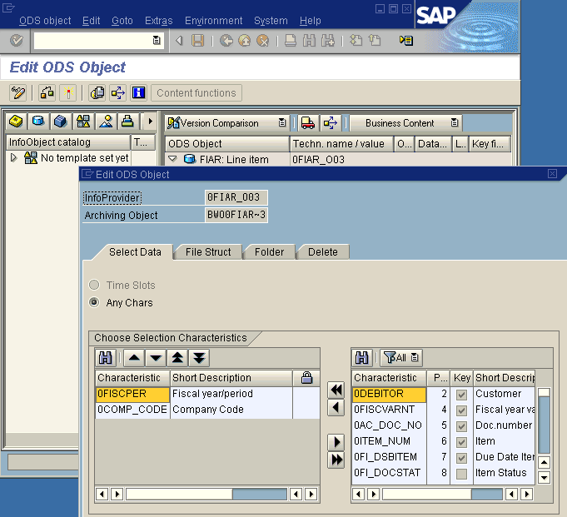
- In the second tab strip, you define the structure of the archive file (data object) and settings for the archive file. The data object defines the grouping of the data in the archive. All records that have the same data object key are stored in the same group. This group is only split when the maximum size of an archive file is reached.  The maximum size of the file can either be defined in Mbytes (2 GBytes is the default) or by the number of records in an archive file. When the maximum size of the archive file is reached, and all data is not yet written to the archive file, a new archive file is opened. | 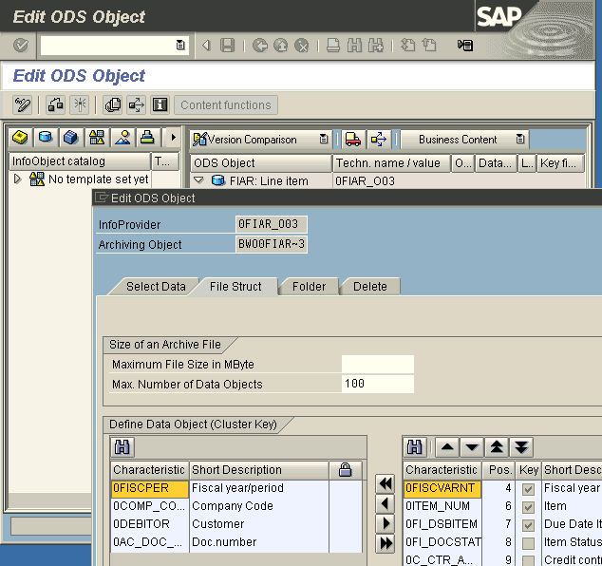
- On the third tab strip, you define the settings for storing the archive file, that is, the logical file name (which is mapped to a physical path name), whether the subsequent transfer of the archive file to another storage is to be performed automatically or not, and so on. | 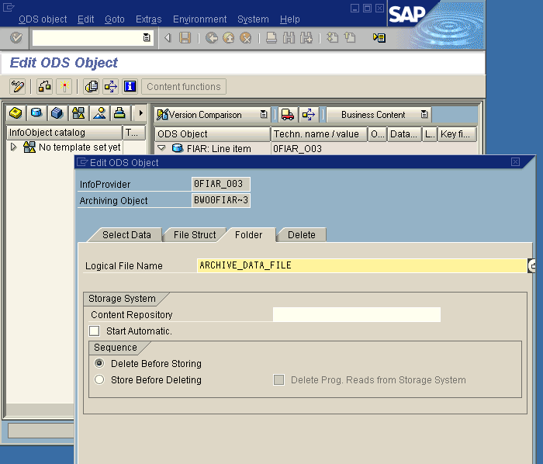
- On the last tab strip, you define the processing for the ‘Delete’ job. This job can be either started automatically after the ‘Write’ job is finished, after a certain event, or not at all. If you choose the last option, you have to schedule the ‘Delete’ job manually. | 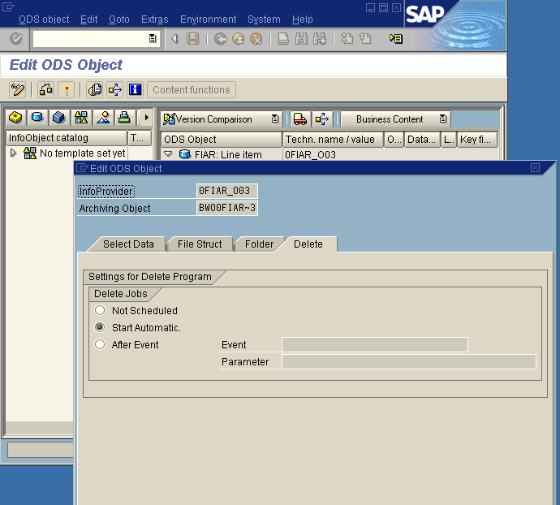
- After you have confirmed your definitions with the return button, you have to activate the data target (). This generates the archiving object and the necessary programs. | 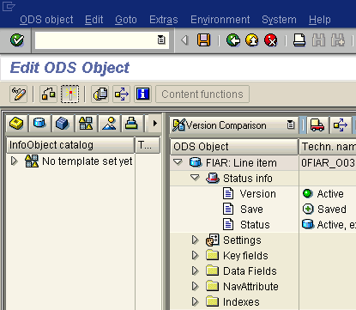

Scheduling the archiving session
The archiving process in the BW system works slightly differently to that in an R/3 environment. In an R/3 system, the data is written to an archive file. Afterwards, this file is read and the deleted from the database, driven by the content of the file. In a BW system, the data from the archived file is not used in the deletion process (only verified to be accessible and complete). The values of the selection characteristics, which have been used for retrieving data in the ‘Write’ job, are passed to the selective deletion of the data target. This is the same functionality that is available within data target management in the Administrator Workbench (‘Contents’ tab strip). This functionality tries to apply an optimal deletion strategy, depending on the values selected, that is, it drops a partition when possible or copies and renames the data target when more than a certain percentage of the data has to be deleted.

- After you have activated your data target, a new menu entry is available in the context menu. In order to schedule the archiving session, you have to select this menu entry (‘Archive Administration’). | 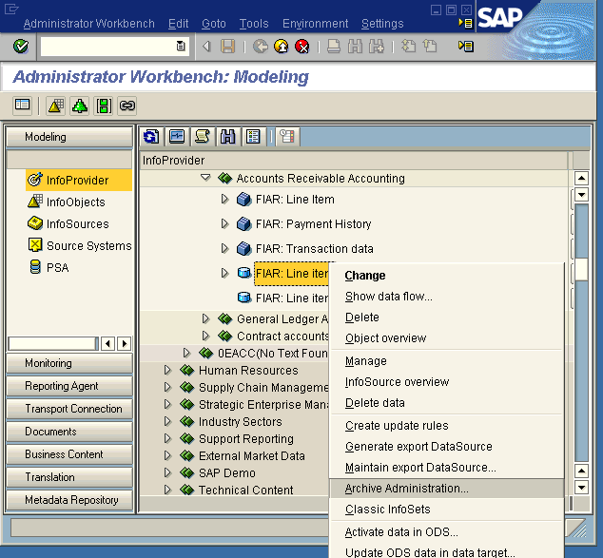
- This will call the transaction SARA, where you can perform all the settings for your archiving session. | 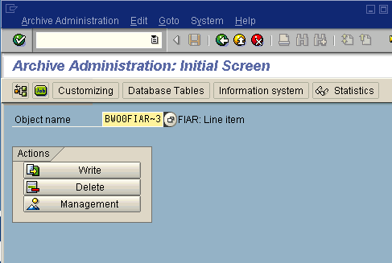

- First you have to schedule the write job. You can do so by pressing the ‘Write’ push button.  You have to perform the following steps:  - Maintain a variant for the selection  - Define the ‘Start date’  - Maintain the spool parameters  - Execute the archiving session | 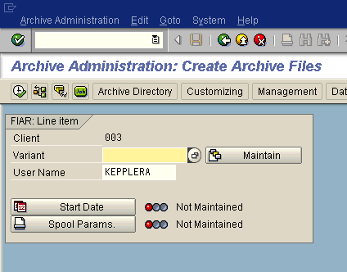
- Choose one of the existing variants, or press the ‘Maintain’ push button, to jump to the variant maintenance.  If you select the radio button ‘Archive and Delete’, ‘Delete’ jobs are started directly by the ‘Write’ job. The customizing of the archiving object (see above) determines whether the ‘Delete’ jobs run in productive or in test mode. If you select ‘Archive’, you have to schedule the ‘Delete’ job separately. | 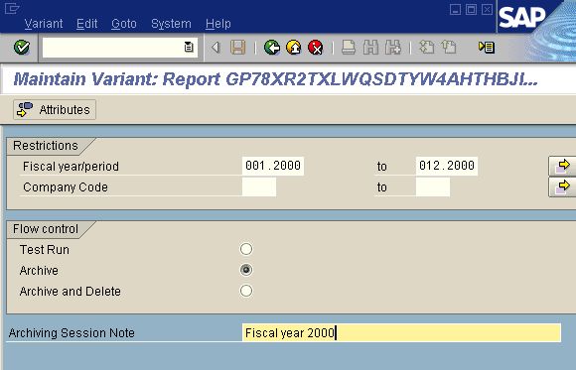
- The next step is to define the ‘Start date’. You have the option to start the job immediately, at a certain date, after another job, or after an event has been triggered by the system. After you have saved the entries, the system will set the status for this activity to ‘Green’. This indicates that this activity has been executed successfully. | 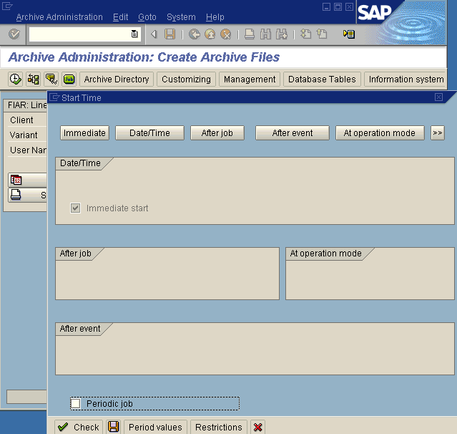
- The third step is to maintain the spool parameters. Here, you have to define the output device, and other properties for the output of the list created by the ‘Write’ job. The push button ‘Properties’ allows you to maintain additional properties for the spool request. | 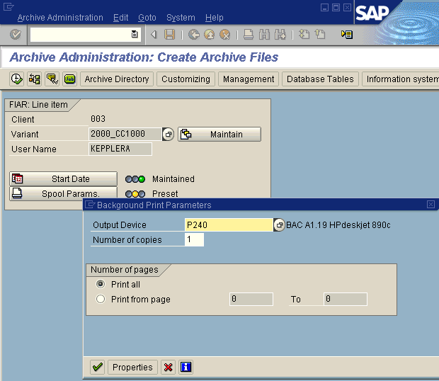
- In the final step, you have to start the archiving session by pressing the ‘Execute’ button. | 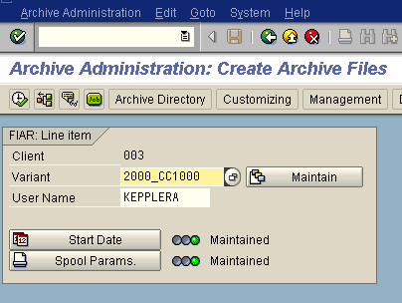
- If the ‘Delete’ job is not started automatically, you have to schedule it manually. You do so by pressing the ‘Delete’ push button. | 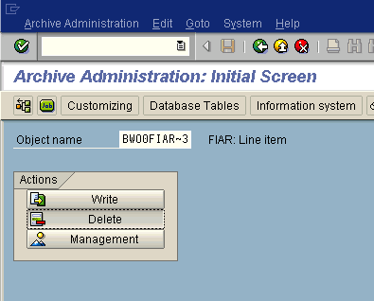
- The ‘Start date’ and the spool parameter settings are already filled with the values you defined for the ‘Write’ job. You have only to verify them by entering the respective maintenance and confirming (or changing) the existing entries.  In addition to theses settings, you have to define which data (archive files) are to be deleted from the data target. You do so by pressing the ‘Archive Selection’ push button and selecting the desired archive files. You have to select all files of an archiving session in order to delete data from the data target. Otherwise the selected archive files are verified only and not deleted. | 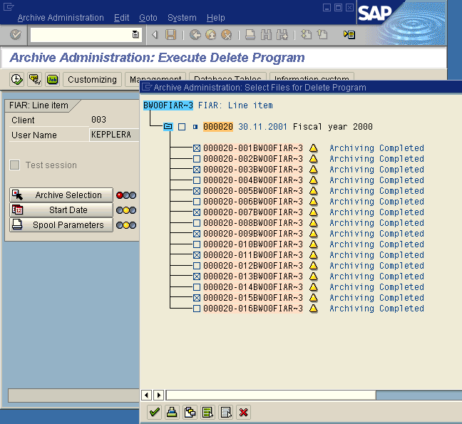

Monitoring and statistics of the archiving session

- During and after the completion of the archiving session, you have the opportunity to track the progress of the jobs that are running and control the jobs that are finished.  You do so by pressing the ‘Job’ button. | 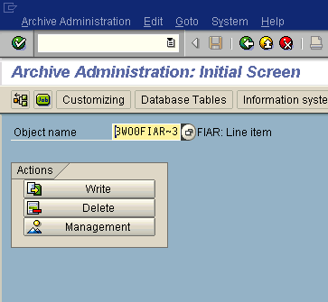

- While a job is active, you can track its progress in the job overview.  While there is only a single write job, you will notice that multiple delete jobs are executed (one per written archive file). | 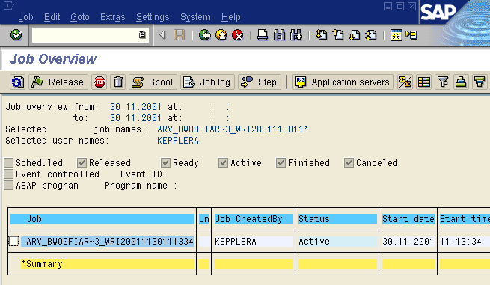
- When the job is finished, you can get various information about the activities performed, for example:  - The path information of the archive files and the number of records and data objects that have been written by this job via the job log.  - More detailed information about the job via the spool entry created by the job. | 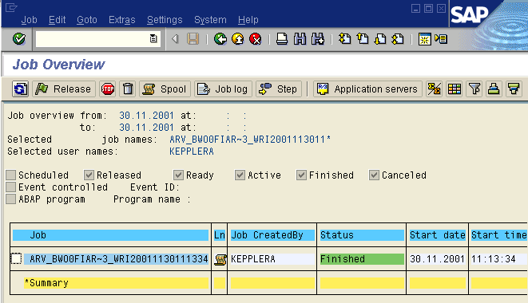
- In addition to job monitoring, you can also the use ‘Statistics’ function to get information about your archiving sessions. | 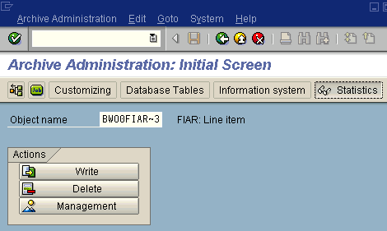
- This report displays mainly database and status information. | 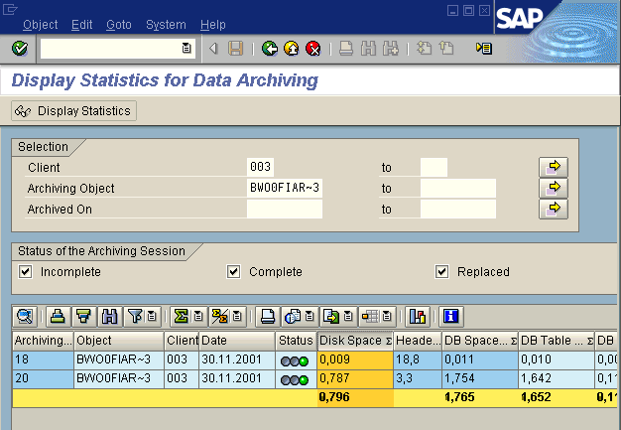

Reloading archived data to a data target

Reloading archived data should be an exception rather than the general case, since data should be archived only if it is not needed in the database anymore. When the archived data target is serving also as a datamart to populate other data targets, we recommend that you load the data to a copy of the original (archived) data target, and combine the two resulting data targets with a MultiProvider.
In order to reload the data to a data target, you have to use the export DataSource of the archived data target. Therefore, you create an update rule based on the respective InfoSource (technical name 8<data target name>). You then trigger the upload either by using ‘Update ODS data in data target’ or by replicating the DataSources of the MYSELF source system and subsequently scheduling an InfoPackage for the respective InfoSource. In this scenario we have used the first option.

- Call the Administrator Workbench and search for your archived data target.  Select the entry ‘Update ODS data in data target’ from the context menu of your data target. | 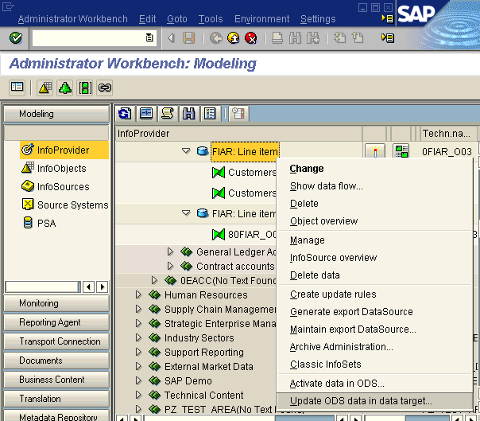
- Select ‘Full update’, since only this method is supported for extracting data from an archive file.  On the ‘Select data’ tab strip of the InfoPackage press a push button ‘Archive selection’, which starts a popup for selecting the DataSource. By default, this is the database, but you can change it to ‘Archive only’ or to ‘Database and Archive’. | 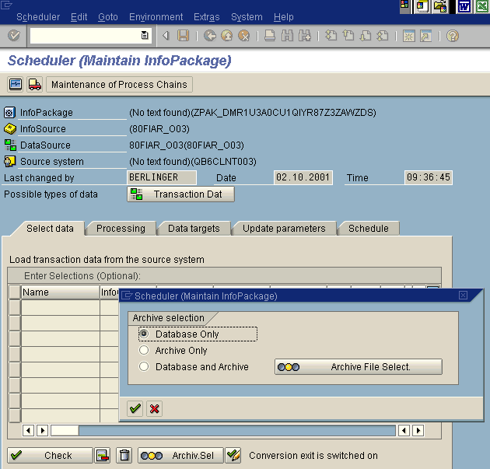

- When you choose one of the two options, which include the archive, you have to select the archive files containing the data that is to be extracted. | 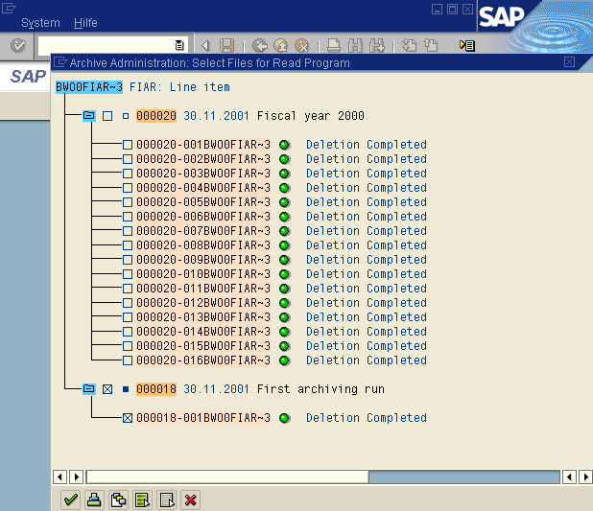
- After selecting the archive files, you can schedule the InfoPackage in the usual way. | 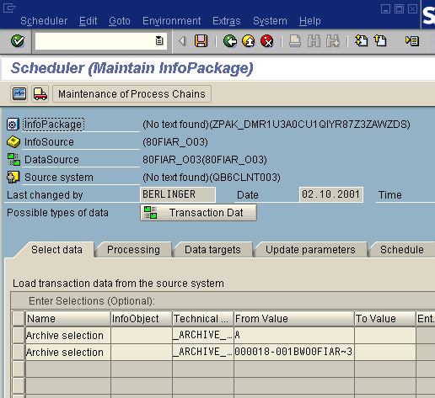

Reporting or displaying archived data

This chapter provides additional information on how to report or display archived data. It is not mandatory for the archiving process and can therefore be skipped when such a function is not needed.
Currently, there is no direct index support for archive files. If you want to read the data for reporting or control purposes, you have to write a report, which reads data from the archive files sequentially. Alternatively, you can also use the Archiving Information System (AS). This tool enables you to define an InfoStructure, and create reports based on these InfoStructures. The InfoStructures define an index for the archive file data. At the moment, the archiving process in the BW system does not fill the InfoStructures during the archiving session automatically. This has to be performed manually when needed.
Another way of displaying data from the archive file is by using the ‘Extractor checker’ (TCODE RSA3). Enter the name of the export DataSource of the respective data target (name of the data target preceded by ‘8’), and choose the archive files that are to be read. The extractor checker reads the selected archive files sequentially. Selection conditions can be entered for filtering but have to be entered in in internal format (e.g. 20011130 for date 30.11.2001).
- Press the ‘Information system’ push button. | 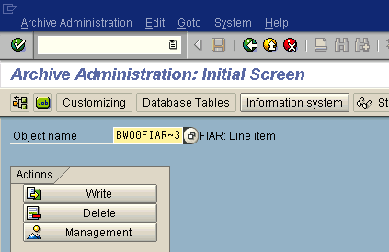
- If you have not yet defined an InfoStructure for the archiving object, you have to define this InfoStructure first. Press the ‘Customizing’ push button to jump to the InfoStructure maintenance screen. | 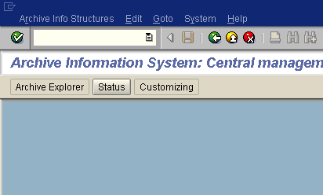
- If you have not defined an appropriate field catalog, you have to do so first. To jump to the field catalog definition, use the relevant entry in the ‘Environment’ menu.  As a template for defining the field catalog, you can use the technical field names of the InfoObjects of your data target, for example, the ‘Active’ data table of an ODS Object. | 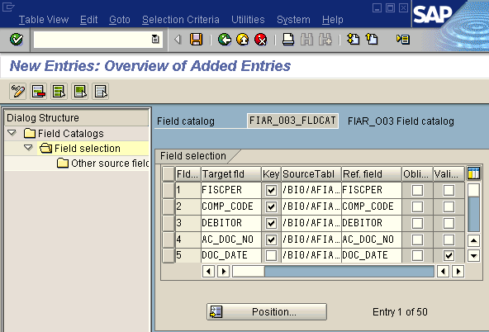
- After you have defined the field catalog, you have to define the InfoStructure. Press the ‘Create’ button and enter the data requested.  Activate the InfoStructure after your return to the initial InfoStructure maintenance screen. | 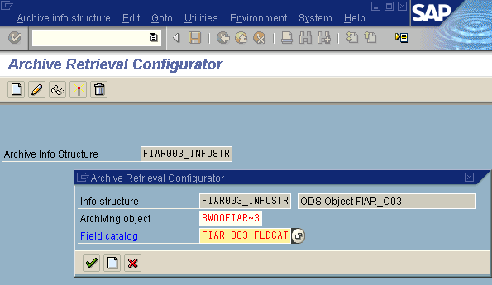
- In order to use the InfoStructure for reporting, you have to fill / create the InfoStructure. Choose the ‘Create structure’ entry in the ‘Environment’ menu. | 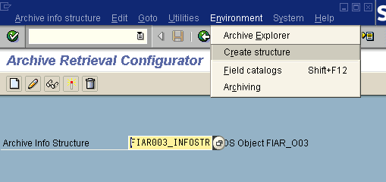
- Choose the archive sessions that are to provide the data for the InfoStructure, and press the button ‘Build Structures’.  The system highlights the data that has been included in the InfoStructure with a green traffic light in front of the respective archiving session. | 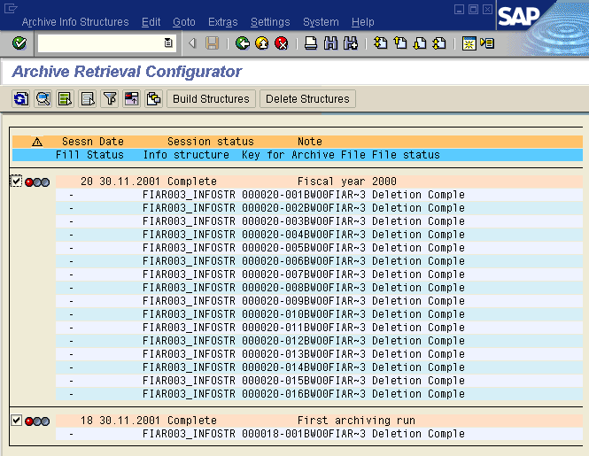
- In the final step, you can run the ‘Archive Explorer’ to run a report on the InfoStructure that you defined and filled. You do this by:  - Choosing the respective push button (Archive Explorer) on the initial screen of the ‘Information System’.  - Entering an Archiving object and InfoStructure and pressing execute.  - Filling the fields on the selection screen with the desired values, and executing the report. The available fields are the ones from the field catalog (defined in one of the previous steps).  - A sample output of such a report is shown on the right. | 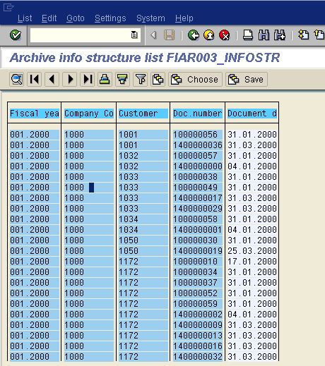

Limitations
In the current release (3.0A), there are some limitations to archiving in BW. If you are in doubt whether certain limitations are still valid, check the available notes in the OSS system and the relevant release notes for required topic.

- Master data and PSA cannot be archived (planned in one of the next releases).
- Only one archiving object per data target can be defined.
- Indexing is currently not supported. No indexes are created and maintained for the archiving objects and files in BW.
- Protection of the archived data ranges against further changes. Subsequent loads of data into the data targets are not checked in respect of a potential conflict with data that is already archived.
- The deletion of the data from the data targets is not passed on to other data targets (data targets that are populated from the archived data targets - data marts).
- The data is only deleted from the Active table (for ODS Objects) and from the fact table(s) (for InfoCubes).
- The archived data is not integrated in BW queries.
- The extraction of archived data is only supported for BW extractors and for the Export DataSources of the archived data targets.
- Only the ‘Full’ extraction method is supported for the extraction of data from the archive file.
- There are currently no business contents objects available that are delivered with a pre-defined archiving object.

Appendix
In order to archive and reload data from InfoCubes with non-cumulative key figures, there are some directives that have to be kept in mind.

Generals remarks

The keeping of stock in an InfoCube is based on the most granular time characteristic in the InfoCube (time-reference chararcteristic). The InfoCube stores only stock movements and the final stock (=marker). The marker is independent of the values in the validity table, and is defined for the maximum value of the time-reference characteristic (e.g. 31.12.9999 for 0CALDAY). The marker is also stored in the InfoCube with a special record type (characteristic 0RECORDTP = ‘1’) as a stock movement.
A stock, in respect to another point in time within the validity table, is calculated by the OLAP processor during the execution of a query. The OLAP processor uses the final value stored in the marker and calculates the actual stock by adding stock movements from the requests that have not yet been compressed in the InfoCube and subtracting all posted stock movements after the requested date for the actual stock (compressed and uncompressed ones). This method requires that all stock movements (either as stock initialization or as stock movement with adjustment of the marker) up to the end of the validity interval have to be contained in the final stock value without any gap.

Archiving of data

The archiving of InfoCubes with non-cumulative key figures is only using the posted values in the fact tables. It does not consider the special semantic of the stock keeping in the OLAP processor, i.e. the archive files do only contain the stock movement (see also note #571347 for further explanation).

Time slot archiving (recommended approach)

The processing methode for InfoCubes with non-cumulative values should be set to a time slot according to the time-reference characteristic, which is also the basis for the stock keeping. This characteristic is also the default value on the creation of a new archive object for the respective InfoCube. The processing metod for the archiving has to be defined before the first archiving session, and cannot be changed afterwards.
It is advisable to archive at the beginning only stock movements up to a certain point in the past in order to reduce the data volume of an InfoCube. Thereby remains the marker (=final stock value) untouched. The archiving of the marker is an additional option and should only be performed together with all stock movements. The content of a cube with non-cumulative key figures is afterwards completely archived.
In order to separate stock movements and marker in the archive, it is advisable to archive first all stock movements (for all time intervals) and afterwards in a separate archiving session the marker information.

Note The advantage of the time slot archiving is the option to schedule all archiving session with a single variant with a relative time restriction. This advantage does not exist for the alternative approach described in the next paragraph.

Alternative approach

An archiving, which is purely based on time slot s, can in certain cases not provide the desired extent of data reduction in an InfoCube. This is the case, if the relevant object for the stock keeping is heavily undergoing changes, i.e. data for new objects is constantly loaded into system with the old objects becoming obsolete. In case of a time slot archiving, the final stock value for all objects remains in the system until the eventual archiving of all data from the InfoCube. This holds true even if already all stock movements for an object are archived.
In such a scenario, it would be desirable to archive and delete objects, which are not active any more, completely (including the marker) from the InfoCube. For the others (active objects) only the stock movements from the past should be archived without touching the marker.
Therefore, you cannot choose time slot archiving in the definition of the archive objects for your respective InfoCube with non-cumulative values. You have to pick as selection characteristics the relevant characteristics manually. In this selection, you should also include the time-reference characteristic for which the marker values are defined.
With this archiving method you have to define a single variant for the selection condition of each archiving session. In this variant, you can also specify selection conditions for the chosen chararcteristics, and whether stock movement and / or marker information should be archived.

Note It is important to include the maximal value for the time characterisitic in the selection condition of the variant in order to archive the marker information correctly.

Reloading of data from the archiv

The general recommendation to reload the archived data to a copy of the original data target holds also true for the reloading of data for an InfoCube with non-cumulative key figures. If the data of both InfoCubes should be combined in a query, you can define a MultiProvider, which spans the original data target and the copy with the reloaded information.
For the reloading of data into an InfoCube with non-cumulative key figures, certain considerations have to be taken into account. There is a different proceeding that has to be choosen for the reloading of stock movements and the reloading of marker information.

It should be adhered to the following guidelines:

- The reloading of marker information and the reloading of stock movements should be scheduled with different InfoPackages.
- Marker information should be reloaded prior to the reloading of stock movements.
- Marker information cannot be reloaded directly into the marker of an InfoCube with non-cumulative key figures. This is due to the fact that the Export DataSource, which is used for the reloading of the data, does not support the intialisiation of stock values.
Workaround The marker information can be reloaded as a stock movement in Full update mode. The value of the time-reference characteristics has to be transformed to a value in the distant past (before the potential lower threshold of the validity area). This request should afterwards be compressed with the flag ‘Marker upadte’ switched on. The point in time at which the data has been reloaded should afterwards be excluded from the validitiy table.
Note At the current release BW 3.0B, the selective deletion (as performed in the archiving process) is not adjusting the validity table automatically. This has to happen manually via the transaction RSDV.
- If the archiving session contains both stock movements and marker information, it is possible to separate the two types of data in the reloading process. This is achieved by restricting the chararacteristic record typ (0RECORDTP) in the selection of the InfoPackage. Choose record typ = ‘1’ to restrict the reloading to the marker information, and record typ = ‘0’ for the reloading of stock movement information.
- Stock movements have to be compressed with the flag ‘Marker Update’ switched off (i.e. no marker update) immediately after the reloading.
- Stock movements should always be reloaded without gaps starting fromt the lower threshold of the validity area. Otherwise, it might happen that stock balances for a certain point in time, which is located time-wise before a gap, cannot be calculated correctly.

Example

The following figures show exemplified the archiving of stock movements with the ‘Time slot’ approach. The reloading is happening into a copy of the original InfoCube, and subsequently the provision of the archived and non-archived data via a MutliProvider. The validity area (marked in blue) has at the current point in time (release BW 3.0B) sometimes to be maintained manually via the transaction RSDV.

Figure 1: State before archiving

Figure 2: Archiving session for the first time interval (January to June 1999)

Figure 3: Archiving session for the second time interval (Juli to December 1999)

Figure 4: Creation of a copy of the original InfoCube and the creation of a respective MultiProvider for the reloading of the archived data

Figure 5: Reload of the second time interval (July to December 1999)

Figure 6: Reload of the first time interval (January to June 1999)

