How to…

use SAP GUI Planning Folders with Status & Tracking System
Business Planning and Simulation
Applicable Releases: SEM 3.1B, SEM 3.2, SEM 3.5, BW 3.5
October 2004

Index
Index 1
1 Business Scenario 2
2 Introduction 3
3 Step-by-Step Solution 4
1. Create a Variant for the start program of a SAP GUI Planning folder 4
2. Create your own startreport for your SAP GUI Planning folder 9
3. Create a shortcut of your SAP GUI Planning folder 13
4. Create URL and insert it into the Status & Tracking System 14
5. Activate Authorization Check 15

Version History

2002 | Initial release of “How-to” paper.
October 2004 | Added chapter 3.5 regarding authorization check

Business Scenario
The Status & Tracking System is a web-based status-monitoring tool. The technology used is web oriented. Therefore when customizing the Status & Tracking System you have to use a URL pointing to Web Planning Applications.
But in some cases it could be useful also allow the usage of SAP GUI Planning folders in the Status & Tracking System.

Introduction
This paper will show you a detailed way, how to use SAP GUI Planning folders within the Status & Tracking Monitor. In general the following steps have to be performed:
- Creating a start program which - when executed - will open the appropriate SAP GUI Plannigfolder.
- Creating a shortcut for this program, which should be located in a directory without spaces in name. Also the name of the shortcut should not contain spaces. The path to this file has to be executable in webbrowsers.
- Open the Customizing transaction of the Status & Tracking System. Navigate to the screen where among other things you can customize the Links to the Planningapplication.
- Navigate to the appropriate node of the hierarchy.
- Enter the following type of link in the appropriate field and save the customizing:
file:// <path_to_your_shortcut>\<name of your shortcut>.sap
(e.g.: file://c:\users\favorites\MyShortcut.sap)
- Note: Be sure that the responsible person(s) on this node all have access to the shortcut, which you created.
- These/This user(s) should now be able to open this SAP GUI Planning folder when clicking on ‘Open Plannig’ within the status monitor of the Status & Tracking System.

The Step-by-Step solution will show you one possible way to realize the use of SAP GUI Planning folder in the Status & Tracking environment. In this sample Windows is use as operating system.

Step-by-Step Solution

Create a Variant for the start program of a SAP GUI Planning folder

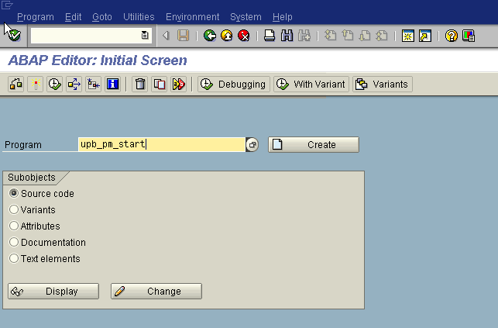

Call transaction SE38.
Steps on this screen:
  - Enter ‘upb_pm_start’ in the input field.
  - Click on ‘Variants’.

The next window will show up.

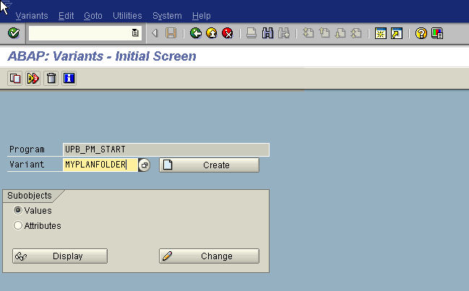

Steps on this screen:
- Now enter a technical Variant name (e.g. ‘MYPLANFOLDER’).
- Click ‘Create’.

The next window will show up.

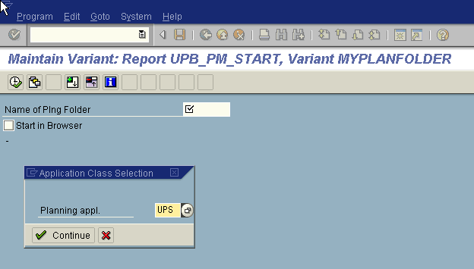

Steps on this screen:
- As Planning Application please enter ‘UPS’.
- Click ‘Continue’.

The next window will show up.
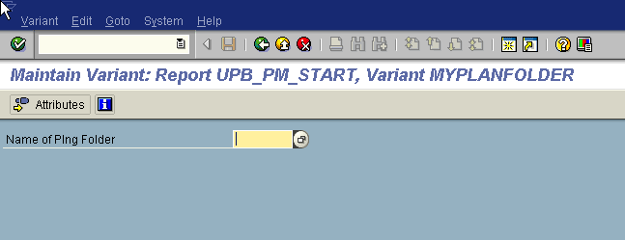

Steps on this screen:
- Now choose a planning folder, which you want to use in the Status & Tracking System.
- Click on ‘Attributes’.

The next window will show up.
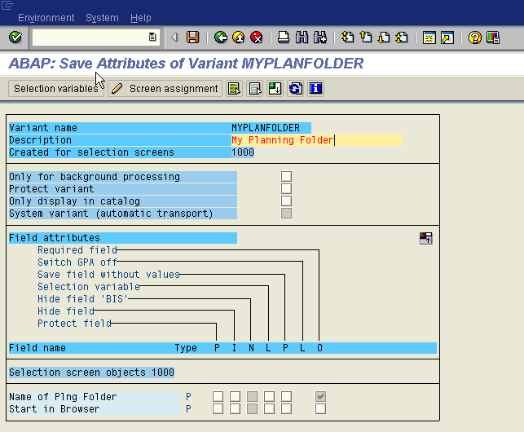

Steps on this screen:
- Please enter a description for the Variant (e.g. ‘My Planning Folder’)
- Save it.

Create your own startreport for your SAP GUI Planning folder

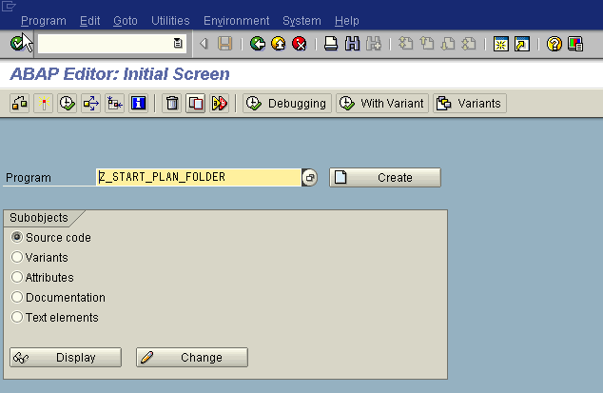

Call transaction SE38.
Steps on this screen:
- Enter a name for your startreport of your planning folder (e.g. ‘z_start_plan_folder’).
- Click ‘Create’

The next window will show up.

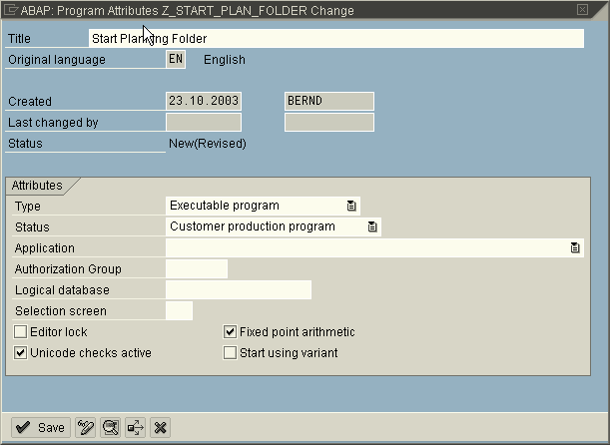

Steps on this screen:
- Enter a title for your program (e.g. ‘Start Planning Folder’).
- Choose ‘Executable Program’ as type.
- Choose ‘Customer production program’ as status.
- Click ‘Save’.

The next window will show up.

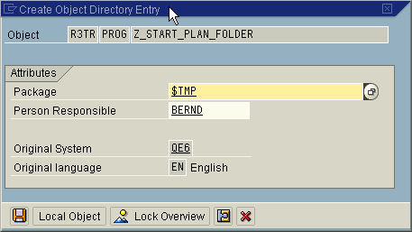

Steps on this screen:
  - Enter your own package or Local Object ‘$TMP’.
  - Click ‘Save’.

The next window will show up.

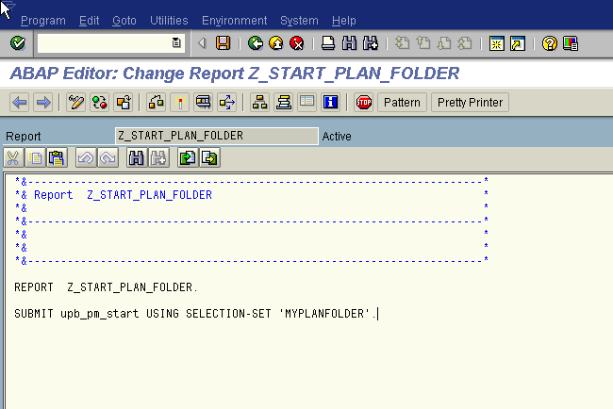

Steps on this screen:
- Append the following line of code to the program:

SUBMIT upb_pm_start USING SELECTION-SET 'MYPLANFOLDER'.

Replace 'MYPLANFOLDER' with the technical name of the Variant you created a few steps above.

- Save and activate the program.

Create a shortcut of your SAP GUI Planning folder
Steps to perform:
- Open the Windows Explorer.
- Navigate to a folder - without spaces in the name and where the appropriate person(s) has/have access to - where the shortcut can be saved.
- Perform a right mouseclick in this folder. Click on new and choose ‘SAP GUI Shortcut’.
- Rename the shortcut. Be sure that your name does not contain any spaces in name (e.g. ‘MySchortcut.sap’).
- Perform a Doubleclick on this shortcut.
- The following Pop Up appears:
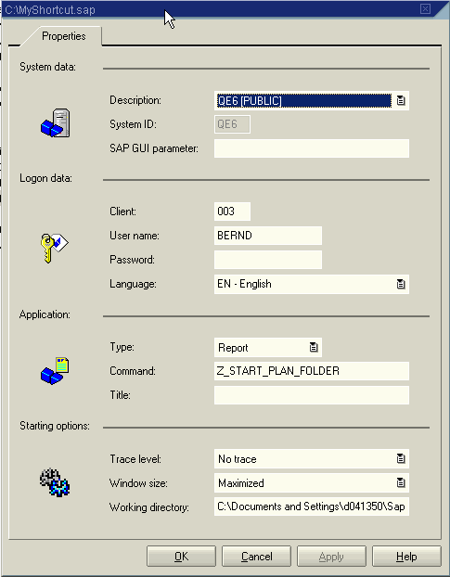

Perform the following steps on this Pop Up:
  - Under ‘System data’: Choose system where your startreport was created.
  - Under ‘Logon data’: Type in the client, the User and password if desired. Note: Type in the password could be a security problem. If user and password are typed in, the user who starts the link later does not have to retype his/her password again. The SAP GUI Plannigfolder appearing directly after clicking ‘Open Planning’ in the status monitor of the STS.
  - Under ‘Application’: Choose Type ‘Report’ and insert the name of you startreport (e.g. ‘z_start_plan_folder’) as Command.
  - Click OK and you can test your new shortcut.

Create URL and insert it into the Status & Tracking System
Steps to perform:
  - Open the Customizing transaction of the Status & Tracking System.
  - Naviagte to the customizing of the subplan and planning session where you want to use the SAP GUI Planning folder.
  - Enter the following type of link in the appropriate field and save the customizing:
file:// <path_to_your_shortcut>\<name of your shortcut>.sap
(e.g.: file://c:\users\favorites\MyShortcut.sap)
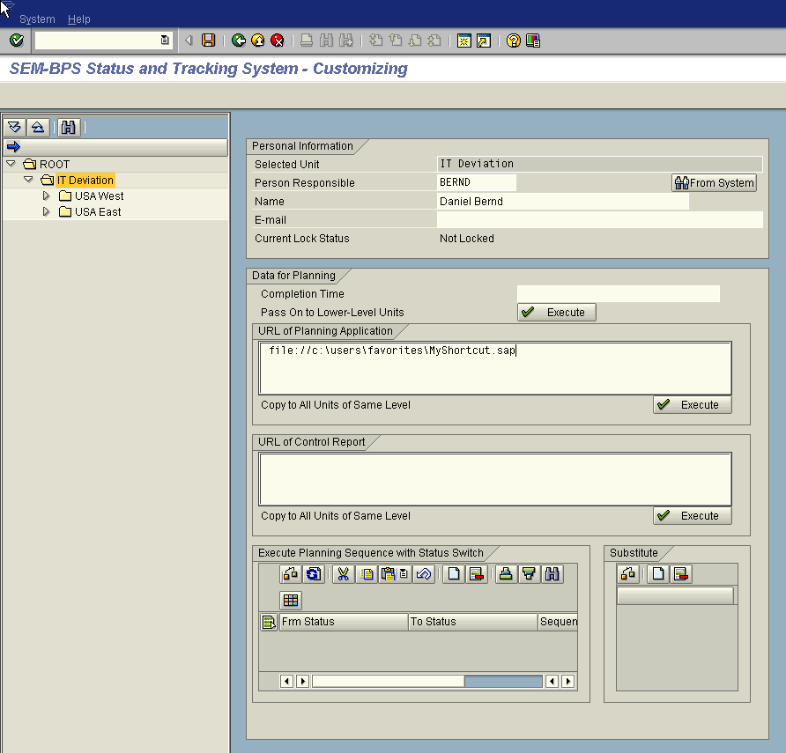

  - Note: Be sure that the responsible person(s) on this node all have access to the shortcut, which you created.
  - These/This user(s) should now be able to open this SAP GUI Planning folder when clicking on ‘Open Plannig’ within the status monitor of the Status & Tracking System.
  - Depending on your browsersetting you can be asked, if you want to open this file (the shortcut) in current location or if you want to save it to disk. Choose open.

Activate Authorization Check

Steps to perform:
  - Go to transaction SU22 to maintain the assignment of authorizations to transactions.
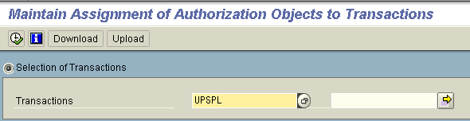
  - Select transaction UPSPL and execute.
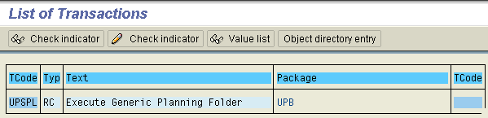
  - Change the authorization check.
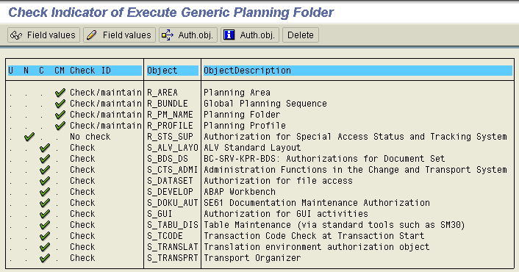
  - Activate the check for object R_STS_SUP.
  - Save the changes to a transport.
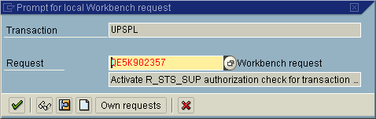
Now the system will also check the STS authorizations and locks when using planning folders.

