How to…

use MOLAP Aggregates
Business Information Warehouse
ASAP “How to…” Paper
Applicable Releases: BW 3.0A
January 2002

Introduction

What BW 3.0 offers
BW 3.0 offers the possibility to create standard InfoCubes with aggregates that are based on MOLAP storage. For BW 3.0A this feature is only offered for the Microsoft SQL-Server® database platform. The reason is that BW's MOLAP storage is based on Microsoft's Analysis Services® (MS AS) which form part of Microsoft SQL-Server and are therefore part of the runtime license. It has still to be determined whether BW's MOLAP features will be extended to other database platforms or whether it remains a platform-specific optimization feature.
MOLAP aggregates constitute an alternative to BW's standard aggregates which are based on relational database tables. Therefore we will refer to the latter as ROLAP aggregates. ROLAP and MOLAP aggregates have the following properties:
- They are transparent to the user, i.e. a query is built on top of an InfoCube which might have aggregates that are used when the query is processed.
- Data in aggregates is redundant; aggregates enhance the performance but not the functionality. You are not able to do more or other things when using aggregates; they simply accelerate query processing.
- There is no direct access to aggregates. In theory, MOLAP aggregates can be accessed via MS AS's OLE DB for OLAP interface. As with ROLAP aggregates (which could theoretically also be accessed via native SQL) such an access is not supported by BW.

What is the difference between ROLAP and MOLAP?
ROLAP is based on standard relational database technology while MOLAP uses proprietary physical storages. There is no general preference for one or the other mode. The following comprises a list of typical arguments in that discussion:
- MOLAP typically precalculates many aggregates at the time when data is loaded. This means that scenarios with frequent changes need to be reprocessed/adjusted frequently if stored in MOLAP mode. Relational storage is much more flexible in that sense.
- Relational DBMS are based on the transaction paradigm and in particular on the ACID properties. These assert concurrency and consistency in a system with frequent update operations. However, OLAP typically forms an (almost) read-only environment. The transactional components in relational DBMS can cause an overhead or do at least not take advantage of the "read-only character" of OLAP. MOLAP tools typically have got rid of that overhead.
- There are doubts about the scalability of MOLAP tools. Scalability in size has improved considerably over time. However, complex scenarios (i.e. many dimensions, complex hierarchies etc.) are more likely to change and will require readjustment as described above.
As there is no general preference for one or the other mode it is up to the person who sets up an InfoCube to decide whether the underlying model suits for MOLAP or not. The arguments listed above and the details about the BW-specific implementation of MOLAP – these are given in following sections of this document – will help to take that decision.

Architecture of MOLAP Aggregates in BW 3.0

Technical Architecture
The simplest way to set up a MS SQL-Server based BW system for MOLAP is to install MS AS as an additional service on the DB server. Furthermore, the SAP MOLAP-Bridge needs to be installed. The latter supplies the interface for accessing MS AS functionality from an ABAP-based environment. The MOLAP-Bridge also runs as a service on the DB server. Figure 1 shows the setup.

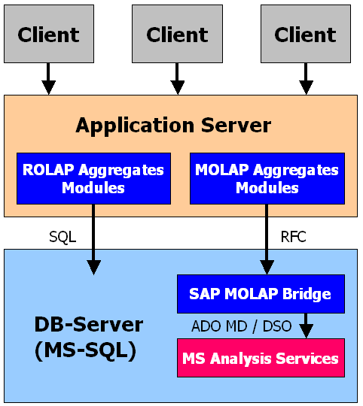
Figure 1: Technical integration of MS AS into BW 3.0.

The MOLAP-Root-Aggregate
As mentioned before, ROLAP aggregates are stored in relational tables. Each aggregate represents a sub-InfoCube which can be derived either directly from the corresponding InfoCube or from another, more general aggregate. In the ROLAP case, both – InfoCube and aggregates – are stored in a relational database. Figure 2 shows that scenario whereby arrows indicate if an aggregate can be derived from another one.

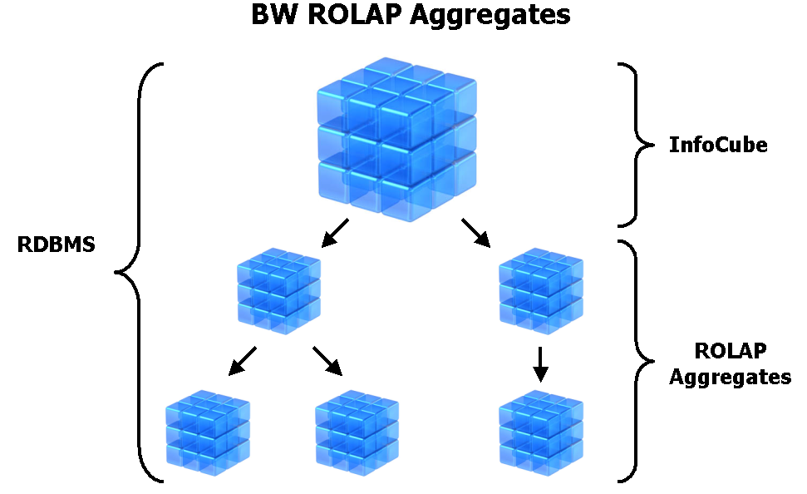
Figure 2: Derivation paths of ROLAP aggregates.

In the case of MOLAP aggregates, the situation is similar with the notable difference that the aggregates are stored in a MOLAP storage while the InfoCube remains in the relational database. There is one dedicated MOLAP aggregate: the so called MOLAP root-aggregate or MOLAP cube. In general, it holds the same information as the InfoCube. One might argue that this is redundant but the reasons behind that are the following:
- With such a root-aggregate all queries can be answered via the MOLAP storage. This will assert that query results are consistent. In experiments, for instance, rouding differencies between ROLAP and MOLAP have emerged. The root-aggregate guarantees that all query results come out of the same storage.
- What applies to consistent query results similarly applies to aggregates. All MOLAP aggregates can ultimately be built out of the MOLAP root-aggregate. This guarantees consistent data among all MOLAP aggregates.
Figure 3 shows the situation for MOLAP aggregates. In BW 3.0, InfoCubes have aggregates that are either based on the ROLAP or on the MOLAP scenario. Mixed scenarios are not possible. However, it is fairly easy (but not necessarily fast – this depends on the associated data volumes) to switch between ROLAP and MOLAP and vice versa. This means that an InfoCube that is set up to have ROLAP aggregates can be switched to have MOLAP aggregates. In that process, the ROLAP aggregates are deleted and the same aggregates are built in MOLAP. The opposite direction is also supported.

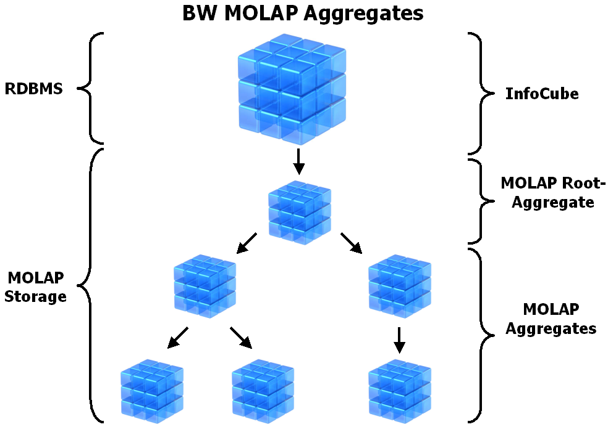
Figure 3: Derivation paths of MOLAP aggregates.

Mapping of a BW InfoCube to MOLAP
The following rules are applied when mapping a BW InfoCube to a corresponding MOLAP cube (i.e. the MOLAP root-aggregate) in MS AS:
- Each BW characteristic is translated into a shared and changing star dimension. Navigational attributes are properties. There is a database view that underlies the star dimension; its name is /BI*/OD<characteristic name>.
- Each (time-independent) navigational attribute becomes a virtual dimension.
- Each (time-independent, non-versioned) BW hierarchy becomes a parent-child dimension. There is a database table that underlies the parent-child dimension; its name is /BI*/OH<BW hierarchy SID number>.
- Each key figure becomes a measure. All measures are found in the MOLAP cube's fact table. The latter is technically a view with name /BI*/OF<InfoCube name> which comprises the actual fact and dimension tables of the BW InfoCube.
This kind of mapping implies the following:
- MS AS is restricted to a maximum of 128 dimensions including the measures dimension. Therefore, BW InfoCubes with NUMBER OF CHARACTERISTICS + NUMBER OF NAVIGATIONAL ATTRIBUTES + NUMBER OF BW HIERARCHIES > 127 cannot be mapped.
- MS AS is restricted to a maximum of 256 dimension levels. Therefore, BW InfoCubes with (NUMBER OF CHARACTERISTICS + NUMBER OF NAVIGATIONAL ATTRIBUTES) * 4 + NUMBER OF BW HIERARCHIES * 2 + NUMBER OF COMPOUND RELATIONSHIPS WITHIN CHARACTERISTICS AND NAVIGATIONAL ATTRIBUTES > 256 cannot be mapped.
- Currently, it is not possible to deal with time-dependent objects in MOLAP. Time-dependency typically requires to dynamically link in certain objects (e.g. BW hierarchies / parent-child dimensions) at query execution time. MS AS is not prepared for that. Therefore, time-dependent objects within BW and InfoCubes that are built on top of them cannot be mapped. Versioned BW hierarchies are a special form of time-dependency and fall under the same restricition.
- BW InfoCubes with non-cumulative key figures cannot be mapped to MOLAP. This has been out of scope for BW 3.0.
- Transactional BW InfoCubes cannot be mapped to MOLAP. The nature of transaction InfoCubes is not suited for MOLAP.
In some circumstances, it is still possible to map an InfoCube, even if some of the restrictions apply. This is the case when time-dependent or versioned hierarchies are involved. In that situation, those hierarchies are not mapped to MOLAP. However, when a query to that cube is processed then BW's own hierarchy processing applies, i.e. hierarchy conditions are resolved withing BW and not within the MOLAP engine.
The MOLAP cube definition screen (see section 4.1) provides you with the possibility to check whether an InfoCube can be mapped to MOLAP. Details are given in the case that the mapping is not possible.

Can MOLAP cubes be directly accessed via ODBO?
What happens if someone tries to bypass BW reporting, i.e. BW-defined MOLAP cubes are accessed directly via MS AS's own ODBO interface? In general, aggregates are objects that should be transparent to the user, similar to DB indexes that constitute redundant objects. A direct access is not supported by BW for various problems than can arise. The ones that we foresee are the following:

- MOLAP cubes do not contain any master data texts, only keys and SIDs. This means that you will see a lot of technical information rather than intuitive or natural language expressions.
- The MOLAP cubes are not set up to handle multiple currencies or units within the same key figure column. If not handled properly, direct accesses will add up dollars, euros, British pounds, ... creating an unusable result. BW handles that problem within its own OLAP engine.
- Specific currencies (like Italian lira, Spanish pesetas) are saved on the database in a particular way: all currency values are saved with two decimals. Currencies that are not used in that way are still saved with two decimals and the adjusted in the BW OLAP engine. Example: a key figure might hold the value (a) ITL 3550.00 on the database (in the fact table) meaning an actual value of (b) ITL 355000. As MS AS is used as a database system its cubes will hold values like in (a) with the adjustment for (b) being made in BW's OLAP engine. If the MOLAP cubes are accessed directly then values as in (a) will show up.
- Authorizations are defined and checked within BW and not within MS AS. A direct access would therefore bypass the BW authorizations.
- The definition of BW-created MOLAP cubes must not be changed as this might cause inconsistencies with BW repository information.

SAP MOLAP Bridge Configuration & Optimization

Setup and installation
The installation procedure is documented in detail in two documents:
- Installation Guide for SAP MOLAP Bridge 3.0A
- Installation Guide for SAP BW 3.0A on MS SQL Server
The installation instructions and described steps are the same in both documents.

Standalone SAP MOLAP Bridge / MS AS installation
In high loaded productive environments it is recommended to install MS AS on a separate, dedicated computer with an appropriate configuration. On this computer can be installed then the SAP MOLAP Bridge including its own gateway component. In addition you have to install an MS SQL Server instance on this machine which contains the MS AS Repository database ( see 3.3.1 ).
One SAP MOLAP Bridge installation is able to interact with more than one BW system and to handle more then one MS AS installation. One MS AS installation can run multiple MOLAP databases belonging to different BW systems interacting with it.

Maintain MS AS Configuration
Migrating MS AS Repository to a MS SQL-Server Database
The MS AS is storing all metadata describing the MS AS objects (cubes, dimensions etc.) in relational database tables. This group of tables is referred to as the MS AS repository. The default database engine for making this information persistant is MS Access. For performance and reliability reasons, it is recommended to migrate the repository to MS SQL Server database:
Create a MS SQL Server repository database
- Run MS Enterprise Manager: Start ➔ Programs ➔ Microsoft SQL Server ➔ Enterprise Manager
- Register the desired SQL Server installation (if it is not already done yet):
  - in the left window open the collection Microsoft SQL Servers
  - mark the collection SQL Server Group
  - click the right mouse button and run New SQL Server Registration; the Register SQL Server Wizard pops up
  - hit the next button
  - select a SQL Server: you see now the list of available servers (left list box), pick up the name of your server from the list or type the name of the server into the textfield on top of the list
  - hit the Add button
  - hit the Next button
  - Select an Authentication Mode
    - Activate the radio button The Windows account information I use to log on to my computer (Windows authentication)
    - hit the Next button
  - Select SQL Server Group
    - Activate the radio button Add the SQL Server(s) to an existing SQL Server group
    - Choose Group Name SQL Server Group
    - hit Next button
  - Completing the Register SQL Server Wizard
    - Validate the entries.
    - Hit the Finish button
- Create the MS SQL Server database for the MS AS repository in the just registered SQL Server
  - Open the collection SQL Server Group
  - The just registered SQL Server will appear
  - Open this collection also
  - Mark the entry databases
  - Hit the right mouse button
  - Run New Database ...
  - The dialog box Database Properties is popping up
  - In this box are three tab strips. We will go through them from the left to the right.
    - General: type in the database name into to textfield Name: (e.g. MSASRep), leave the other entries unchanged and activate the second tabstrip.
    - Data Files: the File Name specified is built using the database name you specified in the tabstrip before. Set the Initial Size (MB) to 10 MByte and change the Location to a path you want to see the database files in or leave it unchanged.
    - Transaction Log: change Location to the same path you specified in Data Files. Set the Initial Size (MB) to 5 MByte.
  - After you finished making the neccessary entries into the three tabstrips hit the OK button at the bottom. The database will be created now. It should appear in the collection databases of this MS SQL Server.
  - Mark this database entry and click the right mouse button. Run Properties.
  - Go to the tabstrip Options.
  - In the area Recovery set the Value for Model to Simple.
  - In the area Settings activate the checkbox Use quoted indentifiers.
  - Hit the Okay button at the bottom for making your changes persistent.
Migrate the MS AS repository the new created SQL Server Database
- Run the MS Analysis Manager: Start ➔ Programs ➔ Micrsoft SQL Server ➔ Analysis Services ➔ Analysis Manager
- Open the Collection Analysis Servers
- Open the Collection named like your MS AS machine. This connects the Analysis Manager to your instance of MS AS.
- Mark the collection named like your MS AS machine.
- Click the right mouse button.
- Run Migrate Repository ...
- The Migrate Repository Wizard pops up:
  - activate the Analysis Services native format ( recommended ) radio button
  - hit the Next button
  - answer the question Which SQL Server computer do you want to use for the repository? by typing in the name of the SQL Server instance where your repository database is located in (see above)
  - hit the Next button
  - The answer for the question How do you want to collect to SQLServer computer? is the activation of the radio button Windows authentication using the network logon id.
  - Hit the Next button.
  - At the next step Which SQL Server database do you want to use for the repository? pick up the right database from the list of available databases
  - Hit the Finish button.
After the task finished, you will see a message box telling you that the migration has been completed successfully.
Configuration Options of MS AS Instance
To configure a MS AS instance you can use the Analysis Manager: Open the Analysis Servers collection, mark the entry of the corresponding server and click the right mouse button. Run Properties. You'll see now a dialog box with six tabstrips:
- TabStrip General: leave all checkboxes marked.
  - The textfield Data folder: specifies where the data (files) of the MS AS databases is stored. In a highloaded environment it is recommended to separate it to an own I/O area to avoid any kind of I/O contention especially during processing (data load into MS AS). Caution: The location should not be changed if data was already loaded into MS AS. The relocation could cause problems.
  - The textfield Temporary file folder: specifies the path of the location of temporary files created during various MS AS activities (processing, query execution ...). In a highloaded environment it is recommended to separate it to an own I/O area to avoid any kind of I/O contention especially during processing (data load into MS AS) and aggregation.
- TabStrip Environment
  - Area Performance settings
    - Maximum Number of threads: default value is two times number of CPU's. Recomended for productive environments: 16 times number of CPU's but not less then 48.
    - Large level defined as: Should not be changed.
  - Area Memory settings
    - Large level defined as: Should not be changed.
    - Minimum allocated memory: This is the amount of memory allocated exclusively for MS AS. As MS AS keeps a lot of data in a special cache, it is recommended to define an appropriate size for this memory. The suggested value is 25% of physical memory but not less then 256 MByte for production environments.
    - Memory conservation threshold: leave this value unchanged.
- TabStrip Processing
  - Area Processing settings
    - Read-ahead buffer size: Size of the buffer used for keeping data resulting form the database query to be loaded into the MS AS cube. Increasing this buffer size speeds up the dataload. Suggested value: 5% of the physical memory size, minimum 30 MBytes.
    - Process buffer size: defines how much data is processed in memory before an I/O is performed. Suggested value: 10% of the physical memory size, minimum 60 MBytes.
    - Server timeout: Do not change this setting.
The other tabstrips do not contain settings to be changed during the configuration procedure. Caution: All changes described above will be active only after you restarted the MS AS service.
Backup of MS AS databases
The MS Analysis server lacks like similar systems from other vendors in a transactional component. That means there is no pool containing logging information regarding the changes applied to the data in the database. That’s why only offline backups are possible. All MS AS databases can be found in the Data Folder (see above). Backups can be taken in two different was:
- using OS functionality,
- using the Archive database ... functionality provided by MS Analysis Manager
Backups should be taken on a regularly basis or after major changes in the database (initial dataload, creation of new database objects ...). The MS AS repository has to be backed up as well. If you already migrated it to a SQL Server database you should use the SQL Server functionality for backing up this database with the same frequency like the MS AS databases. If the repository resides still in the MS Access structure (the default) you have to back up the following files in the same frequency as you do it for the MS AS databases:
- msmdrep.mdb
- msmdqlog.ldb
- msmdqlog.mdb
You'll find these files in the <Drive>\Program Files\Microsoft Analysis Services\Bin. Procedure:
1. Stop the Analysis Services NT service
2. Backup the files using OS functionality to the desired destination
3. Restart the Analysis Services NT service
Using OS functionality
1. Stop the Analysis Services NT service.
2. If you want to backup only one MOLAP database, copy the directory, specified in the parameter Data Folder (see above) with the specific subdirectory named like the MS AS database and all its contents to the desired destination.
3. Restart the Analysis Services NT service.
Using the Archive database ... functionality
- Run the MS Analysis Manager: Start ➔ Programs ➔ Micrsoft SQL Server ➔ Analysis Services ➔ Analysis Manager
- Open the Collection Analysis Servers
- Open the Collection named like your MS AS machine. This connects the Analysis Manager to your instance of MS AS.
- Mark the collection named <SID>MDDB1 (which represents the BW-related MS AS database).
- Click the right mouse button.
- Run Archive Database ... You'll get the Archive Database dialog box. During archiving the desired destination data and meta data information will be copied to.
  - Save In: here you can specify a destination to backup the data to. The archive tool will create one file containing all data belonging to this particular database. The file will have the suffix .CAB.
  - Temp Folder: please specify the path where temporary files, created during bakup can be stored.
- To start archiving push the Archive button. A status window will popup and report the current archive status.

Maintain SAP MOLAP Bridge
Configuration parameters
Currently there is only one configuration parameter available. It makes it possible to increase the number of threads for query and load activities in a heavy loaded environment. The default value is 10 per activity. The name of the parameter is MBR_THREAD_NUM. Set it in the environment of the user running the RfcOlapComBridge Service. Restart the service to make the change available.
Traces and Logs
The SAP MOLAP Bridge writes trace information and logs incorrect MDX statements. The central log is located in %windir%\system32 and named RfcOlapBr.trc . It contains for instance information about the current software version and the number of threads created.
If a syntax error in a generated MDX statement occurs (report execution in BW states a system error occured during execution) the statement text is stored in a file named RfcOlapBadMdx.txt. It is located at %windir%\system32. Please attach this information to the OSS message you will open and assign it to the queue BW-SYS-DB-MSS-MSAS.

Handling of MOLAP Aggregates in BW 3.0

How to set up an InfoCube for MOLAP
Obviously, your BW system must have access to an MS AS server as described in section 2.1. Let us assume that you have an InfoCube that has already been activated so that the underlying database table (fact tables, dimension tables) exist.

- Go to the pulldown menu "Extras" and there to the item "MOLAP Storage". | 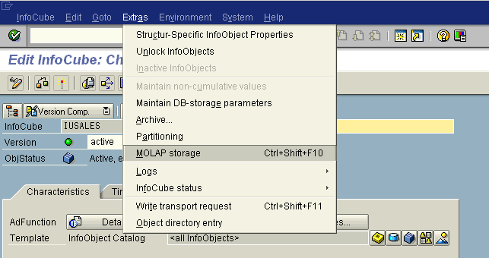
- First, you should check whether the mapping (see section 2.3) is possible. Press the "Check" button for that purpose.  Traffic lights provide you with rough and a message box in the lower part with detailed information.  - If the mapping is possible, then you can create a corresponding MOLAP cube (i.e. the MOLAP root-aggregate) in MS AS. This action corresponds more or less to activating an InfoCube in the BW, i.e. this process creates data objects such as database views, MOLAP dimensions, MOLAP cube partitions and finally a MOLAP cube inside the MS AS server. In addition, this step will create a dummy aggregate definition within the BW repository. This dummy aggregate can be seen when looking at the aggregate definition screen. See below for background information on that dummy aggregate.  - In the third step, the MOLAP cube can be processed. This corresponds to an initial roll-up of the MOLAP root-aggregate, i.e. the MOLAP cube is filled with data. To that end, the underlying dimensions have to be processed. This is done incrementally if the dimension has been processed before; otherwise it is fully processed. There are two processing modes: full or refresh. If the MOLAP cube has not been processed before then it is necessary to employ the full mode. If you want to reload the MOLAP aggregates with data then use the refresh mode which is faster than the full mode.  Another option is to run the MOLAP cube processing in a dialog or in a batch process. If the BW InfoCube already contains a huge amount of data then batch processing is required. If the InfoCube holds only a small amount of data or no data at all then dialog processing is the preferred option as you can immediately see the actions that have been executed. | 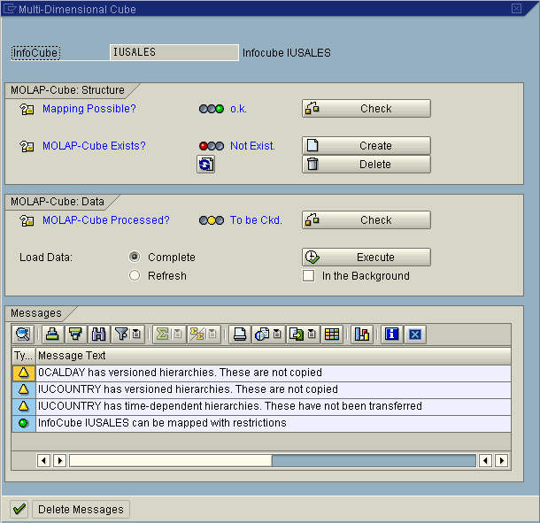  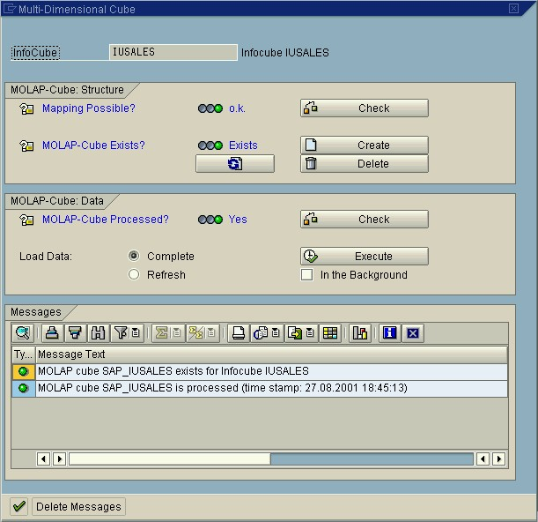
If you have successfully walked through these steps then you should have created the MOLAP root-aggregate as outlined in Figure 3.
Background: Dummy aggregate
The dummy aggregate (or better: its definition in the BW repository) represents the MOLAP root-aggregate in front of other BW modules such as BW's scheduler and monitor. It indicates that the corresponding InfoCube is liable to aggregate roll-ups and master data change runs. The dummy aggregate only contains one single characteristic, typically 0CALYEAR or 0FISCYEAR or another low cardinality characteristic. Consequently, it will (a) only occupy a tiny space on the harddisk and (b) hardly be used when it is activated. In summary, it is simply a dummy. The dummy aggregate is removed when the MOLAP root aggregate is removed.

How to create MOLAP aggregates for an InfoCube
In order to create MOLAP (rather than ROLAP) aggregates for an InfoCube the latter must have been set up for MOLAP as described in section 4.1. That means that the MOLAP root-aggregate for that InfoCube already exists.

- Now, aggregates can be created in the exactly same way as before: go to the BW admin workbench ➔ click on the InfoCube with the right mouse button ➔ "Maintain aggregates ...". | 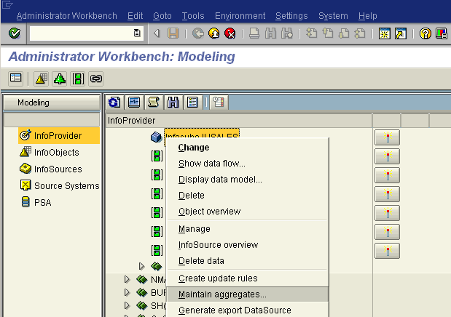
- This will lead you to the aggregate definition screen. There are some minor differences in comparison to the standard (i.e. ROLAP) case:  - In the title bar of the window you will find the word MOLAP.  - Aggregate definitions cannot contain restrictions on characteristics, i.e. defining aggregates means to define a subset of characteristics of the InfoCube.  - Statistics about usage, size, compression etc. are not available for MOLAP aggregates. This might change in BW 3.0B. As a consequence, BW cannot propose suitable aggregates based on statistics.  Defining, saving and activating aggregates from this screen works as usual. The basic difference is that these aggregates are created within MS AS. The aggregate definition, however, is still stored within BW. So if you wish to switch from MOLAP to ROLAP aggregates at a later stage the aggregate definitions are not lost and the aggregates can be easily recreated in ROLAP. The same applies to the opposite direction, i.e. an existing InfoCube and its underlying ROLAP aggregates can be switched to MOLAP. This feature will allow you to test and find the most appropriate storage for your particular data model. | 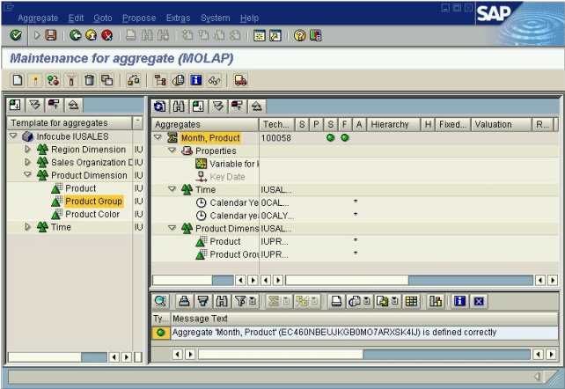

Running queries under MOLAP
The user who runs a query from BW BEX should not notice whether the query is actually executed on the relational database or via MS AS. The notion is that aggregates are transparent.

- However, via the transaction RSRT (which is typically used for debugging or tuning purposes) it is possible to see details about the query execution by running the query via "Execute + Debug" (Ctrl + F8). | 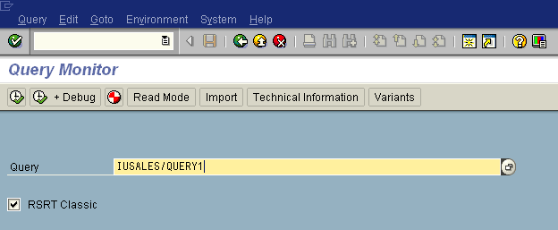  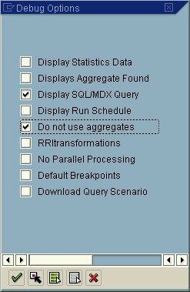

If a BW system is MOLAP-enabled then you will see that not only SQL-statements can be seen from here but also MDX statements. Furthermore, by activating the "no aggregates" option one can execute the query against the actual BW InfoCube, i.e. as SQL statements against fact, dimension and master data tables. This will allow you to compare a query result retrieved from MOLAP with a query result retrieved from the actual InfoCube on the relational database.

Rolling Up MOLAP Aggregates
Rolling up MOLAP aggregates works just like the roll-up of ROLAP aggregates, i.e. via the BW Administrator Workbench.
The only fact that you should keep in mind is that the MOLAP root-aggregate (MOLAP cube) actually is an aggregate, i.e. it has to be rolled up. In other words: when a new data package has been loaded into an InfoCube it has to be rolled up into the MOLAP aggregates if the InfoCube has been set up for MOLAP. The set of MOLAP aggregates comprises at least the MOLAP root-aggregate.

Compressing InfoCubes with MOLAP Aggregates
InfoCubes with MOLAP aggregates can still be compressed. In the context of MOLAP compression means that
- the InfoCube is compressed with data being moved from its F fact table into its E fact table,
- the MOLAP cube partitions (which each holds a data request) are merged into the basic partition which holds data request 0.

Appendix
Useful Reports
RSDP_INFOCUBE_MOLAP_INFO
This report derives a list of database and MOLAP objects that have to exist in order to support an InfoCube being set up for MOLAP. The list and the current status of those objects are given.
RSDP_PROCESS_ALL
This ABAP report processes either an individual MOLAP-enabled InfoCube or all MOLAP-enabled InfoCubes in your system. The processing mode is full for MOLAP cubes and incremental for the underlying MOLAP dimensions.
RSDP_MOLAP_DATABASE_REBUILD
This ABAP report will rebuild the MOLAP database for your system. It executes the following steps:
1. The MOLAP cube / root-aggregate is dropped for all BW InfoCubes that have been set up for MOLAP.
2. All corresponding MOLAP dimensions are dropped.
3. The MOLAP cube / root-aggregate (and the underlying dimensions, if necessary) is recreated for all BW InfoCubes that have been set up for MOLAP.
4. The newly created MOLAP dimensions and cubes are processed (this step is optional).
RSDP_SYNCHRONIZE_MOLAP
This ABAP report scans over the list of existing MOLAP objects (i.e. cubes and dimensions) and checks whether they are in sync with their BW counterparts (see mapping of BW objects to MOLAP in section 2.3). The following situations indicate that a MOLAP object M is not synchronised with the corresponding BW object B:
- M does not exist,
- "last change" timestamp of B > "last change" timestamp of M,
- M has been created with mapping rules that have been revised in the meantime.
In case that a MOLAP dimension M is considered as out-of-date the report will consider all MOLAP cubes that contain M to be out-of-date too.
The report provides the facility to only list those objects M that are outdated. Otherwise it will drop all outdated MOLAP objects, recreate and process them.

Atomic Consistent Isolated Durable
From a BW perspective it is treated as an aggregate; from MS AS's point of view it is a cube. Therefore both terms can be used, depending on which side is emphasized.
In some situations, like with versioned external hierarchies, this is not the case. The MOLAP root-aggregate then lacks the information on the versions of external hierarchies.
/BI* is a shortcut for /BI0 or /BIC.
MDX = (M)ulti-(D)imensional E(X)pressions.
This partition has the same name as the MOLAP cube / MOLAP root-aggregate.
Here, the term "database" refers to the notion as used in MS AS or MS SQL-Server.

