How to…

Drilldown to OLTP using

User Exit mapping
Business Information Warehouse
ASAP “How to…” Paper
Applicable Releases: BW 2.0B, 2.1C
May 2001

Business Scenario
You want to drill down with the report-report interface (RRI) from your query to the OLTP system to retrieve detailed information about a certain object or to display a line item report for a certain object, e.g. show the master data for a cost center, display the general ledger line items for a certain account, etc. In most of the cases, the BW system can derive the necessary mapping of fields for the jump target from the InfoSource underlying the corresponding InfoCube or ODS Object. In some special cases, when the BW system itself cannot derive all the necessary information to call the transactions or report in the OLTP system, the user has to provide some information by implementing a user exit, which populates the necessary fields. An example could be the controlling area, which is not populated when a cost center is selected (compound information). Another example is the mapping of a cost element to a general ledger account. This mapping can also not be derived by the system.

The Result
The user can jump from a query to a transaction, report etc. in the R/3 system. The mapping of the fields that cannot be derived by the system is performed by a user exit, which populates the necessary fields to call the transaction in the OLTP system.

Introduction
When you define a jump target for your query, the system has to pass the parameters from the calling query to the jump target, i.e. another query, ABAP report, transaction etc. In our scenario the cost center value that has been selected in the initial query has to be mapped to the cost center field in the R/3 system. The system provides various alternatives to derive the correct mapping:
- The DataSource that is used to populate the InfoCube from the corresponding source system determines the field mapping for the selected fields. The name of the respective InfoSource can be entered in the maintenance of the jump targets for a query.
- There are two user exits available within the SAP enhancement RSR00004, which are processed during the mapping:
- EXIT_SAPLRSBBS_001 (BW: RRI Field Mapping)
Processed during the mapping of the source system dependent DataSource fields. This User Exit is processed for all jump targets regardless of whether they are within the BW system or in a R/3 system.

- EXIT_SAPLRSBBS_002 (BW: RRI Customer Exit Called before Jump into R/3)
Processed before the jump into the R/3 system.

NOTE: For the description on how to activate the SAP enhancement look into the CMOD/SMOD documentation or follow the detailed description in one of the following chapters.

The Step By Step Solution

Define a query and jump target

- Define a query, which contains a drill-down of the cost centers by cost elements. | 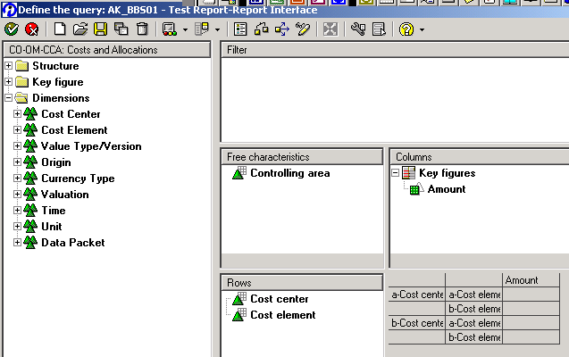
- Goto the maintenance of the Query Jump Targets (SAP Easy Access Menu → Business Explorer → Query Jump Targets [Transaction RSBBS]). | 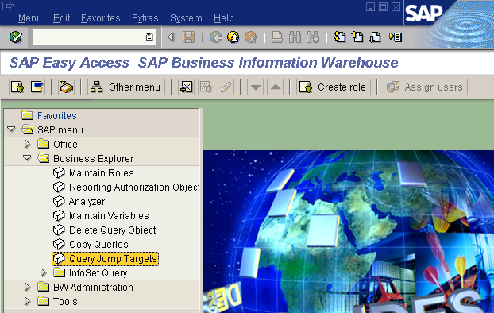
- Create the jump targets for your query.  For our scenario we create jump targets to transcations:  - KS03 – display cost center master data  - FBL3N – G/L account list for the cost element  NOTE If you do not enter a source system or an InfoSource, the system will assist you during the execution of the jump with a wizard. | 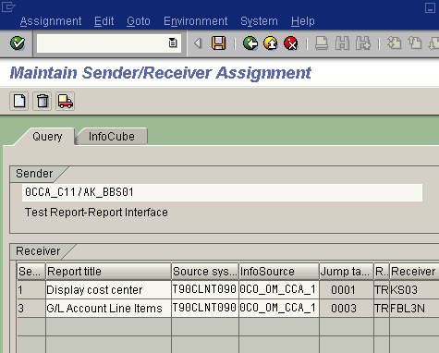

Implementation of the user exit

- Create a project with the SAP enhancement RSR00004, and the component EXIT_SAPLRSBBS_002. | 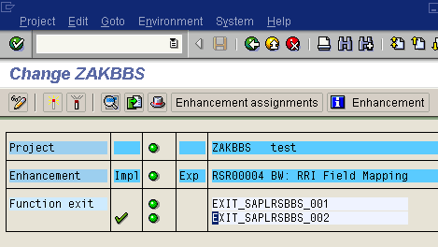
- By double-clicking on the component, you enter the implementation of the user exit. Double-click also on the include module ZXRSRU06. This creates the include module (if it has not been created beforehand).  The following fields are available:  - I_INFOCUBE - Name of the InfoCube  - I_COMPID – Name of the initiating query  - I_S_RECEIVER – Information about the jump target  - I_THX_MAPPING – Mapping derived from the system  - E_THX_MAPPING – Changed or additional mapping derived in the user exit (return table) | 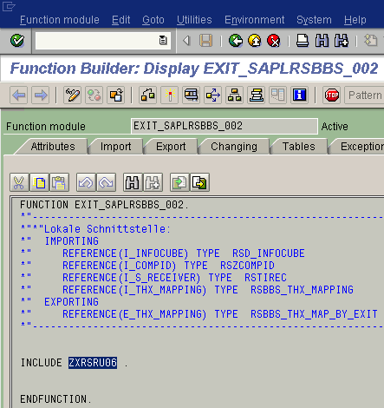
- Enter the source code (see Appendix for source code example).  - The first part maps the cost element to the GL account and adds the company code information to the mapping table (call of G/L account list)  - The second part just adds the compounded controlling area to the mapping table (call of cost center master data display) | 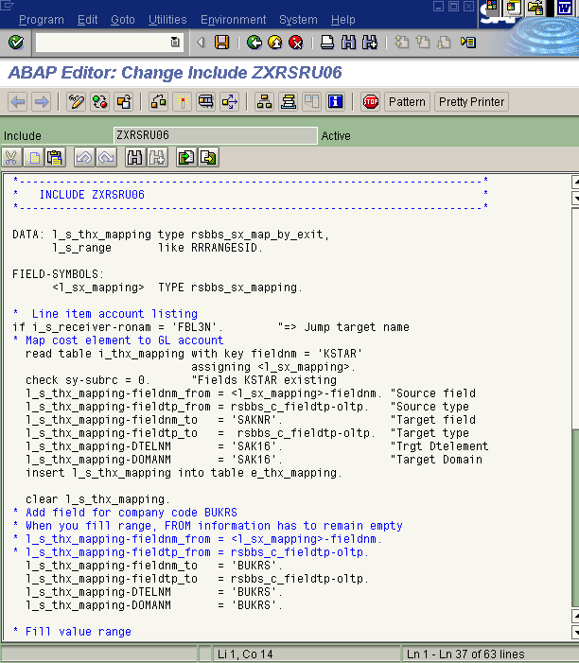
- After activating your coding return to your project and activate it by pressing  Afterwards, the project shows the status “Activated”. | 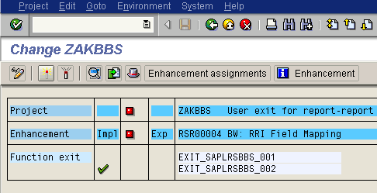  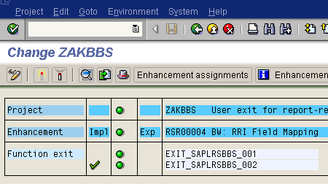

Execute the jump target

- Run the query, and position the cursor either on a cost center or on a cost element. | 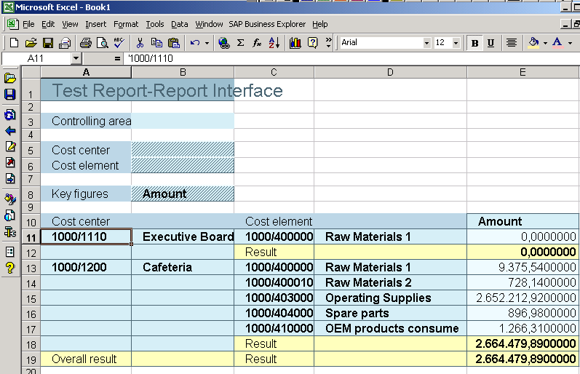
- Select a jump target for the respective object, e.g. display a cost center when a cost center is marked or display a GL account line item when a cost element is marked. | 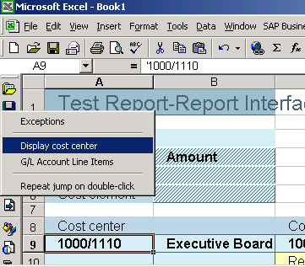
- The respective transaction is called in the R/3 system. | 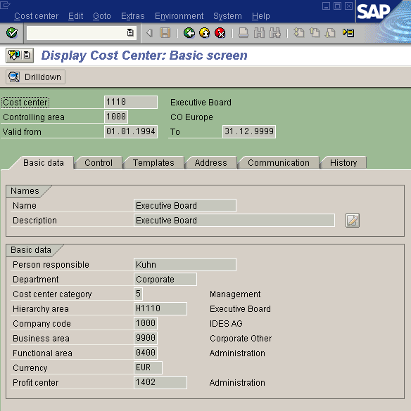

Appendix
Sample source code for the user exit (a template can also be used for the SAP standard exit, function module RREX_BBS_OLTP_EXIT, which has the same interface):

*----------------------------------------------------------------------*
* INCLUDE ZXRSRU06 *
*----------------------------------------------------------------------*

DATA: l_s_thx_mapping type rsbbs_sx_map_by_exit,
l_s_range like RRRANGESID.

FIELD-SYMBOLS:
<l_sx_mapping> TYPE rsbbs_sx_mapping.

* Line item account listing
if i_s_receiver-ronam = 'FBL3N'. "=> Jump target name
* Map cost element to GL account
read table i_thx_mapping with key fieldnm = 'KSTAR'
assigning <l_sx_mapping>.
check sy-subrc = 0. "Fields KSTAR existing
l_s_thx_mapping-fieldnm_from = <l_sx_mapping>-fieldnm. "Source field
l_s_thx_mapping-fieldtp_from = rsbbs_c_fieldtp-oltp. "Source type
l_s_thx_mapping-fieldnm_to = 'SAKNR'. "Target field
l_s_thx_mapping-fieldtp_to = rsbbs_c_fieldtp-oltp. "Target type
l_s_thx_mapping-DTELNM = 'SAK16'. "Trgt Dtelement
l_s_thx_mapping-DOMANM = 'SAK16'. "Target Domain
insert l_s_thx_mapping into table e_thx_mapping.

clear l_s_thx_mapping.
* Add field for company code BUKRS
* When you fill range, FROM information has to remain empty
* l_s_thx_mapping-fieldnm_from = <l_sx_mapping>-fieldnm.
* l_s_thx_mapping-fieldtp_from = rsbbs_c_fieldtp-oltp.
l_s_thx_mapping-fieldnm_to = 'BUKRS'.
l_s_thx_mapping-fieldtp_to = rsbbs_c_fieldtp-oltp.
l_s_thx_mapping-DTELNM = 'BUKRS'.
l_s_thx_mapping-DOMANM = 'BUKRS'.

* Fill value range
l_s_range-sign = 'I'.
l_s_range-opt = 'EQ'.
l_s_range-low = '1000'.
append l_s_range to l_s_thx_mapping-range.

insert l_s_thx_mapping into table e_thx_mapping.

endif.

* For cost center display add only compounded controlling area
if i_s_receiver-ronam = 'KS03'. "=> Jump target name
* Add field for controlling area KOKRS
* When you fill range, FROM information has to remain empty
* l_s_thx_mapping-fieldnm_from = 'KOKRS'.
* l_s_thx_mapping-fieldtp_from = rsbbs_c_fieldtp-oltp.
l_s_thx_mapping-fieldnm_to = 'KOKRS'.
l_s_thx_mapping-fieldtp_to = rsbbs_c_fieldtp-oltp.
l_s_thx_mapping-DTELNM = 'KOKRS'.
l_s_thx_mapping-DOMANM = 'KOKRS'.

* Fill value range
l_s_range-sign = 'I'.
l_s_range-opt = 'EQ'.
l_s_range-low = '1000'.
append l_s_range to l_s_thx_mapping-range.

insert l_s_thx_mapping into table e_thx_mapping.
endif.

Frequently Asked Questions (FAQs)

Warning displayed by the system
The warning messages can be ignored. They inform for example about missing field mappings. The warnings do generally not impose any restriction in processing on the system, yet the user should be aware of any possible problems. When the warning messages indicate an erroneous behavior of the system, try to resolve the problem before proceeding.

Selection of multiple values in a query
In order to pass multiple values to the jump target the user has to select the respective values and keep them as filters beforehand. When the values are kept in the filter, the user can call the respective jump target and the held values are passed on.

Handling of compounded characteristics
The handling of compounded characteristics, e.g. the controlling area and the cost center, has to be performed by the user. The respective characteristic, e.g. the controlling area, has to be included in the mapping table. In this case, it is important to fill also the value range and to leave the FROM-field information unpopulated.

Transaction call in R/3 not successful
The passing of the field values is performed via SPA/GPA parameters. Some transactions do not populate their entry fields in this way. A possible workaround is sometimes the creation of an ABAP report, which populates the entry fields and calls the transaction. This ABAP report has to be defined as the jump target in the BW system (see also note #363203).

How to chek the field mapping in the R/3 system
Use the option “Run and Debug” in the query monitor (RSRT). Select the check button “RRI transformation”. On the execution of the jump into the R/3 system the program is interrupted at various stages, i.e. during the mapping of the fields in the BW system as well as in the R/3 system. When the system stops in the R/3 system, you can verify whether the mapping of the fields (and the value transfer) has been performed properly. You can check the internal tables I_T_FIELDS and I_T_SEL.

