How To...

work around the ‘Single Key Date’ limitation for time dependent master data
Business Information Warehouse
ASAP “How to…” Paper
Applicable Releases: BW 2.0B, 2.1C
July 2001

Introduction
The BW architecture allows for time dependent master data attributes, which are linked dynamically to the relevant fact table characteristics (typically transaction data) at query execution time. This approach of modeling the master data attributes externally to the InfoCubes offers great flexibility. Data changes can be immediately reflected (after master data load and master data activation / realignment), without even touching the InfoCubes. Moreover, historical views on the data remain available on demand.
Just to give a few typical examples of time dependent master data attributes:
- The responsible person (owner) for a cost center.
- The annual salary of an employee.
- The retail price of an article for sale.

The specific point of time, for which the master data attributes should be selected, is identified via the parameter ‘key date’ in the query properties screen:
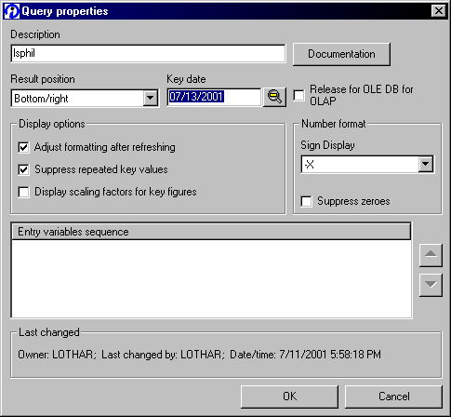

(Alternatively, the key date could also be selected via a variable popup by the end-user).

While the approach outlined above covers most requirements, it does not account for ‘dynamic key dates’, that means situations where you want to link the master data attribute time selection to some drilldown criteria in your query (e.g. to the calendar day 0CALDAY). Including the attribute values directly in the infocubes would help to mitigate this limitation, however with the drawback of limited flexibility on future changes (realignments). In the following, this paper will explain a practical work-around, at the example of a typical business requirement in the retail industry. Also, some limitations of the work-around will be highlighted.

Business Scenario
In retail business, for a specific article in a BW query the respective retail price should be displayed. The retail price of an article is generally determined by conditioning technique on the R/3 side. From the BW perspective, the retail price has many properties of an (time-dependent) attribute:
- The retail price is specific for the article (or e.g. article / site combinations).
- The retail price for an article can change over time.
- The retail price should be tracked over time.
- The retail price might need to be restated for any point back in time.
However, as compared to master data attributes, there is one major difference in how the retail price should be treated in reporting: It should be linked dynamically to the calendar day, i.e. for any given point in time within the query, the valid retail price current at that specific point in time should be displayed.

Solution Approach
In the following, a practical (and tested) solution approach is introduced. It takes advantage of virtual key figures, which are populated at query execution time by the respective master data attributes, based on the drilldown state of the query.
Note however, that there are some limitations to this approach, primarily in terms of performance:
- Master data a read via custom ABAPs at query execution time. This can have some performance impact, especially in cases of large master data tables, and inefficient custom ABAP developments.
- More important, once the virtual key figure is included in the query, the OLAP processor will be required to read on the detail level, which is needed to determine the respective value. For example, should the value be determined based on the material number and the calendar day, the OLAP processor will make sure to read data on (at least) that detail level from the database – even if the user did decide not to drilldown to that level, and even if aggregates do exist on the level which the user wants to report against. (The reason for this is quite simple: Since virtual key figures are calculated dynamically at run-time, they cannot be included in aggregates).

Step By Step Solution

Include the Virtual Characteristic in the data model
The virtual key figure needs to be included in the data model, so that it can be populated by the exit, and so it can be used in the query. Include it in all infocubes, where required. Also you can append this field to existing (already populated) infocubes. It is also possible to include the field in a multicube, however first it needs to be available in at least one of the underlying basic cubes.
In addition to the virtual key figure for the retail price ‘ZVRRETAIL’ another virtual key figure is required (‘ZRPCOUNT’) here. This is to avoid the retail price to multiply by the number of times, a specific record is found for the requested characteristic value combination (remember, retail price should behave similar to an attribute here).

- Create the InfoObject (of type ‘key figure’) that you want to use as ‘retail price attribute’. Make sure to select the correct data type and unit of currency (chose a unit of currency that you can reference to in the InfoCube).  In our example, we create the infoobject ZVRETAIL with the following properties:  Data type = CURR  Unit = 0LOC_CURRCY | 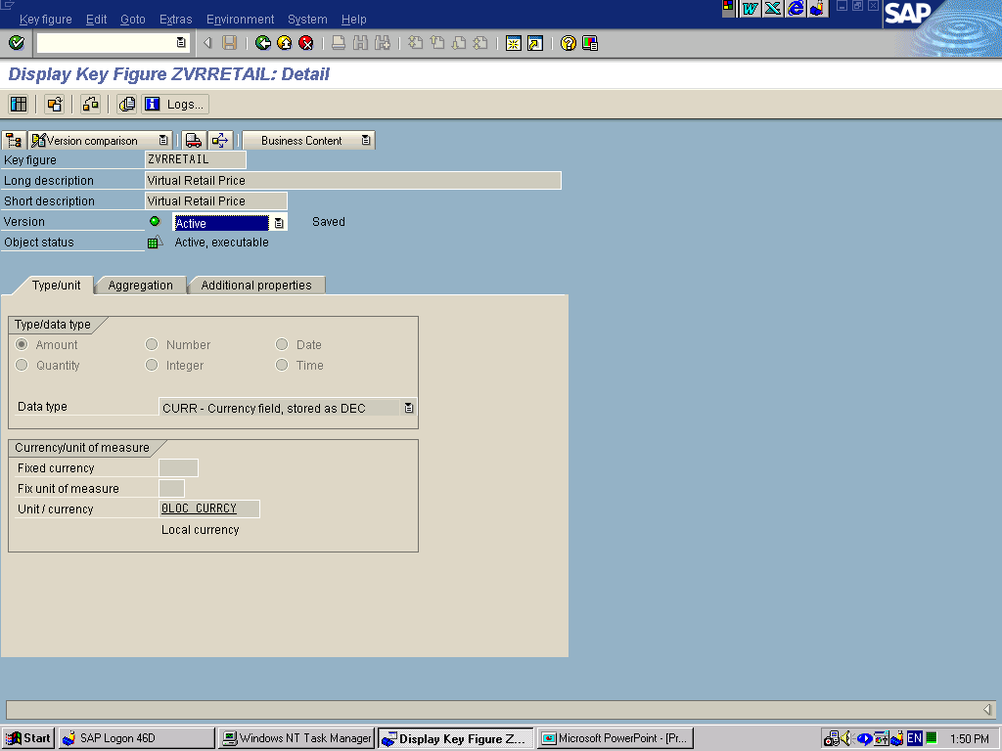
- Create the InfoObject (of type ‘key figure’ as well) that you want to use as ‘counter’. Make sure to select the correct data type.  In our example, we create the infoobject ZRPCOUNT with the following properties:  Data Type = Number / DEC | 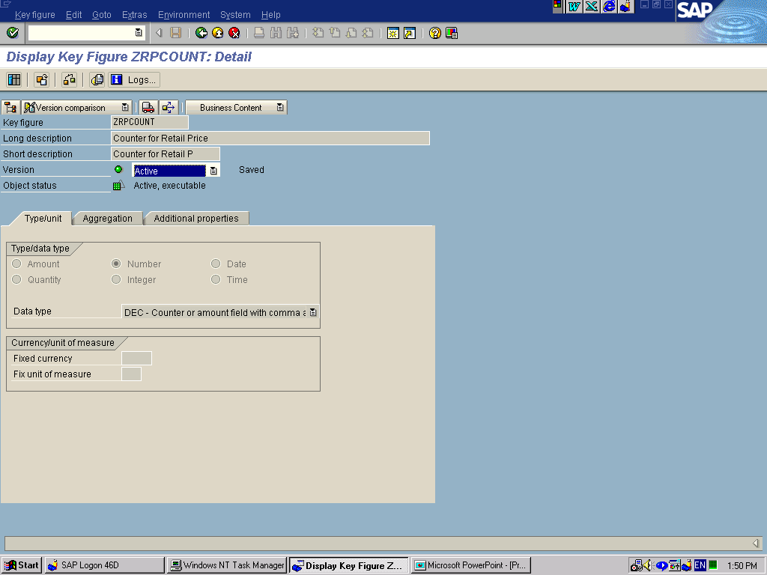
- Include the infoobjects ZVRETAIL and ZRPCOUNT in your InfoCube. Since you do not populate these fields with any data (remember, the InfoObjects are virtual key figures!), it is not required to delete (and reload) the infocube contents. Besides this, however, you treat the virtual key figures technically just like any other key figure.  In our example, we are using the infocube ZRT_C99. | 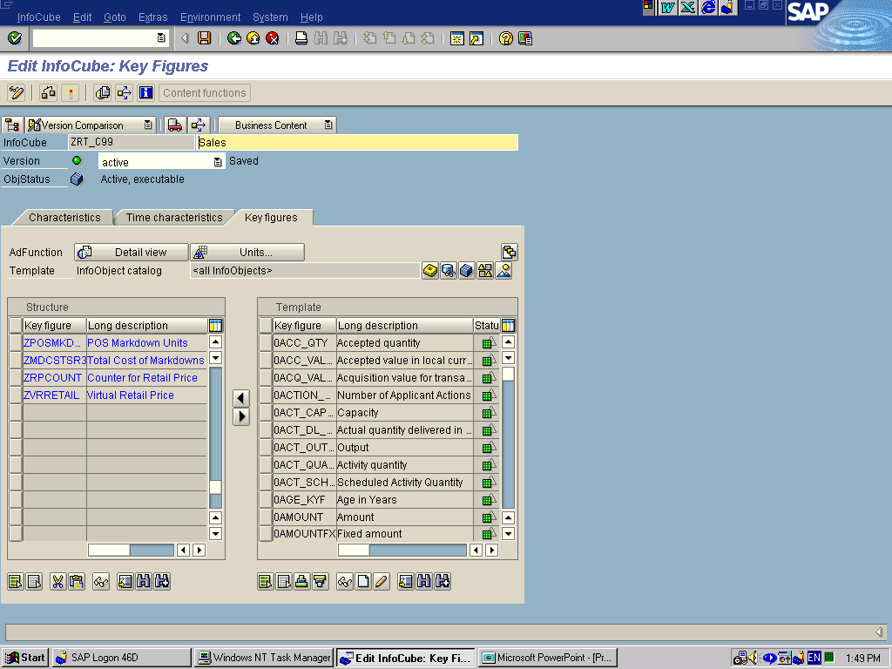
- Make sure to re-activate the respective update rule(s). You do not need to assign any mapping InfoObjects to the virtual key figures. | 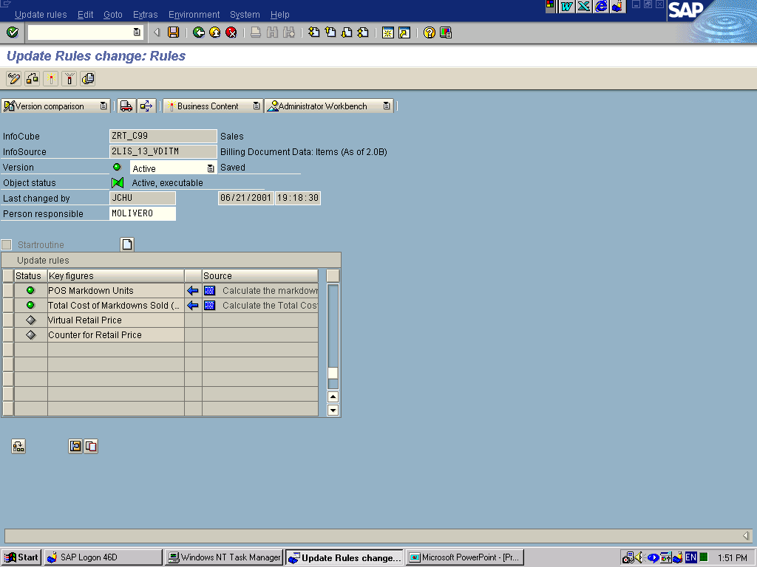

Maintain the Lookup Table for Master Data
In the next step, you need to maintain the lookup table, which should be read by the virtual key figure exit. You can either use a regular table of time dependent master data attributes (i.e. the /BI0/Q… or /BIC/Q… table), or you can alternatively use a regular transparent table created for just this purpose in the data dictionary. In any case, you will need to make sure, of course, to populate the table. For populating the table you have the typical tools available (data sources, custom ABAPs); the usage of those tools should be straightforward and will not be covered in this ‘How To’ paper.
- In our example, we create a lookup table as a transparent table in the data dictionary. You can see, that it’s modeled just like a time dependent master data attribute table – we also could have used such a table directly.  Also, you can see that the retail price is depending on the following characteristic values:  - Sales Organization  - Distribution Channel  - Article  - Color  - Date  (And, we also included an object version key). | 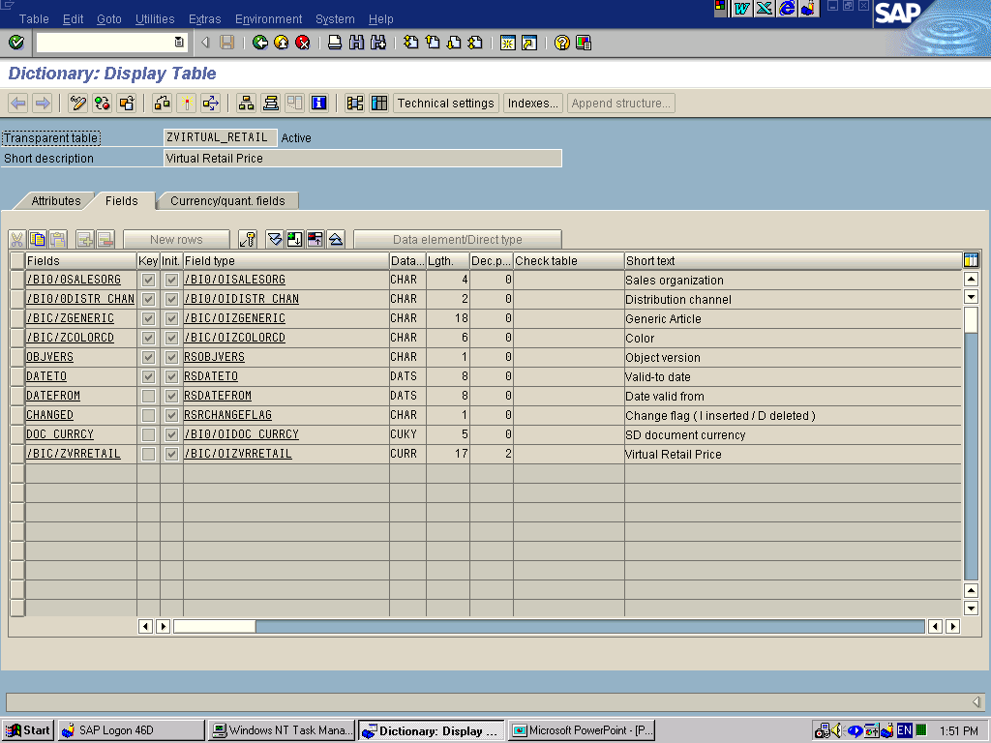

Maintain the update logic for the Virtual Characteristic
In the enhancement project for the virtual characteristic, the logic for the population of the InfoObject values is developed.

- Via transaction CMOD, create a customer enhancement project. In our example, we called the customer project LSVIRT. When choosing the name (and short description) for the project, remember that you can define only one project for all virtual infoobjects system-wide (in case you want to define more than one exit). Assign a (transportable) development class, and save the project. | 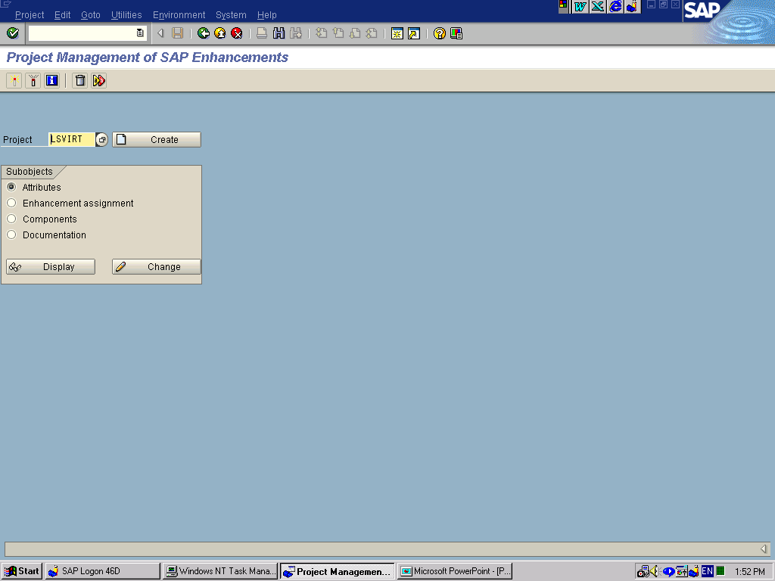
- Assign the SAP enhancement RSR00002 (virtual characteristics and key figures) to your project. | 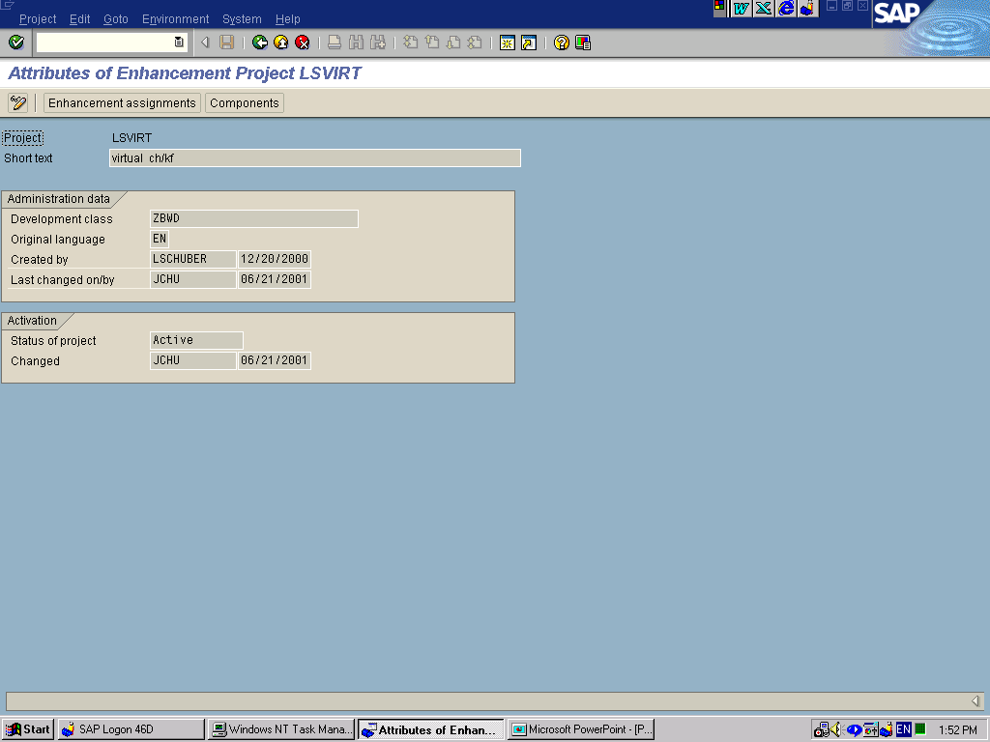
- Via Menu >> Components, you can display the relevant components for this project. If you are not familiar yet with virtual InfoObjects, it is absolutely essential to study first the relevant information, specifically the online documentation, which can be accessed via transaction SMOD (enter project RSR00002). Although the following steps contain the complete sample coding for our example, this “How To” paper is no replacement for the online documentation. | 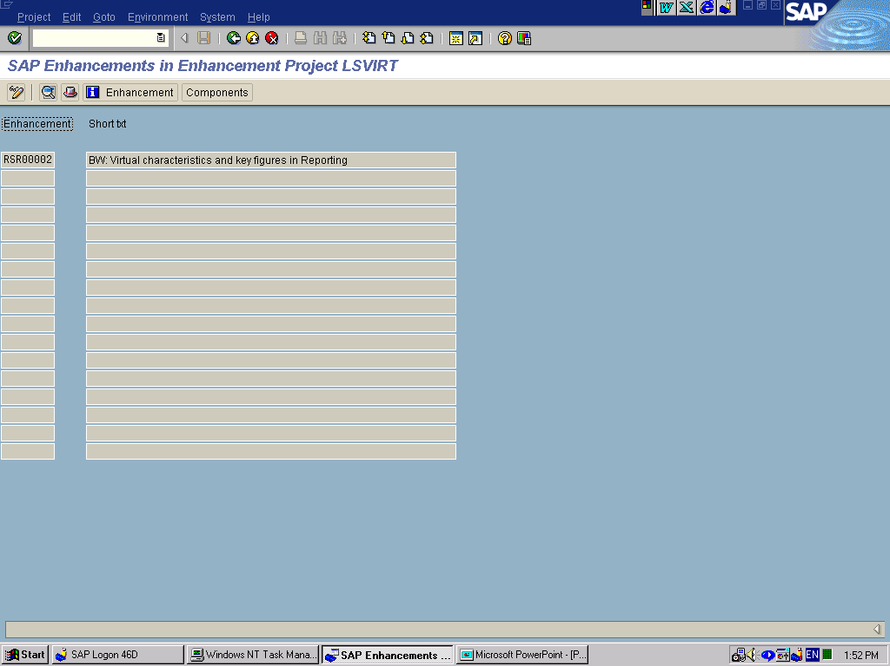
- Doubleclick on the term EXIT_SAPMRSRU_001 in order to arrive at the ABAP coding (enter change request information where required). From here you can branch via ‘Goto >> Main Program’ to the main program SAPLXRSR.  Alternatively, you could call up the program SAPLXRSR as well directly via the ABAP/4 Editor, in transaction SE38.  There will be exactly 3 areas, where you need to do coding within this enhancement project:  1. INCLUDE LXRSRTOP  >> INCLUDE ZXRSRTOP  2. INCLUDE LXRSRUXX  >> INCLUDE LXRSRU02  >> INCLUDE ZXRSRU02  3. INCLUDE ZXRSRZZZ | 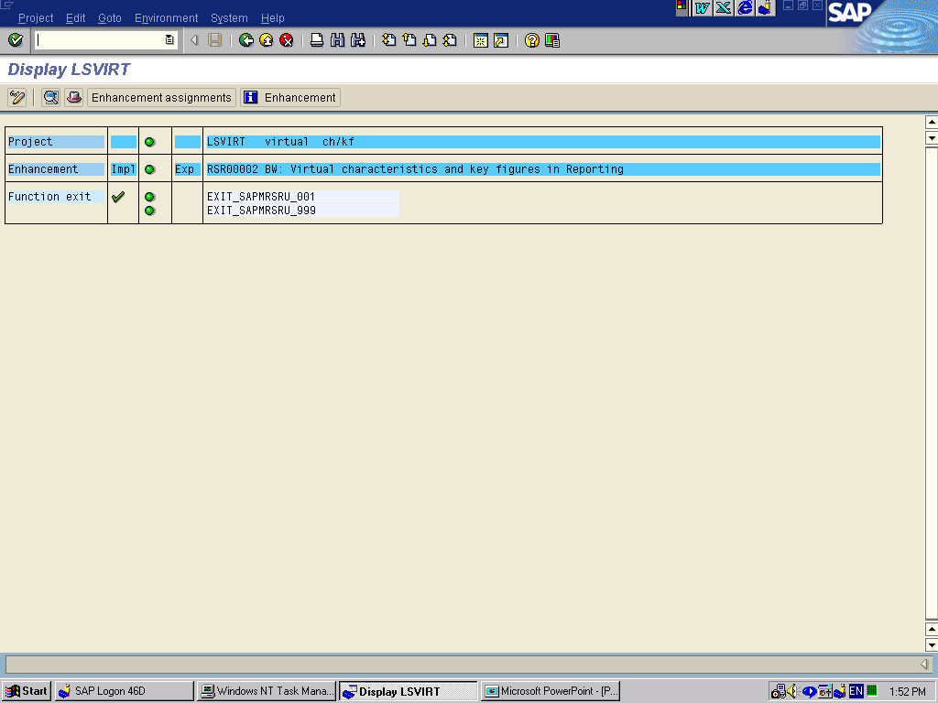
- In the first step of the coding portion, you will need to define several variable to be used. In our case (for the InfoCube ZRT_C99), we are using variables for the following InfoObjects:  - 0SALESORG  - 0DISTR_CHAN  - ZGENERIC  - ZCOLORCD  - 0CALDAY  - ZVRRETAIL  - ZRPCOUNT | *--------------------------------------  - INCLUDE ZXRSRTOP  - *--------------------------------------  * for retail price  data: g_pos_zrt_c99_0salesorg type i.  data: g_pos_zrt_c99_0distr_chan type i.  data: g_pos_zrt_c99_zgeneric type i.  data: g_pos_zrt_c99_zcolorcd type i.  data: g_pos_zrt_c99_0calday type i.  data: g_pos_zrt_c99_zvrretail type i.  data: g_pos_zrt_c99_zrpcount type i.
- In the next step, you decide on whether an InfoObject should be read or populated during data execution. ZVRRETAIL and ZRPCOUNT are the only InfoObjects to be populated, all other InfoObject are to be read.  - Also note the coding portion, where table I_TH_KYFNM is read: This allows you to restrict the usage of the enhancement (and the possible performance impacts associated with this) to those cases, where the virtual key figure ‘ZVRRETAIL’ is actually used in the query (Note: this coding portion will be executing at the point of query generation, not at query execution time). | *----------------------------------------------------------------------*  * INCLUDE ZXRSRU02 *  *----------------------------------------------------------------------*  data: l_s_chanm type rrke_s_chanm.  DATA: L_SUBRC1 TYPE SY-SUBRC. "execute only, if key figure really used  case i_s_rkb1d-infocube.  when 'ZRT_C99'. "retail price  READ TABLE I_TH_KYFNM_USED  WITH KEY TABLE_LINE = 'ZVRRETAIL'  TRANSPORTING NO FIELDS.  L_SUBRC1 = SY-SUBRC.  IF L_SUBRC1 = 0. "only if KYF used at all....  l_s_chanm-chanm = '0SALESORG'.  l_s_chanm-mode = rrke_c_mode-read.  append l_s_chanm to e_t_chanm.  l_s_chanm-chanm = '0DISTR_CHAN'.  l_s_chanm-mode = rrke_c_mode-read.  append l_s_chanm to e_t_chanm.  l_s_chanm-chanm = 'ZGENERIC'.  l_s_chanm-mode = rrke_c_mode-read.  append l_s_chanm to e_t_chanm.  l_s_chanm-chanm = 'ZCOLORCD'.  l_s_chanm-mode = rrke_c_mode-read.  append l_s_chanm to e_t_chanm.  l_s_chanm-chanm = '0CALDAY'.  l_s_chanm-mode = rrke_c_mode-read.  append l_s_chanm to e_t_chanm.  append 'ZVRRETAIL' to e_t_kyfnm.  append 'ZRPCOUNT' to e_t_kyfnm.  endif.
- In the third step of the enhancement project coding, you finally define the update logic:  - First, some variables need to be declared (using field symbols) as well as any database table to be referenced in the exit. Again, if you are unsure on how to do this, please refer to the documention (SMOD).  - Then, the relevant data are read via SELECT statements. In case that you read directy from master data tables, you could also use available function modules, e.g. RSAU_READ_MASTERDATA (however note, that the function modules could change with any release / support package).  - In the final step, the virtual key figures are calculated. | *----------------------------------------------------------------------*  * INCLUDE ZXRSRZZZ *  *----------------------------------------------------------------------*  * retail price (style selling cube)  form user_zrt_c99 using i_s_rkb1d type rsr_s_rkb1d  changing c_s_data type any.  tables: ZVIRTUAL_RETAIL.  field-symbols <l_0salesorg>.  field-symbols <l_0distr_chan>.  field-symbols <l_zgeneric>.  field-symbols <l_zcolorcd>.  field-symbols <l_0calday>.  field-symbols <l_zvrretail>.  field-symbols <l_zrpcount>.  *break-point.  assign component g_pos_zrt_c99_0salesorg  of structure c_s_data to <l_0salesorg>.  assign component g_pos_zrt_c99_0distr_chan  of structure c_s_data to <l_0distr_chan>.  assign component g_pos_zrt_c99_zgeneric  of structure c_s_data to <l_zgeneric>.  assign component g_pos_zrt_c99_zcolorcd  of structure c_s_data to <l_zcolorcd>.  assign component g_pos_zrt_c99_0calday  of structure c_s_data to <l_0calday>.  assign component g_pos_zrt_c99_zvrretail  of structure c_s_data to <l_zvrretail>.  assign component g_pos_zrt_c99_zrpcount  of structure c_s_data to <l_zrpcount>.  select * from ZVIRTUAL_RETAIL  where /BI0/0SALESORG eq <l_0salesorg>  and /BI0/0DISTR_CHAN eq <l_0distr_chan>  and /BIC/ZGENERIC eq <l_zgeneric>  and /BIC/ZCOLORCD eq <l_zcolorcd>  and OBJVERS eq 'A'  and DATETO ge l_0calday  and DATEFROM le l_0calday.  exit.  endselect.  if sy-subrc eq 0.  <l_zvrretail> = ZVIRTUAL_RETAIL-/BIC/ZVRRETAIL.  <l_zrpcount> = 1.  endif.  endform.
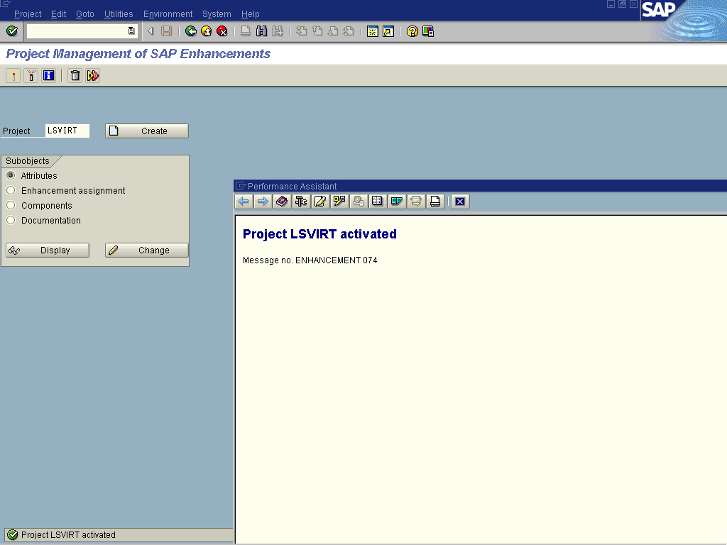
- Activate your enhancement project via transaction CMOD >> Activation.

Create and execute the Query

In the final step, you create and execute a query using the virtual key figures. In the query definition and execution, you can treat the virtual key figures just like any other key figure. Note, that in order to arrive at the individual retail price, you will need to create a calculated key figure (formula):
Retail Price = ZVRRETAIL / ZRPCOUNT.

