How to...

Perform Data Load Consistency Checks in BW
Business Information Warehouse
ASAP “How to…” Paper
Applicable Releases: BW 2.0B, 2.1C
September 2001

Business Scenario
Logistics application data are transferred frequently from R/3 to BW using the central delta management (refer to transaction LBWE, Logistics Cockpit). The central delta management is a proven, reliable and scalable method for data extraction to BW.
Although you can savely rely on the existing BW technology to assure the data consistency (BW versus R/3) for you, there is currently no standard tool available for you to actively monitor this data quality.
In this scenario we will use the example of Point Of Sales data (POS) for Retail, to show how you can monitor the data quality via a custom solution. This solution is relatively easy to implement. In addition, we will also introduce a fallback scenario, which can be implemented for an additional level of security.

The Solution
The solution consists of the following components:
- Creation of an outbound temporary storage area (OSA).
- Population of the OSA during data collection in R/3.
- Creation of a generic extractor against the OSA for data repair purposes.
- Development of data quality check tools (to be executed manually / automatically).

The Step By Step Solution

Append the datasource by an additional counter field.
The counter field serves as a unique key for identification of each data record. Make sure that the size of the counter field is large enough to count (ideally) through all records that you plan to transfer to BW throughout the lifetime of the infosource. Oversize it, since due to number range buffering some numbers might get lost on the way (see further below).

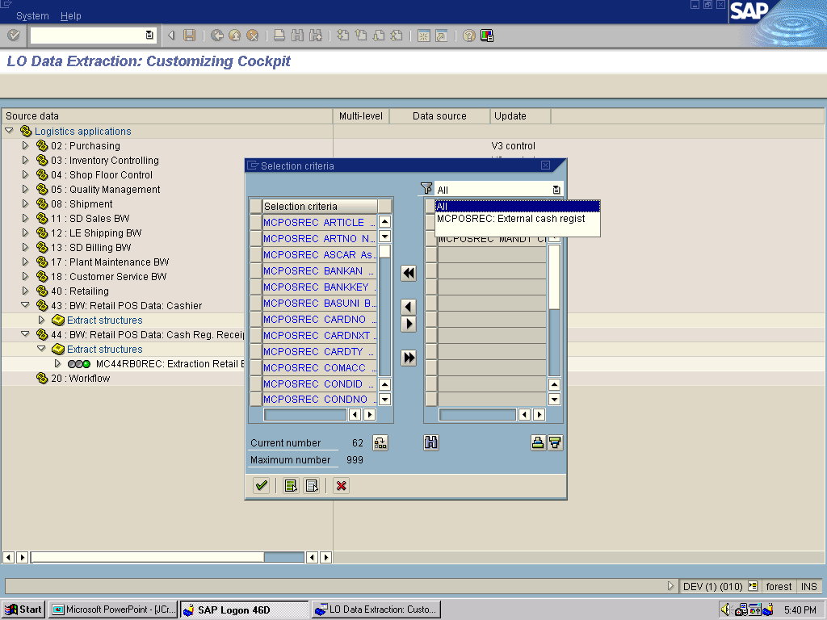
- First you research and determined the communication structure of your datasource. You can do this e.g. by using the logistics cockpit (transaction LBWE). In our case we are using the datasource 2LIS_44_POSREC, and the communication structure is MCPOSREC.
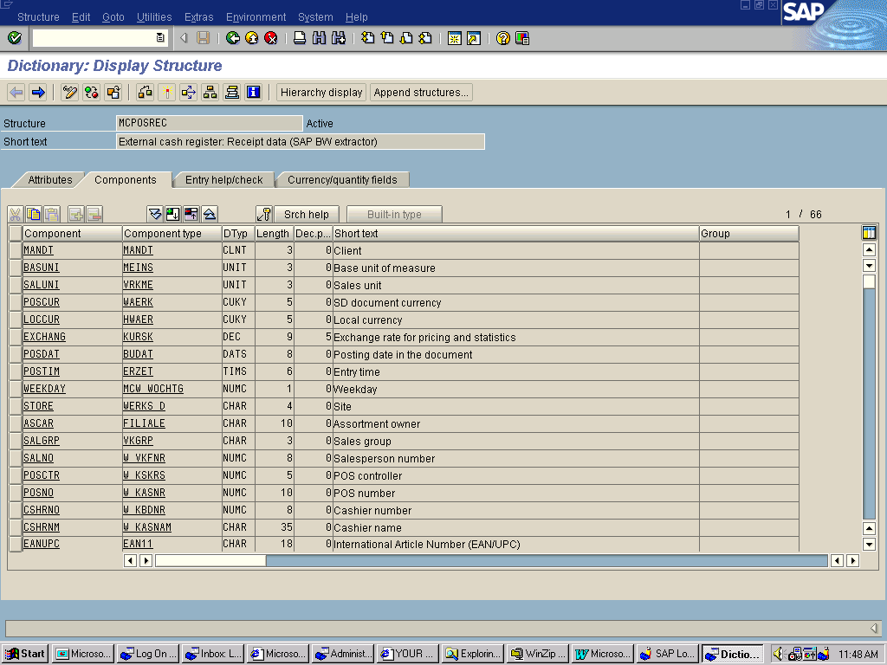
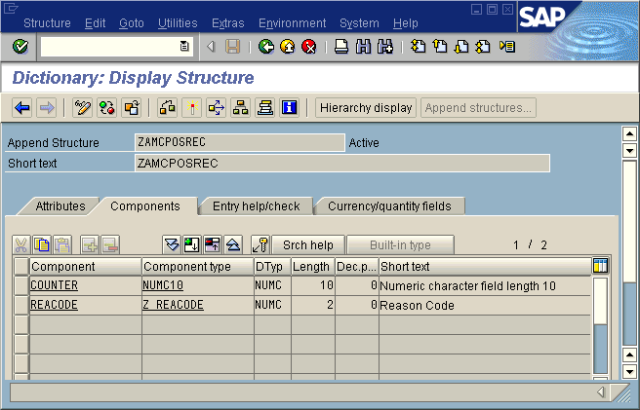
- Via transaction SE11, append the communication structure by a field COUNTER (or ZCOUNTER, if you want to stay conform to the customer name range). As data element, you can either use an existing element or create and utilize your own. Regenerate the communication structure.
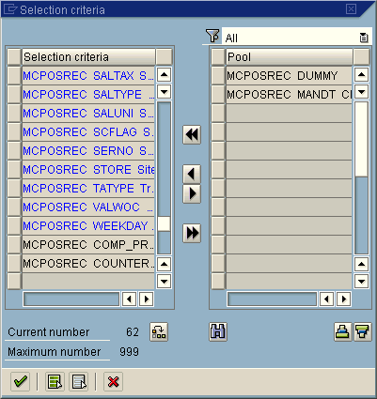
- Append the datasource with the COUNTER field. Reactivate the datasource. You can do all this via transaction LBWE in R/3.
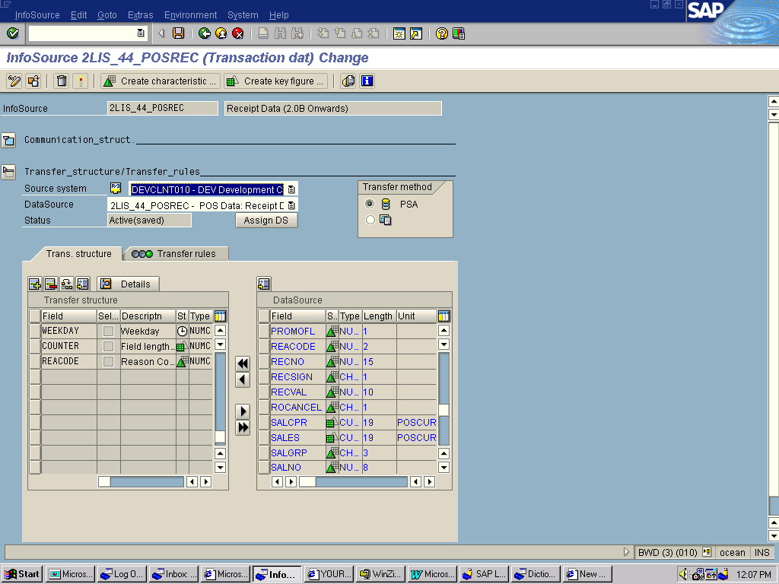
- Replicate the datasource into BW. Reactivate the transfer rule. Note, that you do not need to include the COUNTER into the BW communication structure, and also you do not have to create an InfoObject for this. [However, later-on in this scenario we will do it, for reasons explained below.]

Create the outbound temporary storage Area (OSA), and develop the respective update logic.
The OSA serves as reference for data quality as well as source for corrective postings in case of data contamination. Depending on the datasource that you are dealing with, you already might have adequate tables available in R/3 and hence would not necessarily require this additional table.
The OSA table contents are typically deleted again, after confirmation of data quality in the BW.

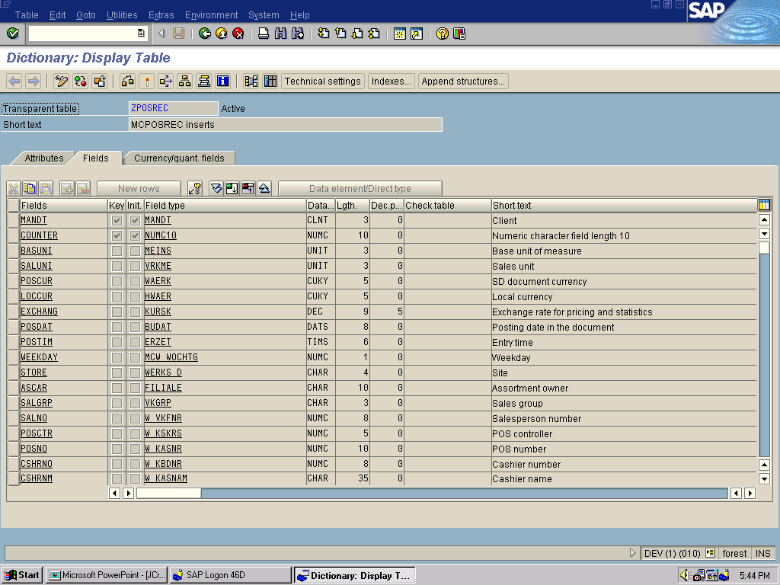
- In the R/3 system, create a transparent table ZPOSREC modeled after the communication structure MCPOSREC. You can do this via transaction SE11, Edit >> Transfer Fields. The primary key should consist of CLIENT and COUNTER.
If you want to have the finest granularity, you can include all fields of the structure. This way you also will have a complete data backup, which you can use to repair data consistencies in BW, should they arise.
If you are only intersted in running checksums, you might not require all fields though.
- Identify an application user exit that you want to use for data access. In that exit you will copy the data (which are passed by standard to the communication structure) to you OSA. In the case of POS/receipts, we have chosen the exit MCPOSEXRECX1. It is imperative that you decide on the right exit to use, as this will determine the reference for your data quality check. Once you identified the exit, develop the respective update logic.  (Specifically pay attention to performance impacts on your OLTP system. Use ARRAY INSERT commands etc. where possible.) | *----------------------------------------------------------------------*  * INCLUDE MCPOSEXRECX1 *  *----------------------------------------------------------------------*  tables: zposrec.  loop at ITMCPOSREC "start loop  CALL FUNCTION 'NUMBER_GET_NEXT'  Exporting  NR_RANGE_NR = 'RE'  OBJECT = 'ZLS4POS'  Importing  NUMBER = itmcposrec-counter. "new fresh number  if sy-subrc ne 0.  raise general_exception. "number range error  endif.  move-corresponding ITMCPOSREC to zposrec.  insert zposrec. "insert into backup table  if sy-subrc ne 0.  raise general_exception " table insert error  endif.  Endloop. " end loop
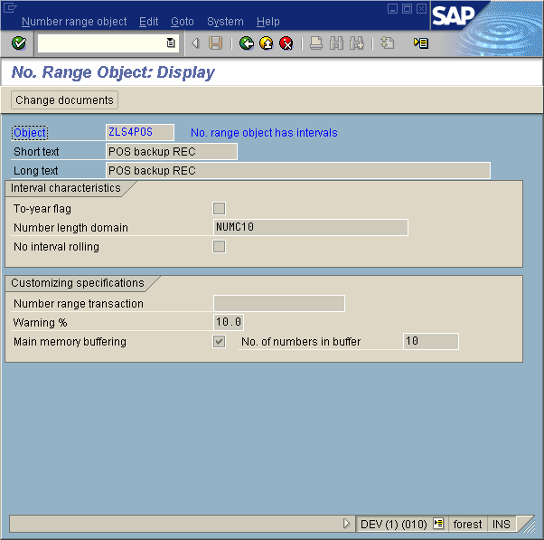
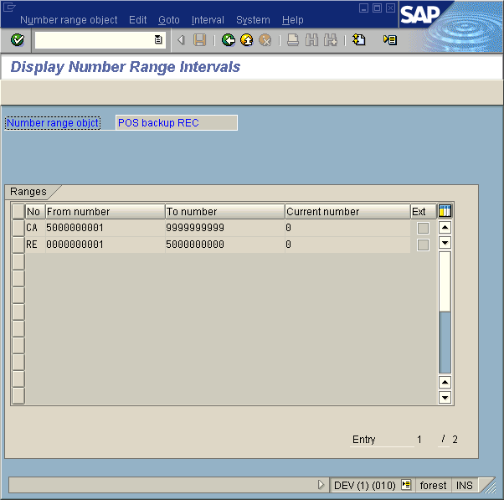
- Create a number range object, which will deliver the unique record counters for you. Consider number range buffering options when doing so, for performance benefits.

Create Generic Extractor based on OSA.
This generic extractor will serve several purposes. You can utilize it to extract specific records out of ZPOSREC (selected by unique identifier COUNTER), in order to manually synchronize the data status again between InfoCube and OSA. You also can utilize it for the setup of an automatic data quality assurance system, as described at the end of this document.

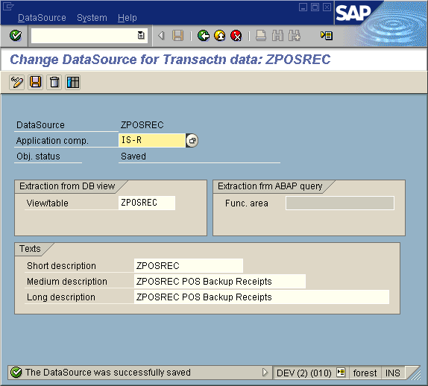
- Via transaction RSO2, create a generic datasource extractor, based on ZPOSREC. Make COUNTER available as selection criteria for the InfoPackage.
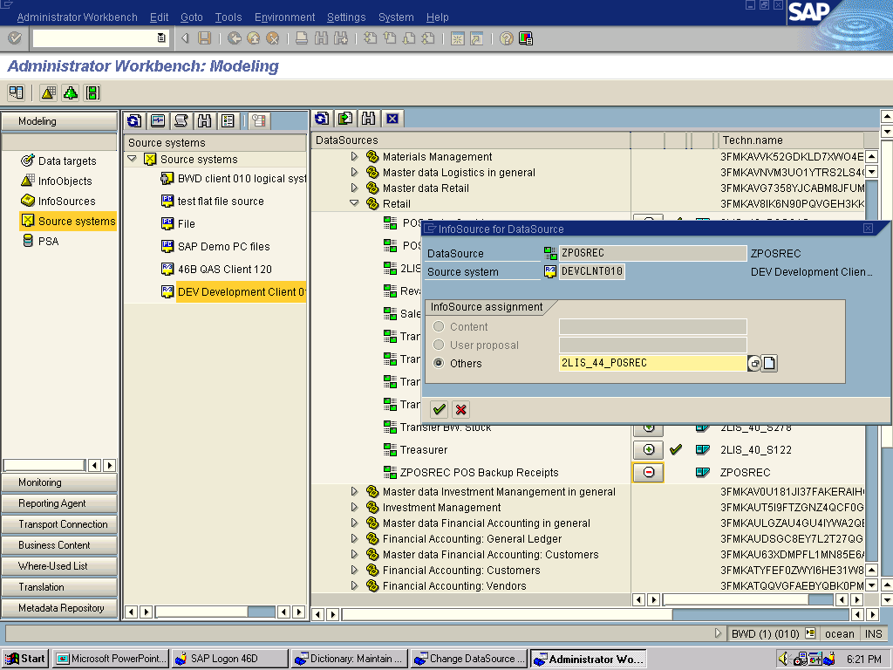
- Perform datasource replication to BW. Connect the generic datasource ZPOSREC to the existing datasource 2LIS_44_POSREC.
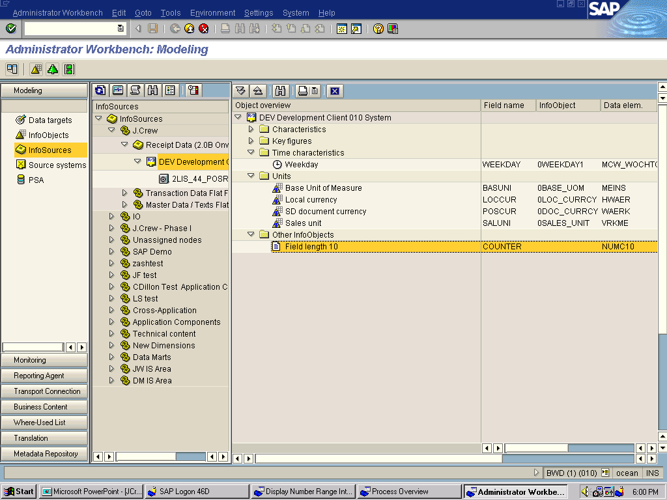
- Verify that the COUNTER field is part of the datasource. If you did not map this field to an InfoObject, it will show up as ‘Other InfoObject”.

Develop Data Quality Assurance Scenario
In this step you will develop the data quality check tools. There are several possible approaches to this. One approach could be to put a function module in place, which compares PSA (BW) contents and OSA (R/3) contents via RFC, either line-by-line or for a checksum. You should especially consider this approach in case of large data volumes, where performance is very critical.
In the approach described below we will utilize standard BW functionality to execute the check. Note, that the approach outlined below basically means to alternative parallel ways of staging the same data into BW. Due to performance and storage space impacts, care must be taken on how to implement this scenario. For example, you might want to stage only aggregated data from the OSA. Or you might want to perform the data checks only for specific dates, like once a month.

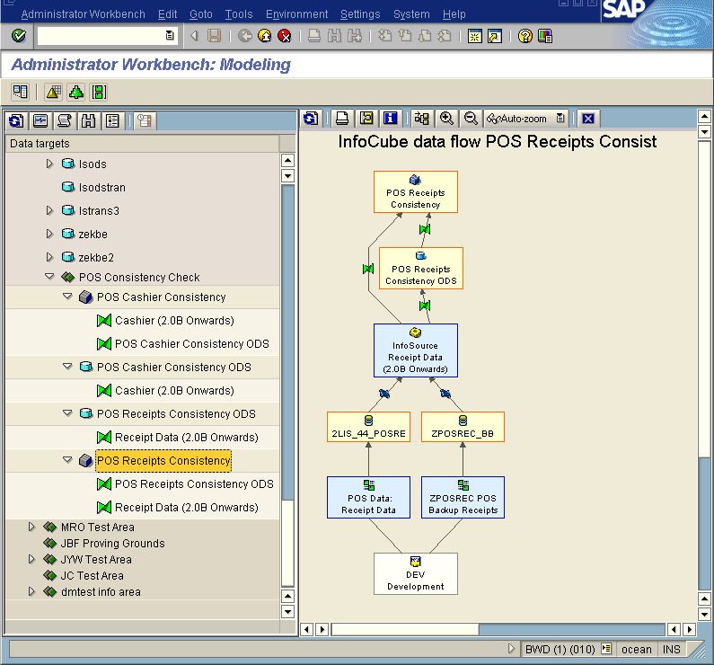
- Develop an update logic in BW, as follows:
- ODS object (ODSCONS) , populated by ZPOSREC
- InfoCube (CUBCONS), populated by both ODSCONS and 2LIS_44_POSREC
- The update rule from ODSCONS to CUBCONS uses negative update logic (i.e. all key figures are multiplied by (-1.0 in the update logic)
- InfoPackage settings assure that the right data go to the right data targets (by selecting the appropriate data targets).

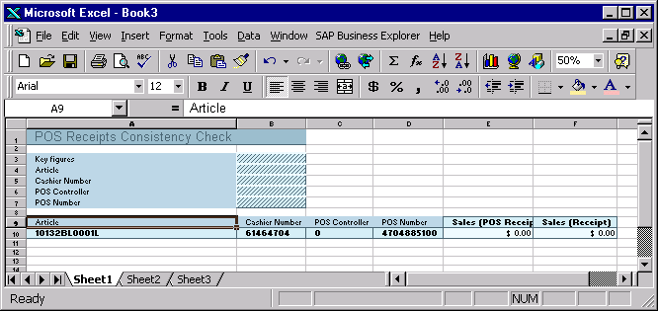
- Create a BEx query against the CUBCONS. All key figure values should zero out after loading. If you use InfoCube compression including zero elimination after each load, the query should not deliver any results at all (“no records found”).
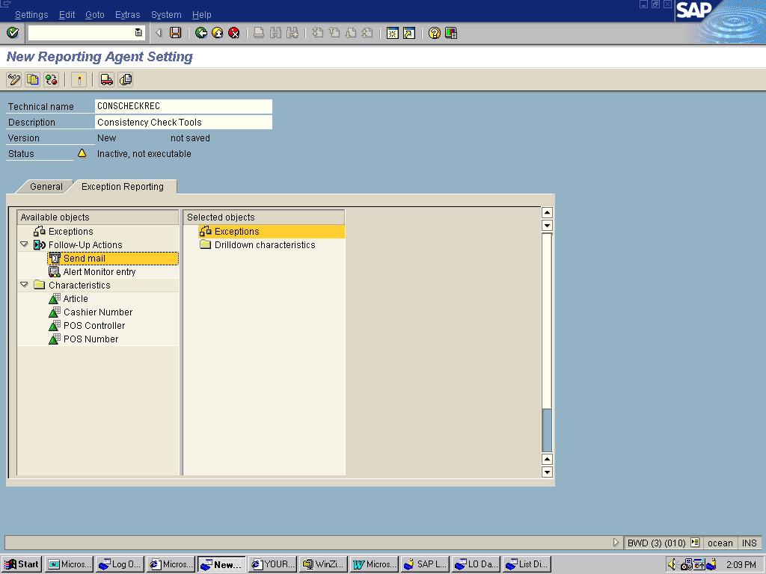
- Create an exception report, which is triggers and event in case the results do not zero out.

