How to…

Implement flexible Master data staging (in concert with ODS)
Business Information Warehouse
ASAP “How to…” Paper
Applicable Releases: BW 3.0
January 2002

Business Scenario
You are dealing with two kinds of Business Partners: Customers and Vendors. Before storing them in separate master data tables you want to bring them together in one consolidated object for Business Partners.

The Result
You will have two separate DataSources, one for Customers and one for Vendors. Before updating the data into the target InfoObjects (Master Data) for Vendors and Customers, you want to have a consolidated ODS Object representing your Business Partners (Customers + Vendors). The dataflow of the scenario described above will be the following:
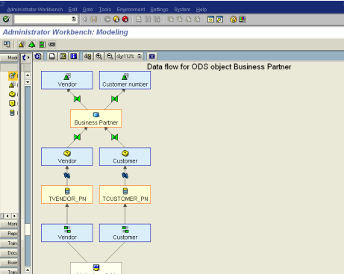

Remark: If you need the flexible master data staging functionality in order to have additional update rules only (besides the transfer rules which are always available), you can connect the InfoSources for Customers and Vendors (created in step 1 to 3) to the corresponding InfoObjects directly. In this case, you only need steps 1, 2, 3, 8, 9, 10, and 11. In the steps 9 and 10 you then don´t define update rules between the InfoObjects and the ODS object but between the InfoObjects and the corresponding InfoSources created in step 1 and 3.

The Step By Step Solution

This example assumes that the customer and vendor values are sourced from a file system (flat file).
- Create an InfoSource for Customers. The InfoSource has to be of type “Flexible Update in any target”. | 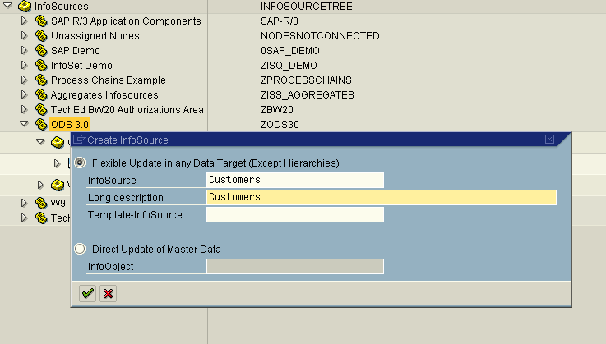
- Assign DataSource (PC Source System) to the InfoSource created in step 1 and define transfer rules. In this example, the flat file for customers contains the columns Customer, Name, City, and Country. We used the InfoObjects 0CUSTOMER, 0NAME, 0CITY, and 0COUNTRY to map those fields. | 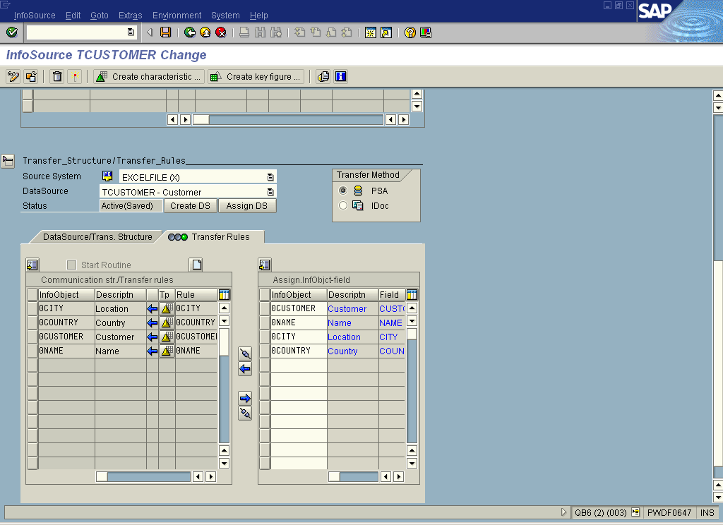
- Steps 1 and 2 have also to be executed for the definition of the InfoSource for Vendors and the corresponding transfer rules.  After this step you have two InfoSources, one for Customers and one for Vendors, both connected to a file system via the necessary transfer rules.  - Create an InfoObject for Business Partner Type. This InfoObject is necessary for the distinction between customers and vendors in the consolidated ODS Object to be defined in the next step. | 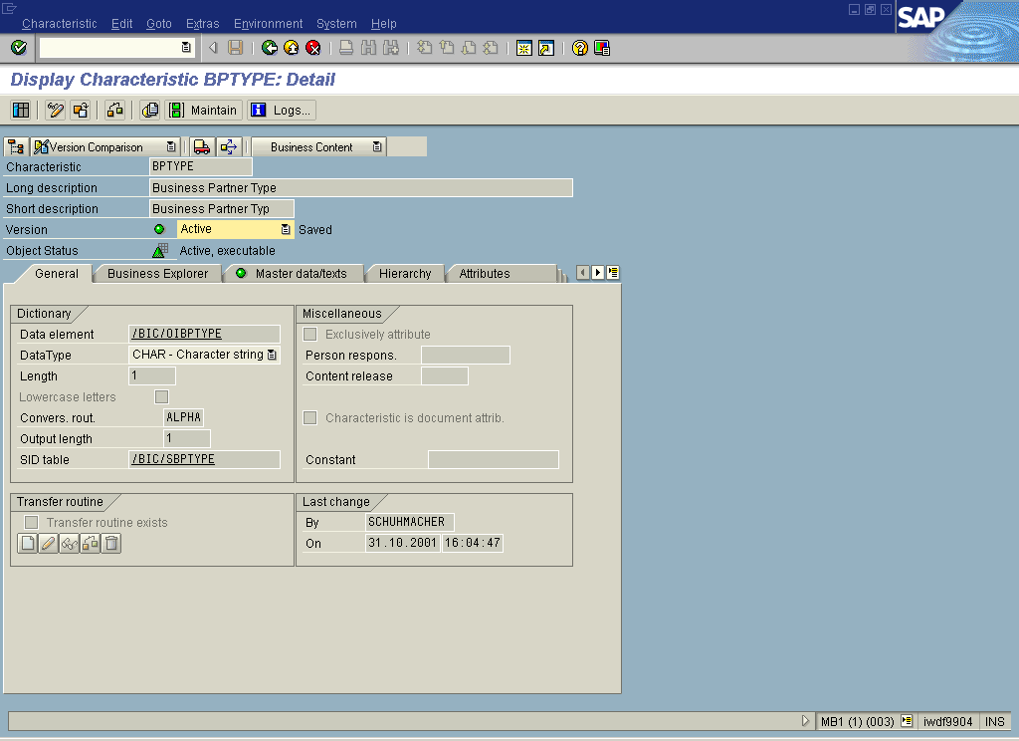
- Create an ODS Object (type ‘Standard’) in order to consolidate customer and vendor data. The ODS Object contains the InfoObjects for Business Partner Type (will contain the values ‘C’ for Customers and ‘V’ for Vendors) and for Business Partners (e.g. 0BPARTNER) as key fields. As data fields it contains the attributes of customers and vendors, which are in this case 0NAME, 0CITY and 0COUNTRY. Furthermore, define the appropiate settings of the ODS Object for your scenario (e.g. BEx Reporting possible). Activate the ODS object. | 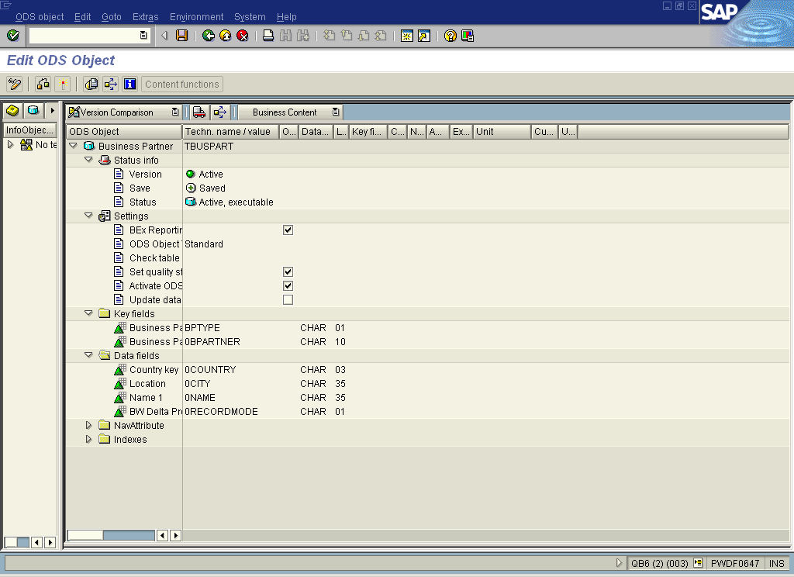
- Create an update rule between the ODS Object created in step 5 and the InfoSource for Customers. | 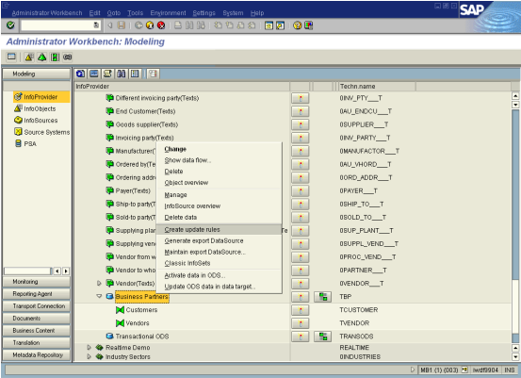
The data fields are assigned automatically. By double-clicking on the first data field you can assign the source characteristic 0CUSTOMER to the key field for ‘Business Partner’ (0BPARTNER in the example). Update the key field ‘Business Partner Type’ with the constant ‘C’ (for Customer). Activate the update rule. | 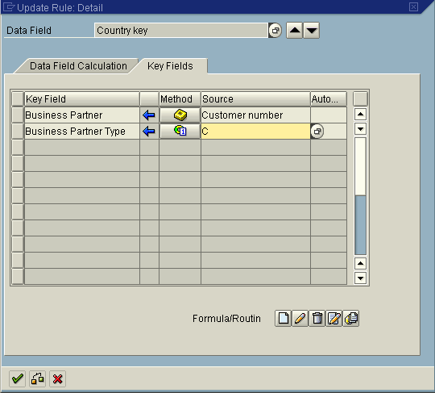
- As described in step 6, create also an update rule between the ODS Object and the InfoSource for Vendors. The data fields are assigned automatically. Assign the source characteristic 0VENDOR to the key field ‘Business Partner’. Update the key field ‘Business Partner Type’ with the constant ‘V’ (for Vendor). Activate the update rule.
- In order to be able to update the master data tables of the InfoObjects 0CUSTOMER and 0VENDOR by the relevant datasets (as sourced from the ODS Object), we have to define the two InfoObjects as data targets. By right mouse clicking on the InfoArea of your choice, you can choose the characteristics to be inserted as data targets. Execute this function twice, once for 0CUSTOMER and once for 0VENDOR. If you do not use the Business Content InfoObjects 0CUSTOMER and 0VENDOR, you have to insert your own InfoObjects as data targets. | 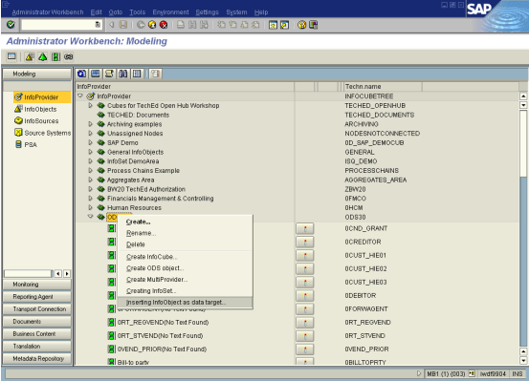
- Define update rules between the InfoObject 0CUSTOMER (or your own one) and the ODS Object created before.  - Define the assignment for the attributes. | 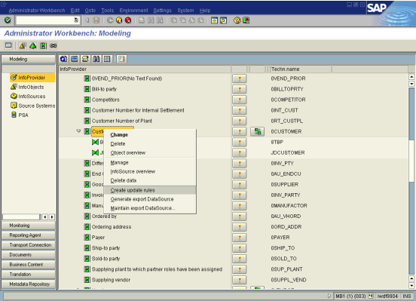
- By double-clicking on one attribute you have the option to define the update rule of the Key field of the InfoObject. Therein you have to apply a routine because you only want to update the datasets representing customers (and not ones for vendors!). Therefore, create the following routine: | 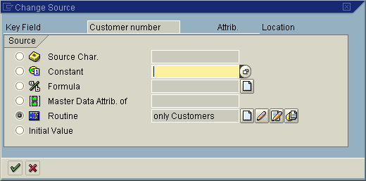
- Save and activate the update rules. | 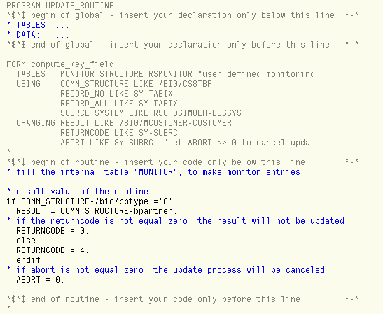
- As decribed in step 9, define also update rules between the InfoObject 0VENDOR and the ODS Object.
- Now you are finished with the definition of the data flow and you can upload your data.

