How to…

Indentify ‘Comparable’ Results within a Query.
Business Information Warehouse
ASAP “How to…” Paper
Applicable Releases: BW 2.0B, 2.1C
September 2001

Business Scenario
Sales results in a query should be separated into comparable and non-comparable results. For example, results are defined as comparable for a specific reporting period, if results exist for the same period in the prior year.

Consider an example in the retail industry:
The grey areas in the graph (1) indicate the dates that a certain store was opened. For reasons of simplicity, we are considering here two seasons per year, with only 2 days each. As you can see in the graph, the store had opened on day 4 of year 1998 (4/1998), and then had closed again for business on 2/2001. The bold framed areas of graph (2) now indicate dates, which dates are considered as non-comparable dates (like 3/1998 or 3/1999, when comparing the sales of those dates). Of course there are more dates to be considered non-comparable: Basically all dates, where either of the two dates for comparison does not fall into the time window where the shop was actually open for business. In contrast, the bold framed areas of graph (3) indicate dates, which are considered as comparable dates (like 3/1999 or 3/2000, when comparing the sales of those dates).
Mixing all dates into one bucket could easily lead to misinterpretation of results, and thus to wrong decision making. Just by opening a new store, sales could be increased significantly. However this actually would not tell anything about the real performance of one store (or sales area), as compared to a prior period.
At this point it is important to note, that the decision on whether the results associated with a specific date are considered to be comparable (or non-comparable), depends e.g. on the parameters: store opening date, store closing date and interval for comparison (within the query).

Now assuming (again, for simplicity) constant sales of $100 for every day of operation in the lifetime of the store, you want to arrive at the following results (examples of 4 query outputs):

Without the solution described in this paper, you would arrive only at the “total” rows. However this information itself would not tell you the true store performance. For example, consider the “Season 1/01 versus Season 1/00” query. Did the overall store performance really descrease by 50%? Well, our breakdown by comp/nonc tells a different story: In fact, the ongoing sales performance of the store did not change at all – however it simple had closed down during the second season, which affected the overall sales results.

Note: comp indicates comparable results, non-comp indicated non-comparable results.
As you would expect, for every non-comparable pair at least one of the sales results has to be zero.

The Solution
- Virtual characteristics are used to identify ‘comparable’ versus ‘non-comparable’ results. It is required to use virtual characteristics (as compared to regular characteristics), since the value determination not only depends on the transaction data and master data (in those cases, probably regular characteristics derived at data staging timer would be indeed sufficient). The value determination also depends on the actual reporting time window (which is selected dynamically by the user at query execution time, via a custom input variable).

Abbrevations used in this paper:
Comp: comparable
Non-comp: non-comparable

The Step By Step Solution

Include the Virtual Characteristic in the data model
The virtual characteristic needs to be included within the data model, so that it can be populated by the exit, and used in the query. Include it in all InfoCubes, where required. Also you can append this field to existing (already populated) InfoCubes. As long as you do not create and activate the field via an enhancement project, its value will be of initial value.

- Create an InfoObject (of type ‘characteristic’) that you want to use for separation between comp / non-comp values.  In our example, we create the InfoObject LSCOMS with the following properties:  Data type = Char; Length: 1;  Texts = Yes. | 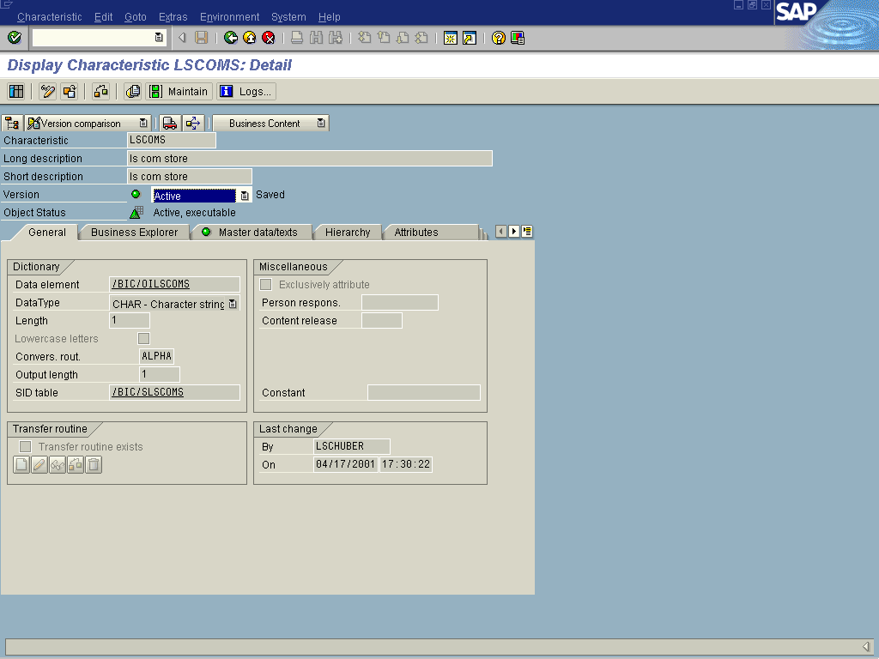
- Maintain characteristic values for the InfoObject:  C = comparable  N = non comparable | 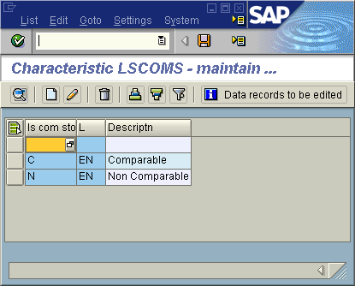
- Include the InfoObject LSCOMS in your InfoCube. Since you do not populate this field with any data (remember, the InfoObject is a virtual characteristic!), it is not required to delete (and reload) the InfoCube contents. Besides this however, you treat the virtual characteristic just like any other characteristic (include it in InfoCube dimension etc). | 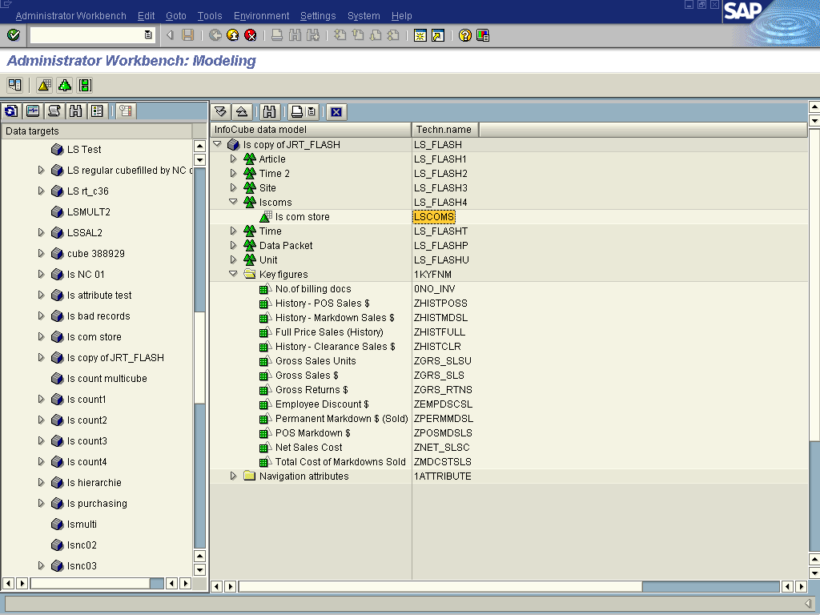
- Make sure to re-activate the update rule as well. In the mapping, assign the initial value (‘Blank’) to LSCOMS. | 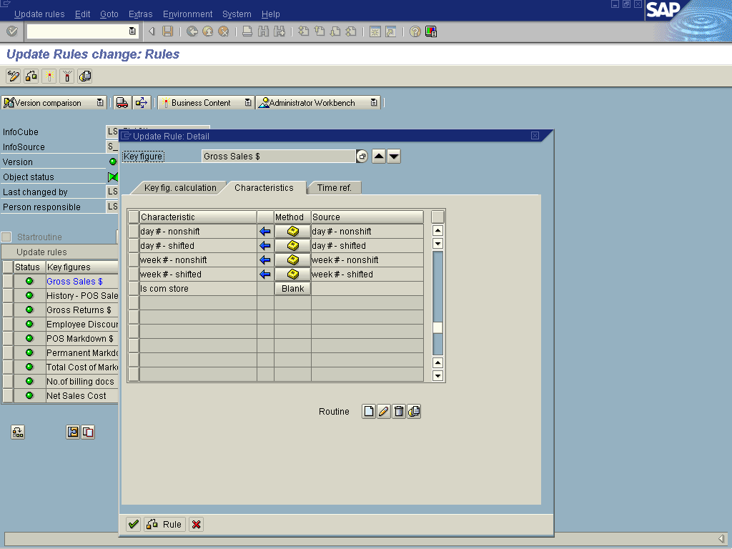

Maintain BEx Variable for Time Window Selection
Since the value of the virtual characteristic should depend also on the time window for reporting, the values (dates) selected need to be communicated to the enhancement exit. Fortuntaly, the exit for virtual characteristics / keyfigures and the exit for variables share the same function group, and hence the same global memory. So, the value selection made by the user for the variables can be made easily known in the virtual exit.
For this purpose, we include some logic into the exit for variables, which reads the user input for data selection, and remembers that vaue via a global variable.
- Create some ABA logic, which reads the user inputs from the selection periods. All it does, once the user selection (ia standard variable 0I_CALMO) is done, it remembers the selected year value in the global memory variable LSVARI. | *----------------------------------------------------------------------*  * INCLUDE ZXRSRU01 *  *----------------------------------------------------------------------*  IF I_STEP = 3.  LOOP AT I_T_VAR_RANGE INTO LOC_VAR_RANGE WHERE VNAM = '0I_CALMO'.  lsvari = LOC_VAR_RANGE-low(4).  EXIT.  ENDLOOP.  ENDIF.
- Doubleclick on the variable LSVARI to define it in the global section.  - Now it will be available in the virtual exit portion! | *----------------------------------------------------------------------*  * INCLUDE ZXRSRTOP *  *----------------------------------------------------------------------*  DATA lsvari like RRRANGEEXIT-low.

Maintain the update logic for the Virtual Characteristic
In the enhancement project for the virtual characteristic, the logic for population of the InfoObject is developed.

- Via transaction CMOD, create a customer enhancement project. In our example, we called the customer project LSVIRT. When choosing the name (and short description) for the project, remember that you can define only one project for all virtual InfoObjects system-wide (in case you want to define more than one). Assign a development class, and save the project. | 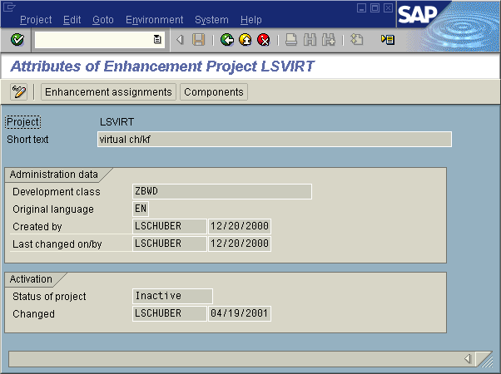
- Assign the SAP enhancement RSR00002 (virtual characteristics and key figures) to your project. | 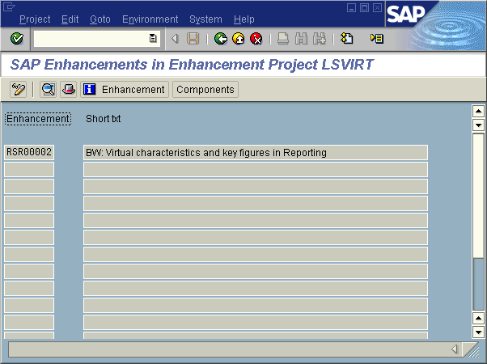
- Via Menu >> Components, you can display the relevant components for this project. If you are not familiar yet with vitual infocobjects, it is absolutely essential to study first the relevant information, specifically the online documentation, which can be access via transaction SMOD (enter project RSR00002). Although the following steps contain the complete sample coding for our example, this “How To” paper is no replacement for the online documentation. | 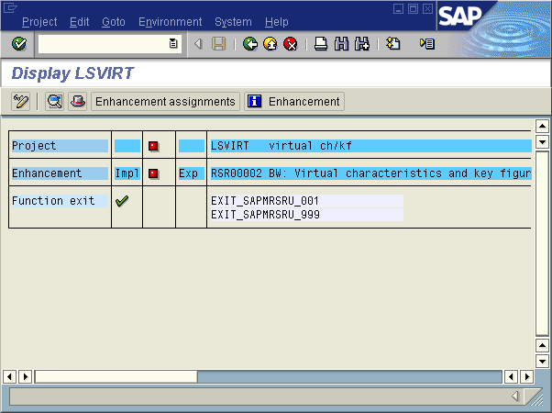
- Doubleclick on EXIT_SAPMRSRU_001 in order to arrive at the ABAP coding (enter change request infromation where required). From here you can branch via Goto >> MainProgram to the main program SAPLXRSR. | 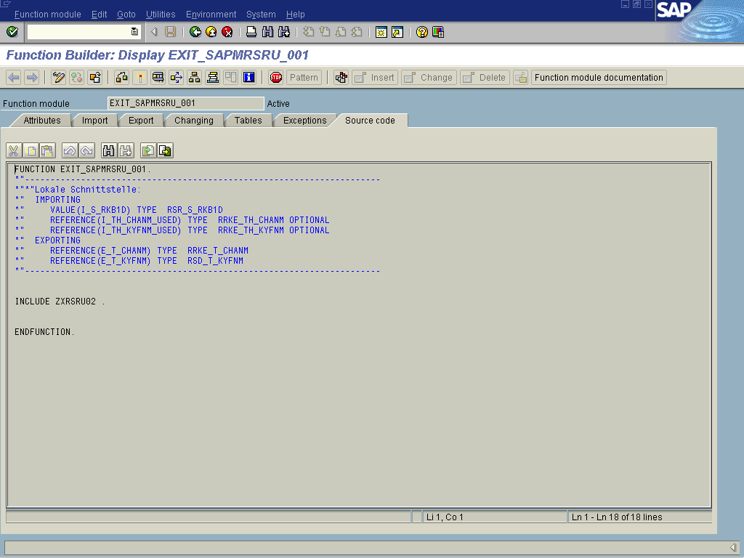
- Alternatively to the last step, you could call up the program SAPLXRSR as well directly via the ABAP/4 Editor, in transaction SE38.  There will be exactly 3 areas, where you need to do coding within this enhancement project:  1. INCLUDE LXRSRTOP  >> INCLUDE ZXRSRTOP  2. INCLUDE LXRSRUXX  >> INCLUDE LXRSRU02  >> INCLUDE ZXRSRU02  3. INCLUDE ZXRSRZZZ | 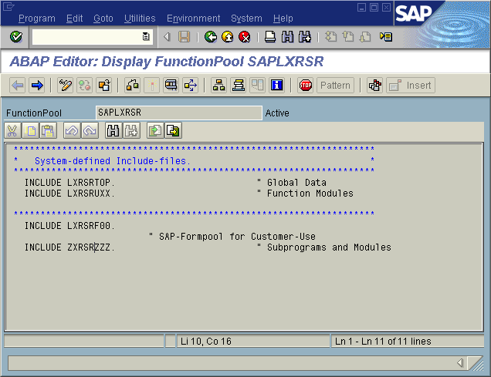
- In the first step of the coding portion, you will need to define several variable to be used. In our case (for the InfoCube LS_FLASH), we are using variables for the following InfoObjects:
*----------------------------------------------------------------------*
* INCLUDE ZXRSRTOP *
*----------------------------------------------------------------------*

data: g_pos_ls_flash_0calday type i.
data: g_pos_ls_flash_0fiscyear type i.
data: g_pos_ls_flash_0fiscvarnt type i.
data: g_pos_ls_flash_zfiscssn type i.
data: g_pos_ls_flash_0plant type i.
data: g_pos_ls_flash_lscoms type i.
- 0CALDAY
- 0FISCYEAR
- 0FISCVARNT
- ZFISCSSN
- 0PLANT
- LSCOMS
- In the next step, you decide on whether an InfoObject should be read or populated during data execution. LSCOMS is the only InfoObject to be populated, all other InfoObject are read.
*----------------------------------------------------------------------*
* INCLUDE ZXRSRU02 *
*----------------------------------------------------------------------*

data: l_s_chanm type rrke_s_chanm.

* break-point.

case i_s_rkb1d-InfoCube.

when 'LS_FLASH'.

l_s_chanm-chanm = '0CALDAY'.
l_s_chanm-mode = rrke_c_mode-read.
append l_s_chanm to e_t_chanm.

l_s_chanm-chanm = '0FISCYEAR'.
l_s_chanm-mode = rrke_c_mode-read.
append l_s_chanm to e_t_chanm.

l_s_chanm-chanm = '0FISCVARNT'.
l_s_chanm-mode = rrke_c_mode-read.
append l_s_chanm to e_t_chanm.

l_s_chanm-chanm = 'ZFISCSSN'.
l_s_chanm-mode = rrke_c_mode-read.
append l_s_chanm to e_t_chanm.

l_s_chanm-chanm = '0PLANT'.
l_s_chanm-mode = rrke_c_mode-read.
append l_s_chanm to e_t_chanm.

l_s_chanm-chanm = 'LSCOMS'.
l_s_chanm-mode = rrke_c_mode-no_selection.
append l_s_chanm to e_t_chanm.
- In the third step of the enhancement project coding, you finally define the update logic:
*----------------------------------------------------------------------*
* INCLUDE ZXRSRZZZ *
*----------------------------------------------------------------------*

form user_ls_flash using i_s_rkb1d type rsr_s_rkb1d
changing c_s_data type any.

tables: /BI0/PPLANT.

data: lsthyear(4) type n. "FY,this year
data: lslayear(4) type n. "FY,last year

data: lsgid like i_s_rkb1d-GENUNIID. "query GID
data: lsnxtyr like /BI0/PPLANT-/BIC/ZSD_OPND. "date (opened + 1yr)
data: lspriyr like /BI0/PPLANT-/BIC/ZSD_CLOSE. "date (closed - 1yr)

field-symbols <l_0calday>.
field-symbols <l_0fiscyear>.
field-symbols <l_0fiscvarnt>.
field-symbols <l_zfiscssn>.
field-symbols <l_0plant>.
field-symbols <l_lscoms>.

* break -point.

assign component g_pos_ls_flash_0calday
of structure c_s_data to <l_0calday>.

assign component g_pos_ls_flash_0fiscyear
of structure c_s_data to <l_0fiscyear>.

assign component g_pos_ls_flash_0fiscvarnt
of structure c_s_data to <l_0fiscvarnt>.

assign component g_pos_ls_flash_zfiscssn
of structure c_s_data to <l_zfiscssn>.

assign component g_pos_ls_flash_0plant
of structure c_s_data to <l_0plant>.

assign component g_pos_ls_flash_lscoms
of structure c_s_data to <l_lscoms>.

lsthyear = lsvari(4). "current FY of query
lslayear = lsthyear - 1.

if ( lsthyear is initial ).
raise general_exception.
endif.

SELECT SINGLE * FROM /BI0/PPLANT
WHERE PLANT = <l_0plant>
AND OBJVERS = 'A'.

if sy-subrc ne 0.
raise general_exception.
endif.

* store open data: /BIC/ZSD_OPND
* store close date: /BIC/ZSD_CLOSE

if ( /BI0/PPLANT-/BIC/ZSD_CLOSE is initial ).
/BI0/PPLANT-/BIC/ZSD_CLOSE = '99990101'.
endif.

lsnxtyr = /BI0/PPLANT-/BIC/ZSD_OPND.
lsnxtyr(4) = lsnxtyr(4) + 1.

lspriyr = /BI0/PPLANT-/BIC/ZSD_CLOSE.
lspriyr(4) = lspriyr(4) - 1.

- First, some variables need to be declared as well as any database table to be referenced in the exit. In our case, we want to look up the “Store Open” and “Store Closed” dates from the master data table for “Site” (which is InfoObject 0PLANT).
Then, field objects are assigned for the InfoObject variables within the global structure C_S_DATA.
- The Parameter ID ‘LSCOMYR’ (which is the primary fiscal year of the query to report against) is read. It was outlined above, how the Parameter ID is populated (Hint: This happened via variable exits).
- The Store Open / Store Close dates are read and adjusted, where required.
- Two helper variables ae calculated: ‘Store Open Date plus one year’ and ‘Store Close Date minus one year’.
- This is a continuation from the coding above, and this is where the final populations of the LSCOMS InfoObject will happen. This is according to the following rules:
* prior to opening
if ( <l_0calday> lt /BI0/PPLANT-/BIC/ZSD_OPND ).
<l_lscoms> = 'N'.
exit.
endif.

* after closing
if ( <l_0calday> ge /BI0/PPLANT-/BIC/ZSD_CLOSE ).
<l_lscoms> = 'N'.
exit.
endif.

* 1 year after opening, but 1 year before closing
if ( ( <l_0calday> ge lsnxtyr ) AND ( <l_0calday> lt lspriyr ) ).
<l_lscoms> = 'C'.
exit.
endif.

* current year (STD) is within first year after shop opening
if ( ( <l_0calday> lt lsnxtyr ) AND ( <l_0fiscyear> eq lsthyear ) ).
<l_lscoms> = 'N'.
exit.
endif.

* last year (SLY) is within one year before shop closing
if ( ( <l_0calday> ge lspriyr ) AND ( <l_0fiscyear> eq lslayear ) ).
<l_lscoms> = 'N'.
exit.
endif.

* all others
<l_lscoms> = 'C'.

endform.
- If (date < SOD) then
(LSCOMS = N)
- If (date >= SCD) then (LSCOMS = N)
- If ((date >= SOD + 1 year)
and (date < SCD – 1 year) )
then (LSCOMS = C)
- If ((date > SOD)
and (date < SOD + 1 year)
and (REPD = date))
then (LSCOMS = N)
- If ((date < SCD)
and (date >= SCD - 1 year)
and (REPD = date + 1))
then (LSCOMS = N)
- All other cases: (LSCOMS = C)
Note on Abbrevations used:
date: date of record (or transaction)
SOD: store opening date
SCD: store closing date
REPD: primary reporting date (e.g. in a query ‘ 2H/2000 vs. 2H/1999, the primay reporting date range would be ‘7/2000..12/2000’
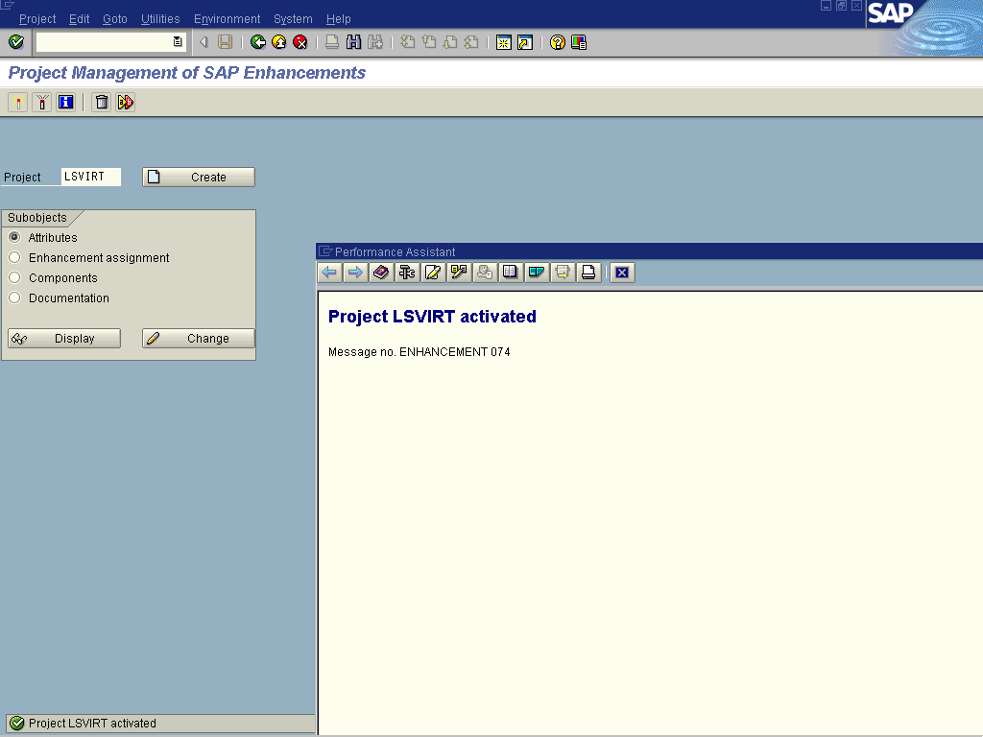
- Activate your enhancement project via transaction CMOD >> Activation.

Create and execute the Query
In the final step, create and execute a query using the virtual characteristic. In the query definition and execution, you can treat the virtual characteristic just like any other characteristic. The example below shows sales results by state, first without comparison indicator, then with indicator.

