How to...

Extend Master Data to Include Social Secrity Number from R/3 HR
Business Information Warehouse
ASAP How to Paper
Applicable Releases: BW 2.0B, 2.1C
July 2001

Business Scenario
As a BW consultant at Superior Brokerage, Inc., you are responsible for implementing Human Resources component. You have evaluated SAP delivered HR business contents and are very pleased that nearly 90% of Superior’s requirements will be met by using the pre-delivered contents. However, one of the important US specific content namely Social Security Number (SSN) is missing. This is a critical piece of data for all Human Resource managers in every division. Your mission is to extend the business content to bring SSN from R/3 into BW data warehouse environment

The Result
The Human Resources manage of Superior Brokerage has the responsibility to report exception activities of employees and applicants who holds a certificate for security trade to the Security Exchange Commission. These exception reports require detailed information about the employee including their Social Security numbers. The following is a quick report of employees who departed during the 1999 – 2000.

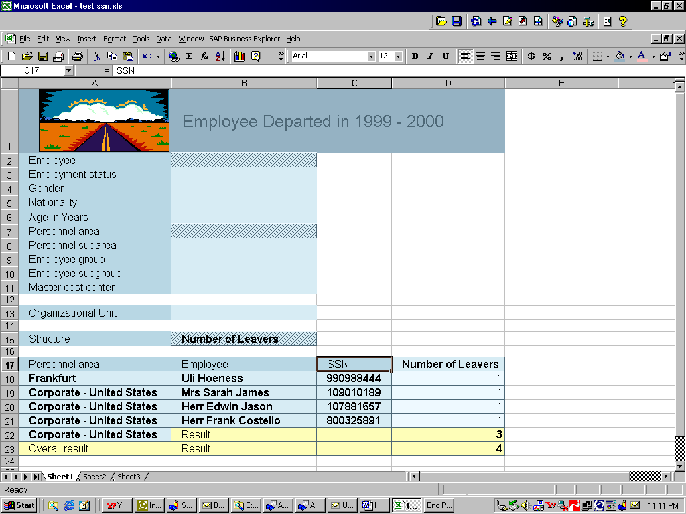

The Step By Step Solution

Determine the Source of Data Elements and which DataSource to extend.
Before you start the actual work to extending business contents, there are several special considerations and data source analysis to be done.

- First you research and determined the table that the data element(s) needed for SSN in R/3 system is in table PA0002. You logon to your R/3 system, use transaction SE11 to display PA0002 table as shown. Review the data structure, you also discovered that the PERID has the SSN, but the PERMO (a country modified) makes SSN unique. Hence, PERMO and PERID will be the source data elements. | 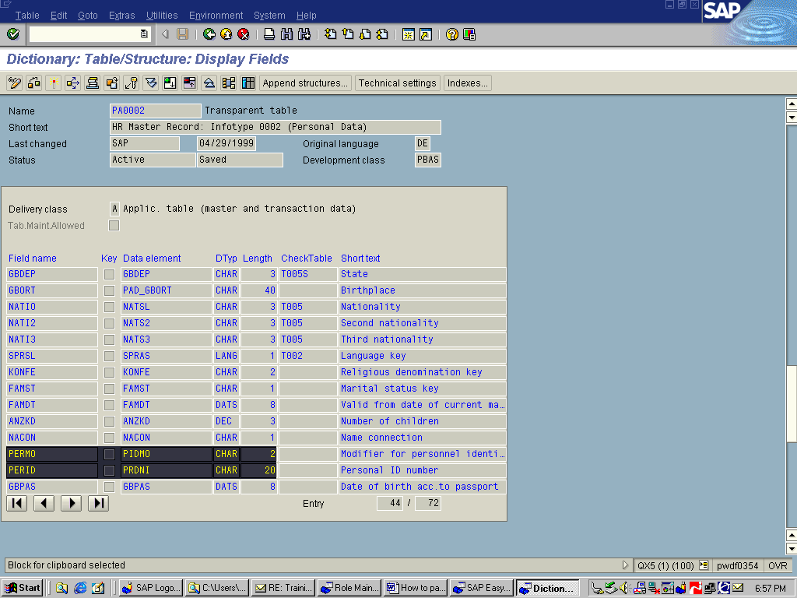
- Review SAP delivered HR Personnel Master Data; 0PERSON is the one consists the individual’s personal information, which is where SSN is most appropriate.

Extend 0PERSON_ATTR DataSource in R/3

- In R/3 system, Execute Transaction “SBIW”. Expand “Subsequent editing of Datasources” and execute “Edit DataSource”. | 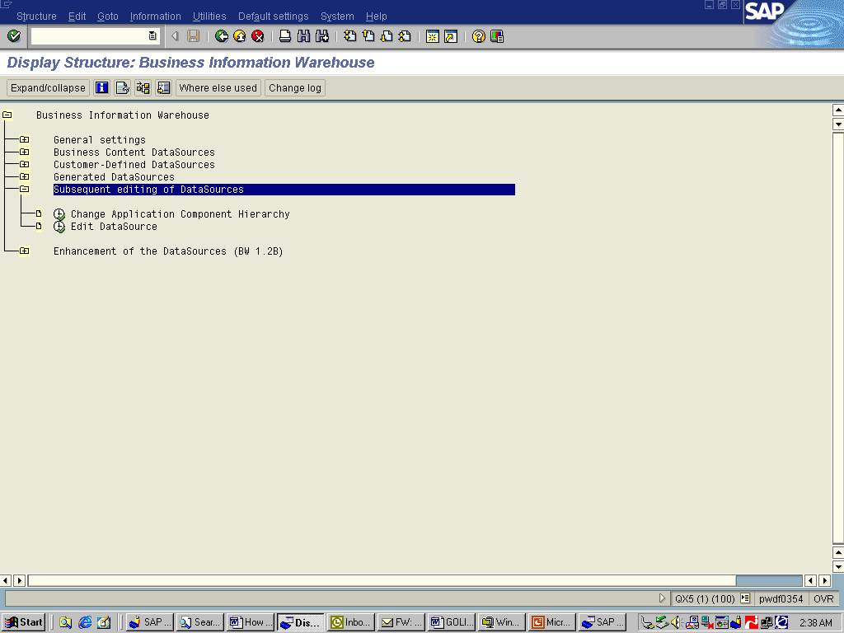
- Enter Application component “PA-PA-IO” (master data for Personnel Administration); execute and all available DataSources under PA-PA-IO will be displayed. Choose 0PERSON_ATTR and Click ‘Enhance Extract Structure’ push button on the menu bar. | 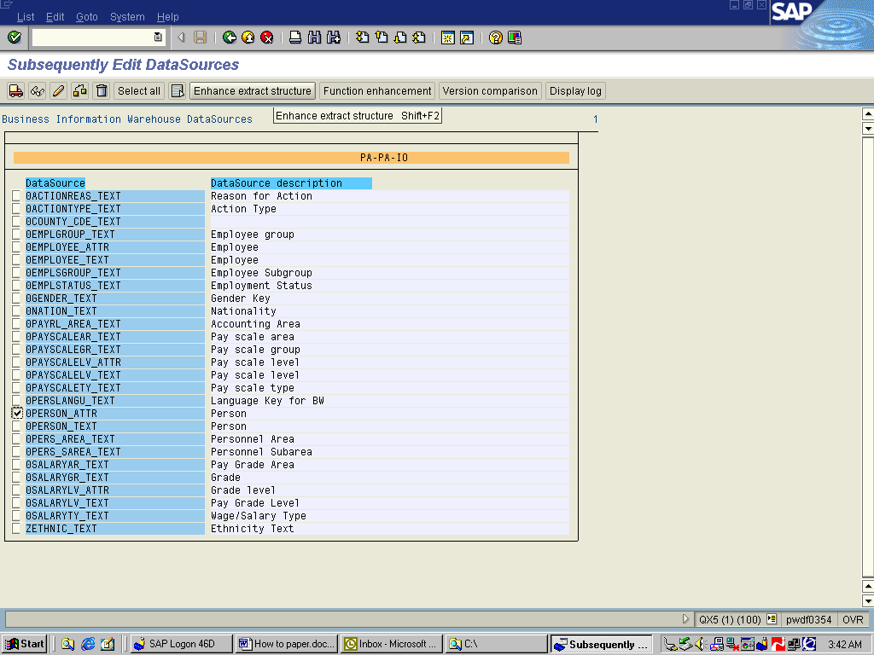
- A default structure with the name ‘ZAHRMS_BW_IO_PERSON’ will appear. Give a description and enter a field name with customer naming convention (such as begin with ZZ) and the technical name of data element names in PA0002 table. | 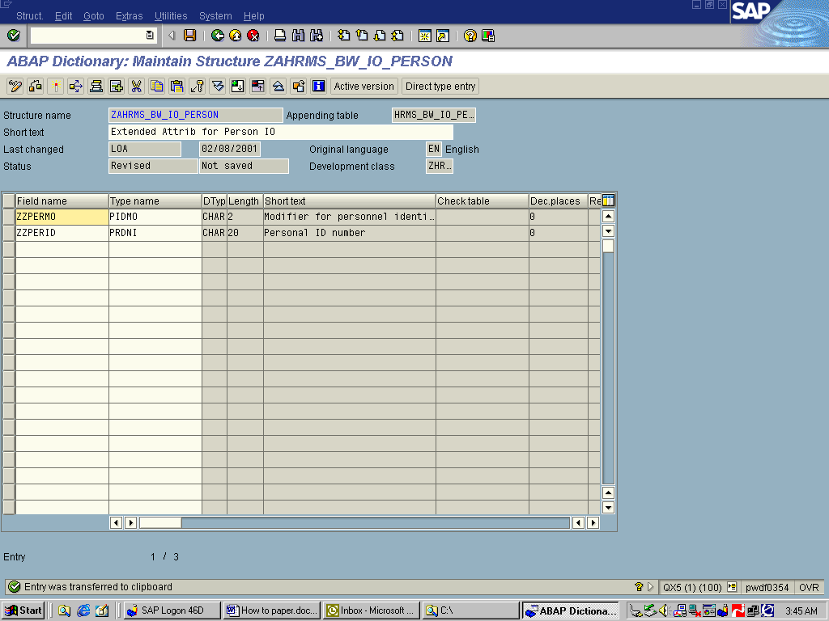
- Save and use a customer defined development class, such as ZBWP and create a BW enhancement transport.
- Back to SBIW screen; expand “Business Content Data Source”; execute “Transfer Business Content Data Source”; Select 0PERSON_ATTR under Pa-Pa-IO; click “Transfer DataSources” push button to activate the extended 0PERSON_ATTR data structure from R/3. Respond to transport request. | 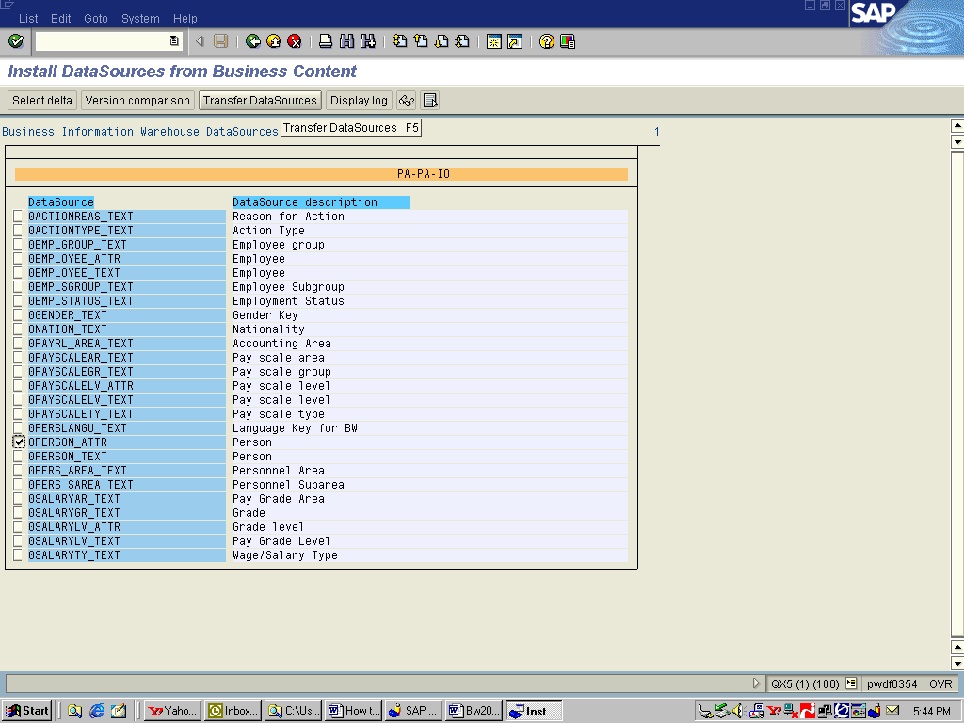

Develop Customer Exit code in R/3

- Return to “Subsequent editing of Datasources” screen and click the push button “Function Enhancement “ to obtain Project Management for SAP Enhancement (or use transaction CMOD) screen and give a project nameyou’re your installation standard, such as “BWHR” | 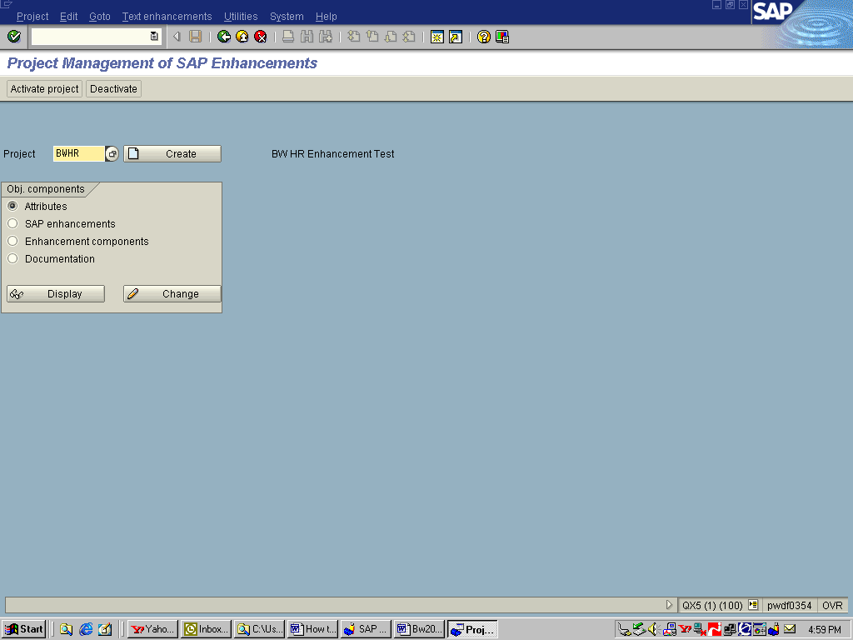
- Enter the attributes for the enhancement project “BWHR” then click “SAP Enhancement” push button. | 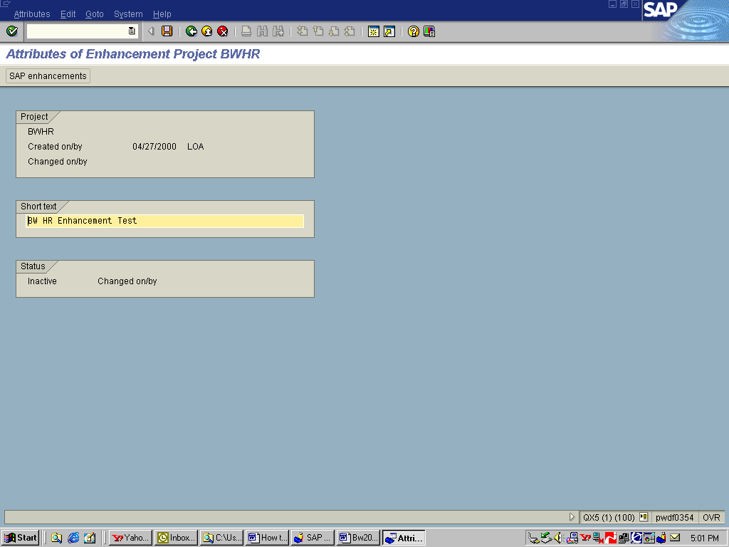
- Enter enhancement name RSAP0001 for BW extractor user exits. | 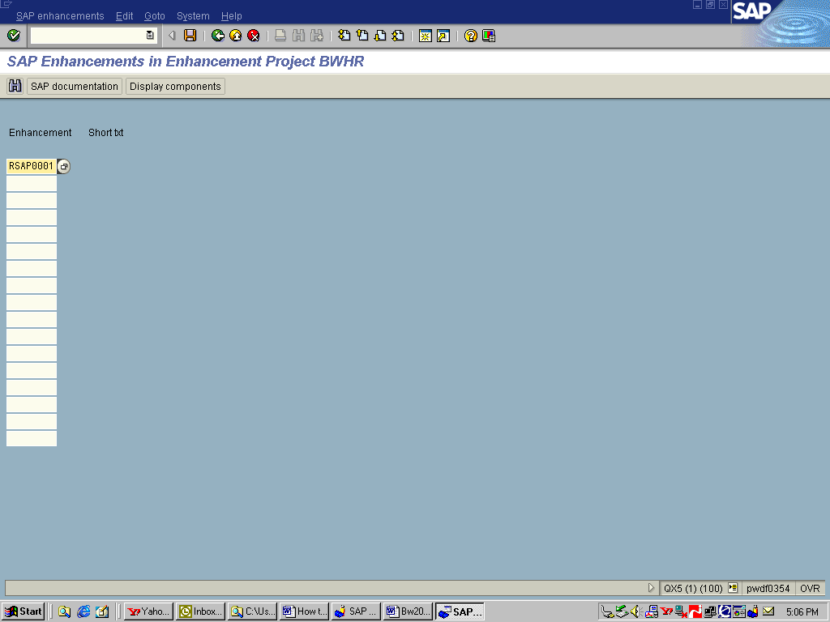
- Click “Display components” push button to display available user exits and highlight EXIT_SAPLRSAP_002 for master data user exit (function module) which consists an include for module ZXRSAU02 . | 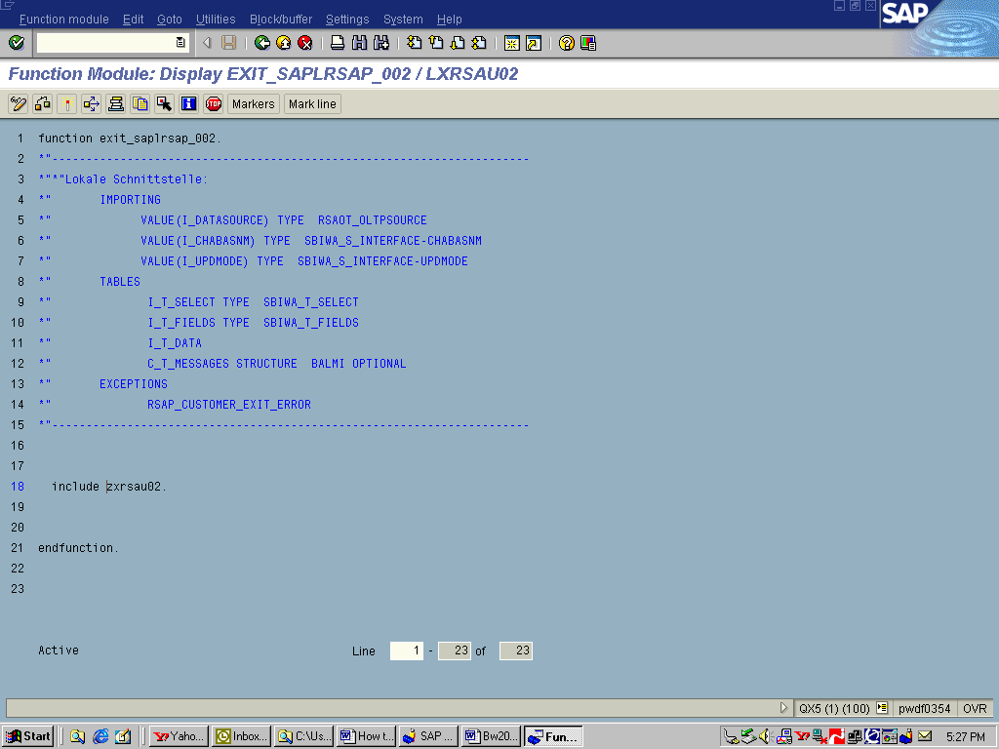
- Double click ZXRSAU02 to develop the code. Partial code shown in the example. For complete coding example, please refer to the Appendix. | 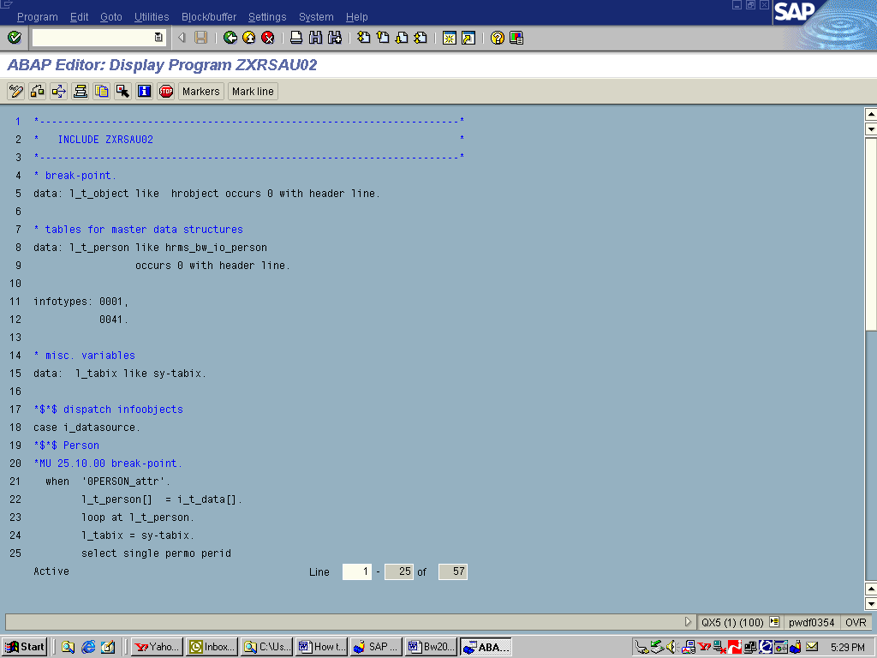
- Check and save the code; transport with your development class such as ZBWD; activate the functional module and your project. | 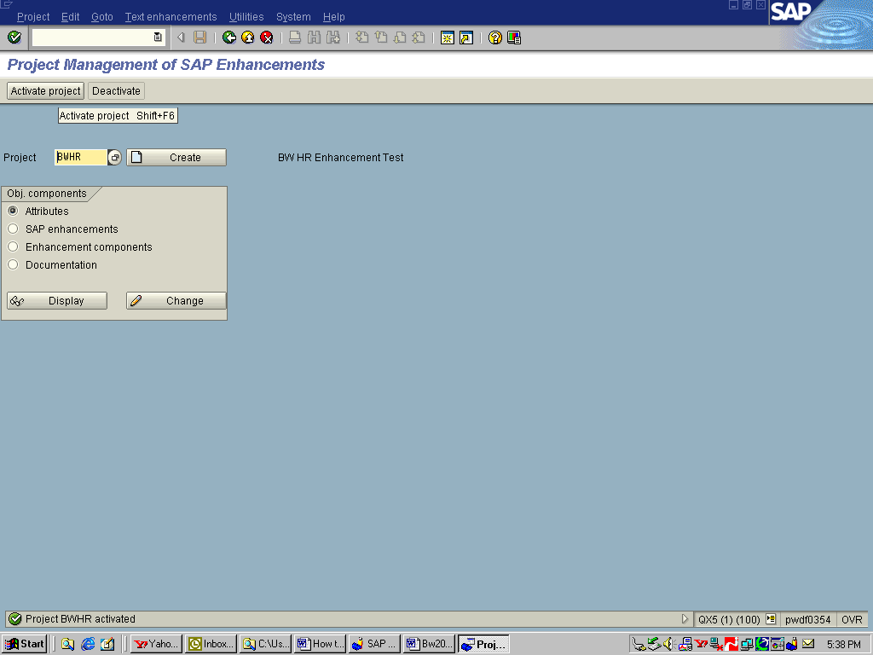

Activate Extended Business Content (SSN) in BW

- Logon to BW system -> Administrator Workbench -> Modeling -> InfoSource -> highlight your R/3 source system under 0PERSON_ATTR Infosource -> Right mouse click -> Select “Replicate DataSource” | 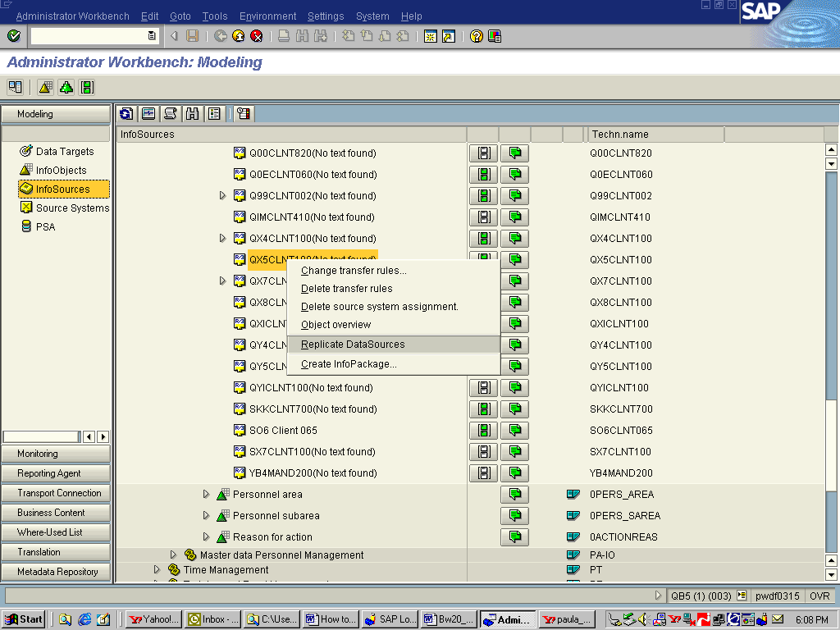
- In BW -> create new InfoObjects for ZPERMO (SSN modifier) as exclusive attribute only. | 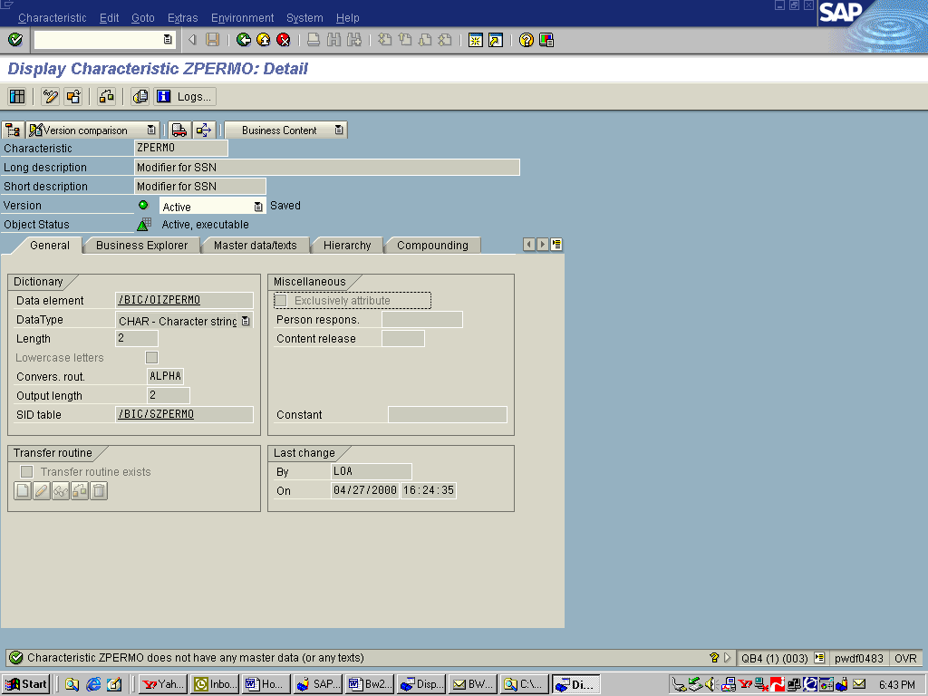
- Create New Infobject for ZSSN (social security number) as an exclusive attribute without text nor master data. This is because social security number will be used for display only and there’s no text data nor any attribute will associate with it. | 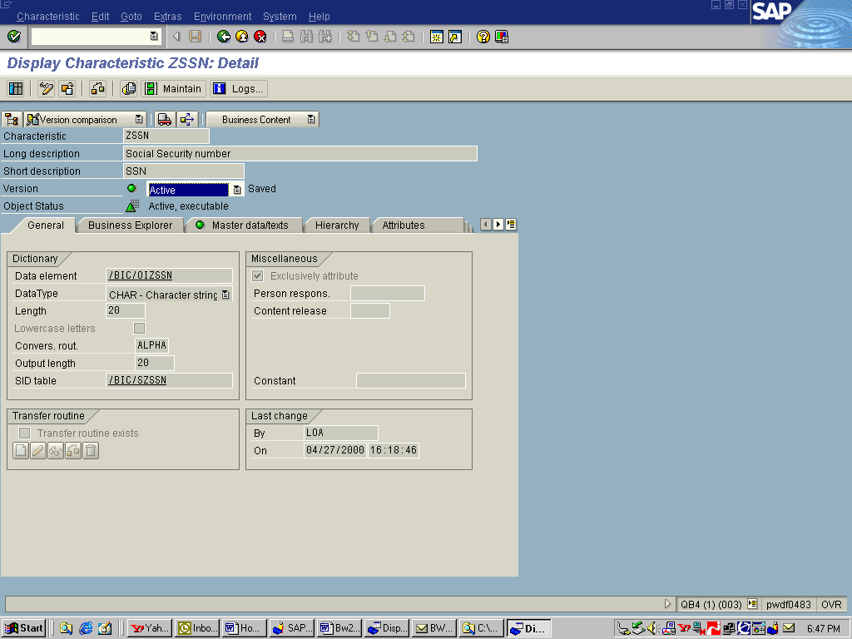
- Add these new InfoObjects as attributes to 0PERSON InfoObject; Check and Activate 0Person InfoObject. | 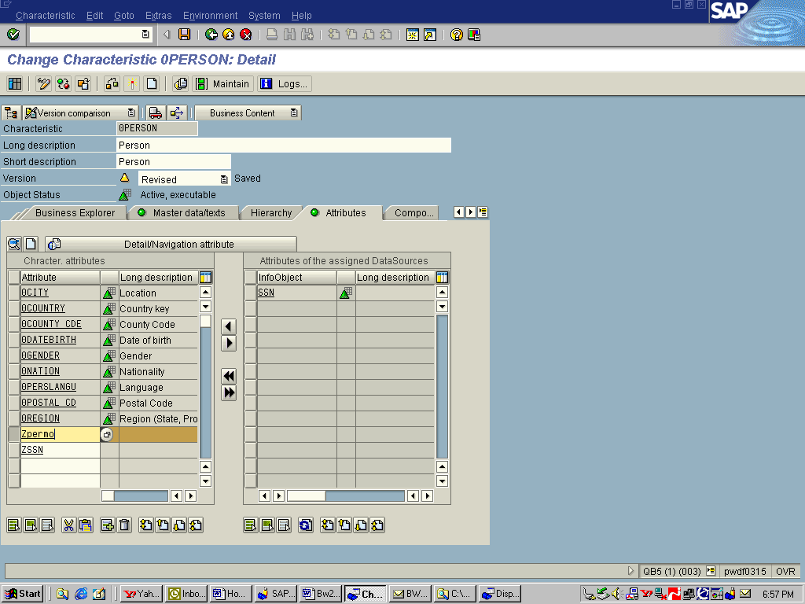
- Update Transfer rules of 0PERSON_ATTR; move the new InfoObjects from the DataSource (right pane) to the Transfer structure (left pane) by highlight and click the single left arrow in the middle of the screen. | 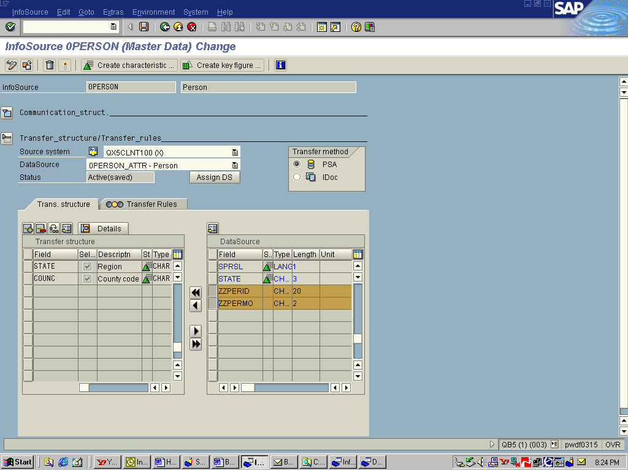
- Click the Transfer Rule tab and assign the InfoObjects to the transfer rules . You may either enter the InfoObject name or let the system making suggestion by data element name, domain name, field name or InfoObject name. | 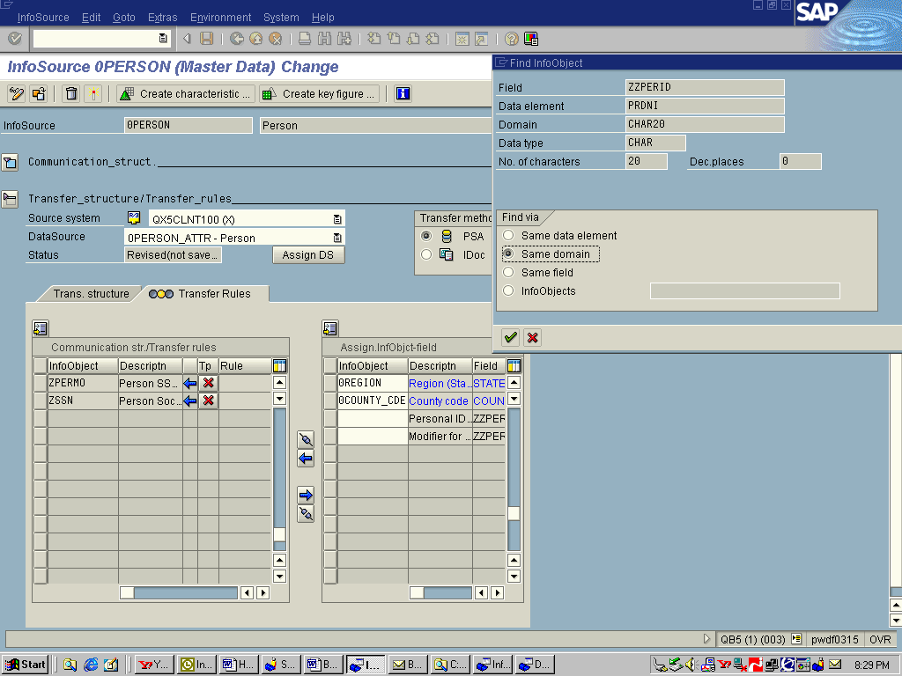
- Click “Propose transfer rule” in the middle of the screen; then Activate the 0PERSON_ATTR Transfer Structure. | 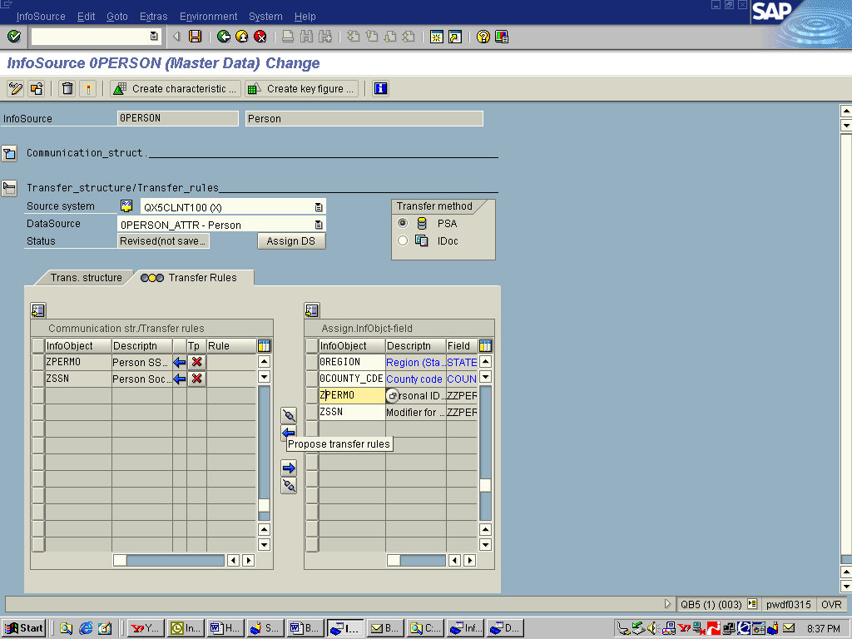
- Now you are ready to reload 0Person master data to populate the additional attributes and Activate the master data change via “Execute Hierarchy/Attribute Change for reporting” function. (Via AWB -> Tool menu option). | 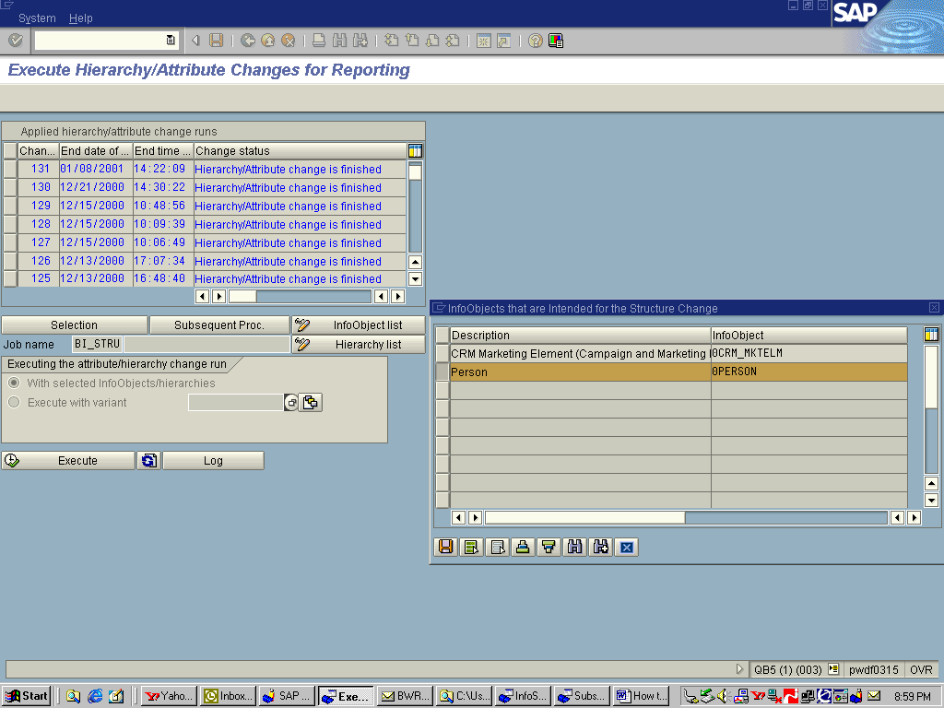

Appendix
*----------------------------------------------------------------------*
* INCLUDE ZXRSAU02 *
*----------------------------------------------------------------------*

DATA: L_T_OBJECT LIKE HROBJECT OCCURS 0 WITH HEADER LINE.

* tables for master data structures
DATA: L_T_PERSON LIKE HRMS_BW_IO_PERSON
OCCURS 0 WITH HEADER LINE.

INFOTYPES: 0001,
0002,
0041,
0077.

* misc. variables
DATA: L_TABIX LIKE SY-TABIX.

*$*$ dispatch InfoObjects
CASE I_DATASOURCE.
*$*$ Person
WHEN '0PERSON_ATTR'.
L_T_PERSON[] = I_T_DATA[].
LOOP AT L_T_PERSON.
L_TABIX = SY-TABIX.
SELECT SINGLE PERMO PERID
INTO (L_T_PERSON-ZZPERMO, L_T_PERSON-ZZPERID)
FROM PA0002
WHERE PERNR EQ L_T_PERSON-RFPNR
AND ENDDA GE L_T_PERSON-BEGDA
AND ENDDA LE L_T_PERSON-ENDDA.

SELECT SINGLE RACKY
INTO (L_T_PERSON-ZZRACKY)
FROM PA0077
WHERE PERNR EQ L_T_PERSON-RFPNR
AND ENDDA GE L_T_PERSON-BEGDA
AND ENDDA LE L_T_PERSON-ENDDA.
* determine 0country_id (molga)
SELECT SINGLE WERKS
INTO CORRESPONDING FIELDS OF P0001
FROM PA0001
WHERE PERNR EQ L_T_PERSON-RFPNR
AND ENDDA GE L_T_PERSON-BEGDA
AND ENDDA LE L_T_PERSON-ENDDA.
IF SY-SUBRC = 0.
SELECT SINGLE MOLGA INTO L_T_PERSON-ZZMOLGA
FROM T500P
WHERE PERSA = P0001-WERKS.
ENDIF.
* If 0country_id (molga) not found, default to country_code ‘99’
IF SY-SUBRC <> 0.
L_T_PERSON-ZZMOLGA = '99'.
ENDIF.
MODIFY L_T_PERSON INDEX L_TABIX.
ENDLOOP.
I_T_DATA[] = L_T_PERSON[].
ENDCASE.

