How to…

Check your BW system before Go-Live
Business Information Warehouse
ASAP “How to…” Paper
Applicable Releases: BW 2.0B, 2.1C
July 2001

Business Scenario
A customer is getting ready to Go-Live with their BW system. They would like to check the system to make sure that some important settings have been maintained.

The Result
Use the following checklist as a guide to check your BW system prior to going into production. This checklist is designed to give you an overview of some common settings that need to be maintained but are sometimes overlooked and is not inclusive. Several other sources of information are available including the BW ASAP Methodology, and Going Live checks performed by the TCC group.

The Step By Step Solution

- Transfer global settings. Goto Administrator Workbench -> Modeling -> Source Systems. Select an R/3 source system -> right-click and choose Transfer global settings. | 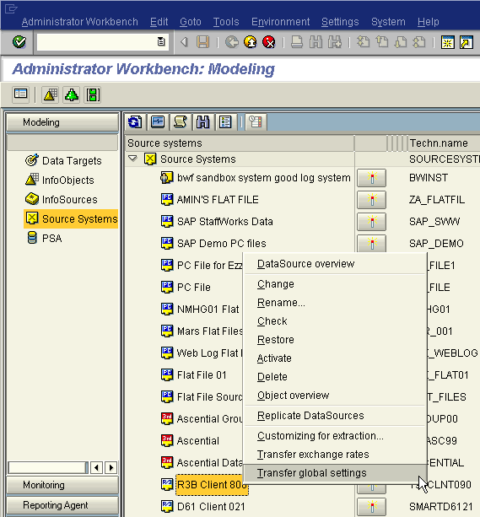
Select Currencies and choose a transfer mode.  Simulation - The transfer of Customizing tables/exchange rates is simulated. No data is updated.  Update tables - The Customizing tables/exchange rates are collected from the source system. The new entries are updated on the database.  Rebuild tables - The Customizing tables/exchange rates are collected from the source system. The tables are rebuilt, old data is deleted.  Then Execute.  Repeat these steps for Units of measurement, Fiscal year variants, and Factory calendar for each R/3 source system in BW. | 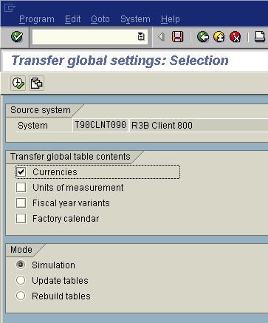
- Transfer exchange rates. Goto Administrator Workbench -> Modeling -> Source Systems. Select an R/3 source system -> right-click and choose Transfer exchange rates. | 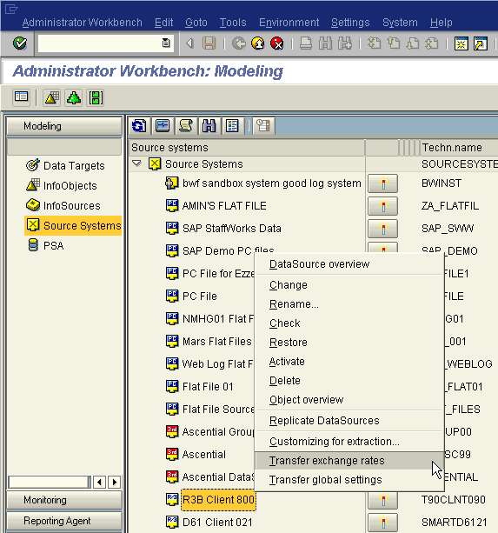
Maintain Exchange rates and the transfer mode.  Simulation - The transfer of Customizing tables/exchange rates is simulated. No data is updated.  Update exchange rates - The Customizing tables/exchange rates are collected from the source system. The new entries are updated on the database.  Transfer exchange rates again - The Customizing tables/exchange rates are collected from the source system. The tables are rebuilt, old data is deleted.  Then Execute.  Repeat these steps for each R/3 source system in BW. | 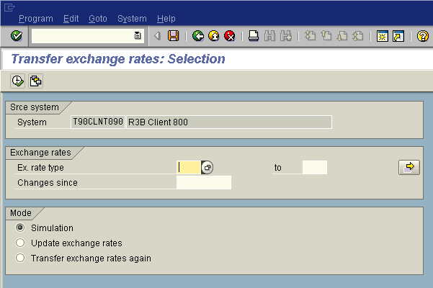
- Maintain the permitted extra characters. Goto -> SAP Easy Access Menu -> SAP menu -> BW Administration -> Permitted Characters. Another path is transaction SPRO -> SAP Reference IMG -> BW Customizing Implementation Guide -> Business Information Warehouse -> General BW Settings -> Maintain permitted extra characters, or use transaction RSKC. | 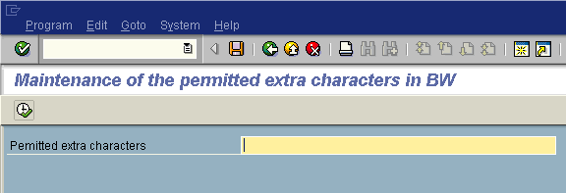
- Release the BW function modules that are required for web reporting. This step is for system security purposes and is done by your Technical Administrator. The function modules that must be released are listed to the right. | - WEBQUERY (for BEx web queries - WebRFC)  - RSBB_WWW_BROWSER_GATE (Browser)  - RSBB_WWW_BROWSER_TREE (Browser)  - RSBB_WWW_NODES_READ (Browser)  - RSBB_WWW_NODES_SEARCH (Browser)  - RSBB_WWW_TITLEBAR (Browser)  - WWW_ALV_CALL (InfoSet web queries)  - WWW_ALV_SELSCREEN (InfoSet web queries)  - FLOW_LOGIC_ALV_CALL (InfoSet web queries)
From the SAP Easy Access menu, choose SAP menu -> Tools -> Business Engineer -> BW Customizing – (transaction SPRO)-> SAP Reference IMG -> Business Information Warehouse -> Reporting-relevant Settings -> Web Reporting -> Releasing the Function Module for Web Reporting -> select Internet Release from the menu -> Function Modules. Release.  Note: The local web browser must be set to accept "per session" cookies; otherwise, the user will get "Invalid Session" error message when starting the BEx Browser for the Web. The local web browser must also support the execution of JavaScript. | 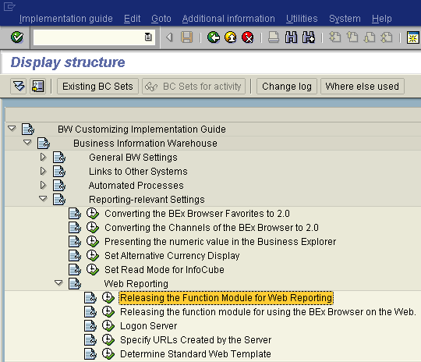
- Check the read mode for queries.
For a query, the OLAP processor can read the data from the fact table in one of three ways:
Reading all of the data
When executing the query in the Business Explorer all of the fact table data that is needed for all possible navigational steps in the query, is read in the main memory area of the OLAP processor. Therefore, all new navigational states are aggregated and calculated from the data of the main memory.
Reading the data on demand
The OLAP processor only requests the corresponding fact table data that is needed for each navigational state of the query in the Business Explorer. Therefore, new data is read for each navigational step. The most suitable aggregate table is used and, if possible, already aggregated on the database. The data for identical navigational states are buffered in the OLAP processor.
Reading on demand when expanding the hierarchy
When reading data on demand (2), the data for the entire - meaning completely expanded - hierarchy is requested for a hierarchy drilldown. For the read on demand when expanding the hierarchy (3), the data is aggregated by the database along the hierarchy and is sent to the start level of the hierarchy (highest node) in the OLAP processor. When expanding a hierarchy node, the children of the node are then respectively read on demand.
In general, the reading of data on demand (2) provides much better performance than reading all the data (1). This read mode should especially be considered for queries with many, free characteristics. A query that contains two or more free characteristics from different dimensions (e.g. 'Customer' and 'Product'), will probably only be efficiently executable in this mode, as the aggregates can only be optimally used when reading the data on demand.
For large hierarchies, aggregates should be created on the middle level of the hierarchy and the start level of the query should be smaller or the same as this aggregate level. For queries about such large hierarchies, the read on demand when expanding the hierarchy method (3) should be set.

Execute transaction RSRT and enter =RMRP into the OK field. After choosing Return, the read mode of your queries is the read mode recommended by SAP. | 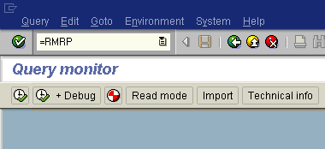
- Switch off all system traces. Execute transaction ST01. Trace status should be set to “Trace switched off”. | 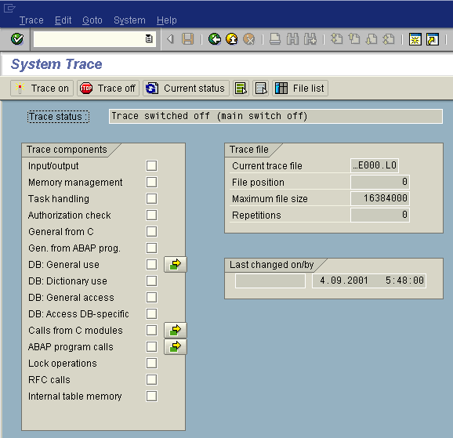
Check trace tool. Goto transaction RSRTRACE. Verify there are no users activated for logging. Users can be removed by selecting the User -> select Deactivate user. | 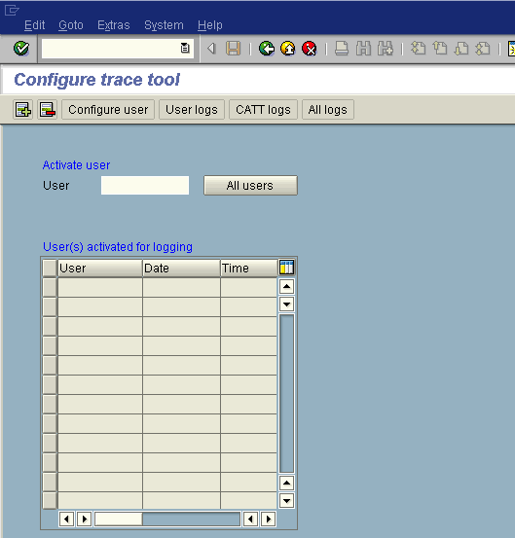
Check BW Reporting Authorization Check Log. Goto transaction RSSM -> Authorizaton Check Log. Select a user to remove -> Remove User from List. | 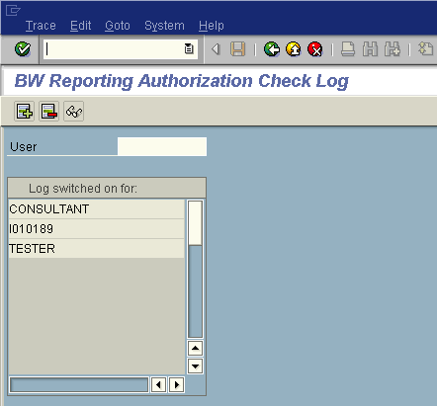
- Check number ranges for aggregates. | When you activate an aggregate, a number is generated from number range object RSDDAGCUBE. When you first activate the aggregate, this number range has no interval assigned. If you activate the aggregate manually, the interval is created. The activation process in the after-import method after the transport is generally executed in client '000'. For technical reasons it is not possible to create a number range interval in a client other than the BW client.
Execute program RSDDK_AGGR_CREATE_INTERVAL_20B in transaction SA38.  Otherwise, you must either manually activate the first aggregate in a new system or you must create an interval for the number range object in Number Range Object Maintenance (Transaction SNUM). The range must be defined as follows:  No = '01'; From number = '100000'; To number = '199999'; Current number ='0'.  Note that you must create the interval in the client in which the BW is operating. | 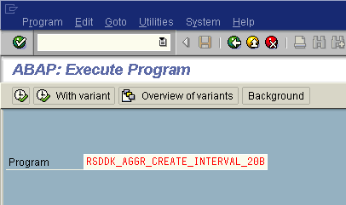
Check Indexes and DB statistics for each InfoCube. Goto transaction RSA11 -> select an InfoCube -> right-click and choose Manage -> select Performance tab. Indices can be deleted before the load process by using Delete indexes and recreated after the loading is finished with Repair indexes. This accelerates the data loading. However, simultaneous read processes to a cube are negatively influenced as they slow down dramatically. Therefore, this method should only be used if no read processes take place during the data loading. Statistics information can be automatically updated after the load process is finished following the same process used for indices. This is generally recommended. Only if very little data is loaded (in comparison to the quantity of that which already exists), then this option should be avoided. These processes should be run automatically on a scheduled basis. | 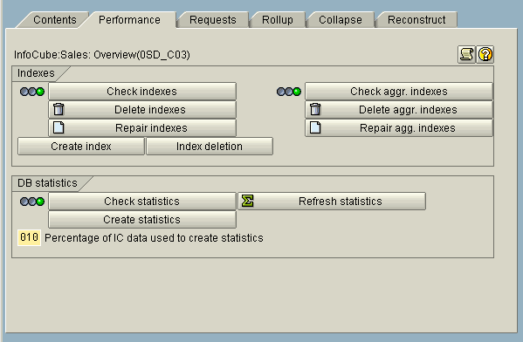
- Maintain the extraction settings for each source system. In R/3 source system goto transaction SBIW -> General Settings -> Maintain Control Parameters for Data Transfer. | 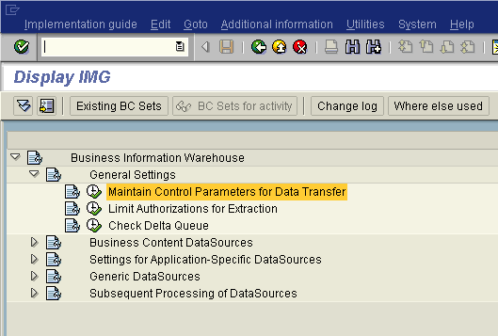  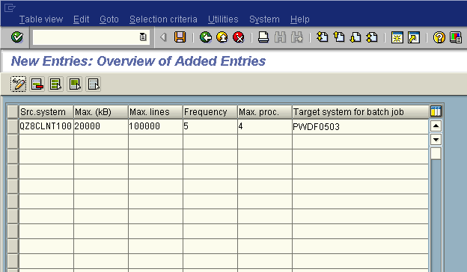
1. Source System  Enter the logical system of your source client and assign the control parameters you selected to it.  You can find further information on the source client in the source system by choosing the transaction SCC4. | 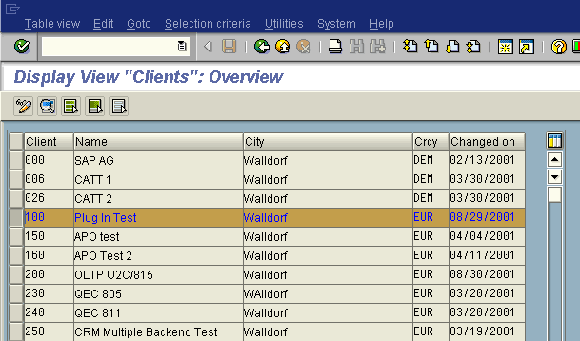  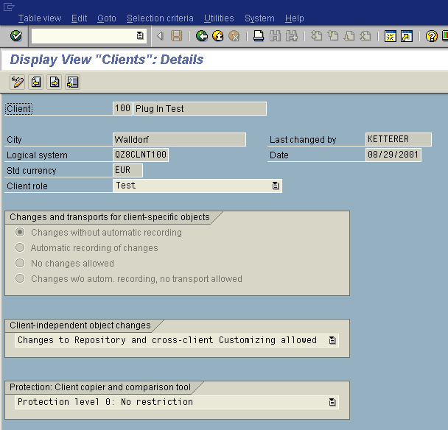
2. Maximum Size of the Data Packet
When you transfer data into BW, the individual data records are sent in packets of variable size. You can use these parameters to control how large a typical data packet like this is. If no entry was maintained then the data is transferred with a default setting of 10,000 kBytes per data packet. The memory requirement not only depends on the settings of the data packet, but also on the size of the transfer structure and the memory requirement of the relevant extractor.

3. Maximum Number of Lines in a Data Packet.
Upper-limit for the number of records per data packet.
The default setting is 'Max. lines' = 100000.
The maximum main memory space requirement per data packet is around
memory requirement = 2 * 'Max. lines' * 1000 Byte, meaning 200 MByte with the default setting.

4. Frequency
The specified frequency determines the number of IDocs that an Info IDoc is to be sent to, or how many data IDocs an Info Idoc describes.
Frequency 1 is set by default. This means that an Info Idoc follows every data Idoc. In general, you should select a frequency between 5 and 10 but no higher than 20. The bigger the data IDoc packet, the lower the frequency setting should be. In this way, when you upload you can obtain information on the respective data loading in relatively short spaces of time.
With the help of every Info IDoc, you can check the BW monitor to see if there are any errors in the loading process. If there are none, then the traffic light in the monitor will be green. The Info IDocs contain information such as whether the respective data IDocs were uploaded correctly.
5. Maximum number of parallel processes for the data transfer.  An entry in this field is only relevant from release 3.1I onwards. Enter a number larger than 0. The maximum number of parallel processes is set by default at 2. The ideal parameter selection depends on the configuration of the application server, which you use for transferring data. Goto transaction OS06 and use Count value as a maximum. | 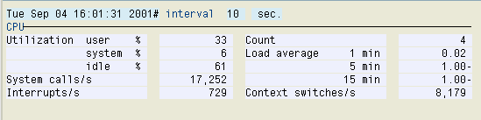
6. Batch job target system  Enter the name of the application server on which the extraction job is to be processed. To determine the name of the application server, choose Tools -> Administration -> Monitor -> System monitoring -> Server. The name of the application server is displayed in the column Host name. | 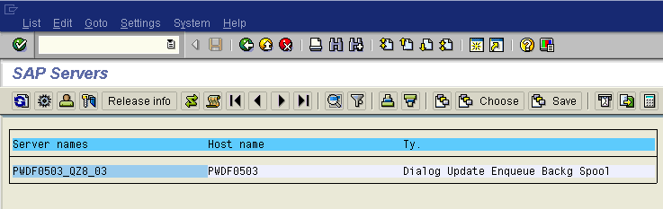
Save the entry.
- Maintain the Flat File source system settings. In BW, goto transaction SPRO -> SAP Reference IMG -> Business Information Warehouse -> Links to Other Systems -> Maintain Control Parameters for the data transfer.  1. Maximum size of data packets  For data transfer into BW, the individual data records are sent in packets of variable size. You use these parameters to control how large such a data packet typically is. If no entry is maintained, the data is transferred with a standard setting of 10,000 kbyte per data packet. The memory requirement depends not only on the setting for data packet size, but also on the width of the transfer structure, and the memory requirement of the relevant extractor.  2. Frequency  With the specified frequency, you detemine after how many data IDocs an Info IDoc is sent, or how many data IDocs are described by an Info IDoc.  The frequency is set to 1 by default. This means that an Info IDoc follows every data IDoc. Generally, choose a frequency of between 5 and 10, but not greater than 20.  The larger the packet size of a data IDoc, the lower you must set the frequency. In this way you ensure that, when loading data, you receive information on the current data load status at relatively short intervals.  In the BW Monitor you can use each Info IDoc to see whether the loading process is running without errors. If this is the case for all the data IDocs in an Info IDoc, then the traffic light in the Monitor is green. One of the things the Info IDocs contain information on, is whether the current data IDocs have been loaded correctly.  Save the settings. | 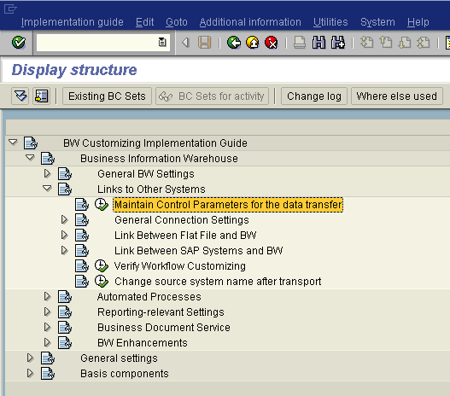  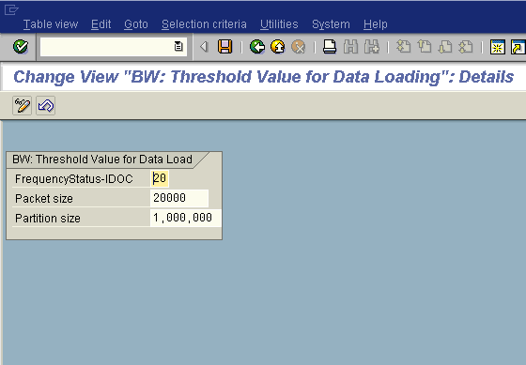
- Schedule the realignment run to be executed periodically. In BW, goto Tools -> Apply Hierarchy/Attribute Change... | 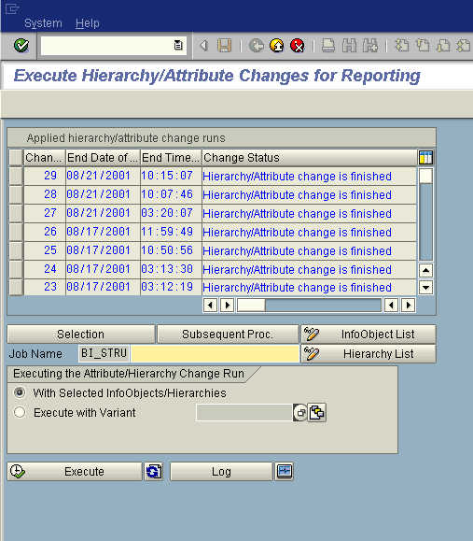
Choose Selection and then maintain the start time. Select Save. | 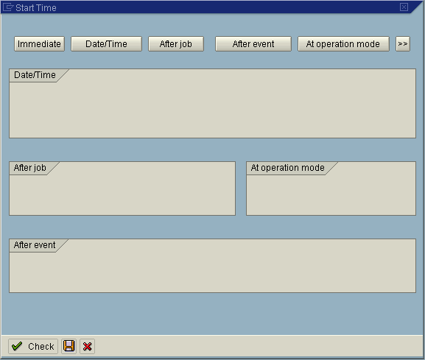
A variant can also be set up. Select maintain variant icon.  Enter a variant and select Create. | 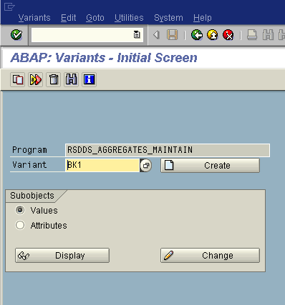
Maintain the parameters. Select Enter. Choose the Selection icon to schedule. | 