How to…

use BADIs (Business Add-Ins) for subsequent processing in BW Data Staging
Business Information Warehouse
ASAP “How to…” Paper
Applicable Releases: 2.1C
January 2002

Business Scenario
When executing data loads into BW, you often want to trigger subsequent processes automatically. Those subsequent processes could include standard processes related to data staging (like aggregate roll-up, infocube compression, ODS content activation or the rebuild of indices). However, there also could be other subsequent processes, which are typically not part of the standard load process (like the transmission of internet e-mails, or the execution of custom ABAP/4 reports).
This document describes a general-purpose interface, which gives you full flexibility over the execution of processes, triggered by the data extraction into BW.
In the appendix also some sample ABAP Objects coding is listed, which can be used to execute an SAP Office mail via the BADI.

Introduction
For subsequent processing in data staging in BW, there are 3 basic options available:
- Trigger of events, which can be picked up by other programs / processes / event chains.
- Call-up of a function module, supplied by SAP (this feature was implemented originally for BW1.2, however should not be used anymore moving forward).
- Trigger of a Business Add-In (BADI).
This step-by-step guide explains the required steps to implement, test and troubleshoot the BADI implementation.
Although the implementation of the BADI is fairly easy, you should have some knowledge and experience in the following areas:
- BW scheduling and administration
- Business Add-Ins (see for example Online Documentation: Basis >> Changing the SAP Standard >> Business Add-Ins)
- ABAP/4 programming (ideally some ABAP Objects programming)
- ABAP/4 debugger

Finally, also note that (while the upgradebility of the BADI interface is supported by SAP), like always when you perform custom development, SAP cannot guarantee the correctness and upgradebility of your coding. Hence, before indulging into extensive Add-In development, it is highly recommended to first analyze the business needs, and to weight them against the potential risks. Also, make sure that you familiarize yourself first with the standard BW functionality – you might actually not need to use the BADIs, in many situations. Also please note, with BW Rel. 3.0 SAP started to ship Process Chains, which might further reduce the demand for BADIs.

The Step By Step Solution
The following steps describe the implementation and usage of BADIs. The first chapter describes the implementation, while the second chapter is dedicated to the debugging of the BADI implementation.

Enable the usage of BADIs for subsequent processing

- Maintain an InfoPackage, (which you must have created for your BW staging scenario). Push the button “Subsequent Process.”. | 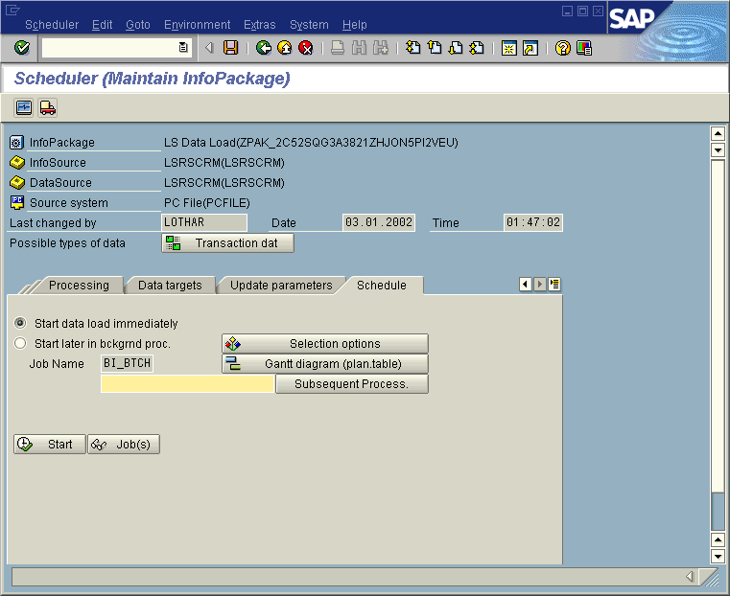
- On the pop-up screen, check the method “Execute Business Add-In…”, and then push “Enter”. | 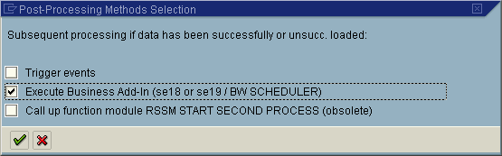
- Once you are back to the scheduler screen, you will note the green checkmark on the “Subsequent Process.” Box, indicating that you have in fact selected some subsequent processing method. Make sure to save your work in the scheduler. | 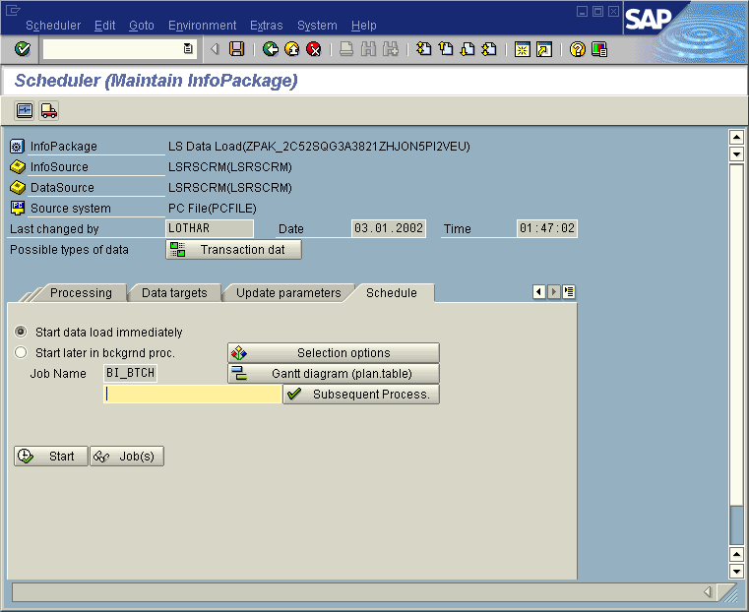

Maintain and activate a BADI implementation

- You can access the required SAP BADI definition either via transaction SE18, or via the menu as indicated on the right (SAP menu >> Tools >> ABAP Workbench >> Utilities >> Business Add-Ins >> Definition). | 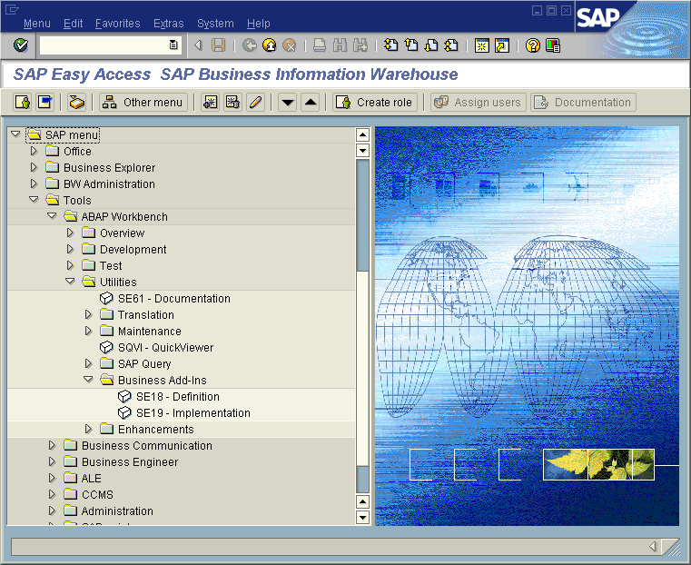
- The BADI definition, that you want to use here, is an SAP defined definition. It is called “BW_Scheduler”. Enter this definition name, and then push “Display”. | 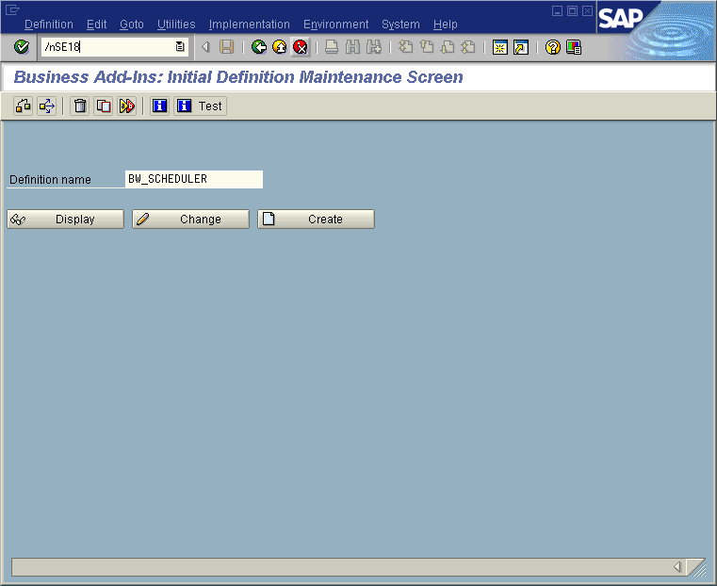
- On this screen, you will see some general properties of the BADI. From here, push the button “Interface”. | 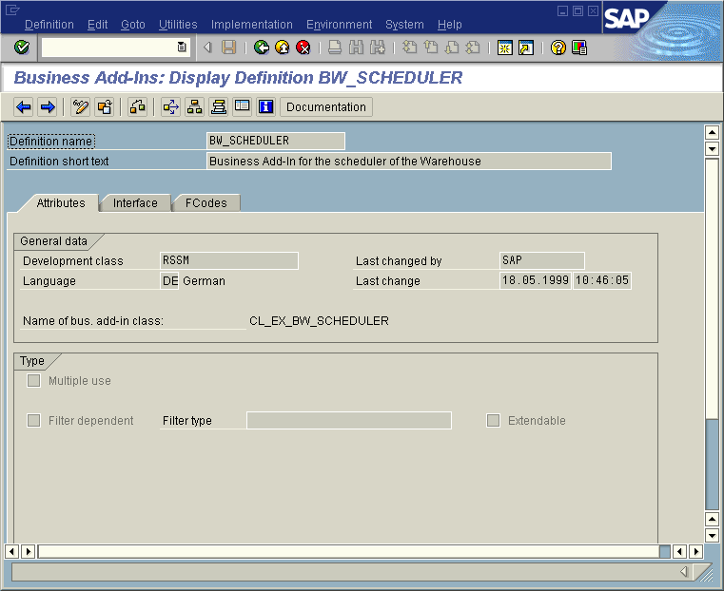
- You will see, that the pre-defined interface is called IF_EX_BW_SCHEDULER. There is a method associated with this interface, called USER_EXIT. Here, double-click on the method description. | 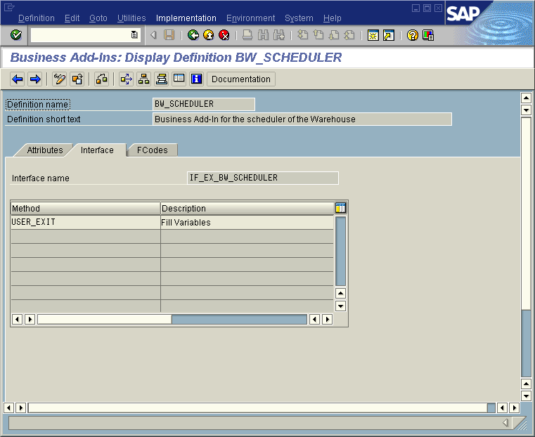
- Double-click will take you to the interface description. The user exit offers the following import parameters (see also OSS note 137991):  - RNR:  The request number of the load process.  - TSTATUS:  Status (Icon_green_light for exited successfully or Icon_red_light for exited incorrectly or SPACE for InfoPackgegroup exited without check).  - SOURCE:  The name of the InfoSource, for which data was loaded.  - OLTPSOURCE:  The name of the DataSource.  - LOGSYS:  The name of the logical system ID (source system), from which data was loaded.  - TYP:  Type of data (D=transaction data, M=master data, attributes, T=texts, H=hierarchies).  - GNR:  Group request number (only filled, if function module is called at the end an InfoPackage Group).  - WRITE_TO_ODS:  ’X’, if an ODS is updated (not filled in case of InfoPackage Group). .  - WRITE_TO_CUBE:  ’X’, if an InfoCube is updated (not filled in case of InfoPackage Group).  - GROUP_CALL:  ’X’, if funtion module is called by an InfoPackage Group (otherwise SPACE). | 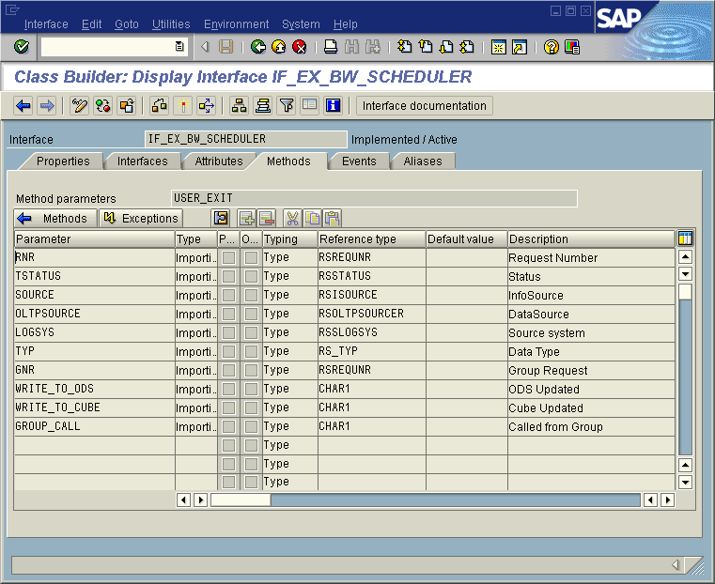
- As a next step, you will need to create a so-called Implementation for your BADI. Implementations can be accessed via transaction SE19, or directly from the menu (from the main screen of the BADI definition) via “Implementation”. | 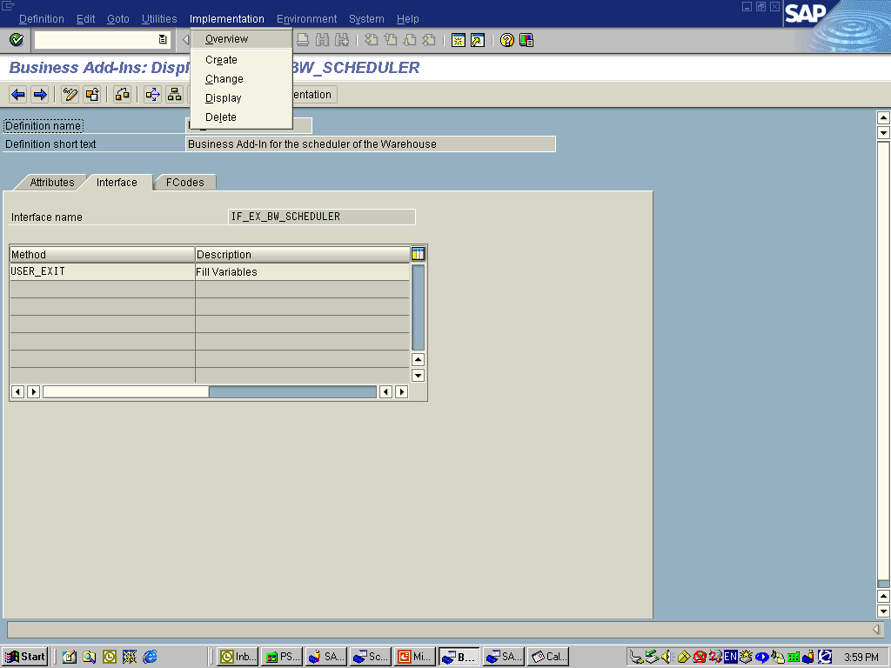
- If you choose “Display” or “Change”, you will receive an error message, in case that there is no Implementation defined yet. | 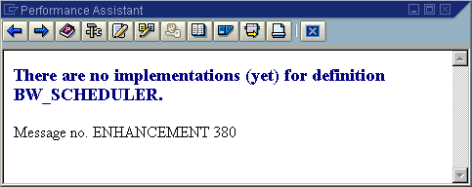
- Via “Implementation >> Create”, you can create a new Implementation. Make sure to follow the naming convention for development objects (i.e. the technical name must start with the letter “Z”). | 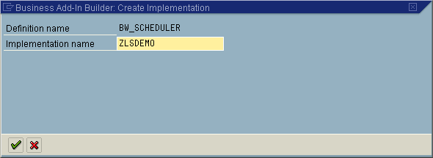
- On the next screen for the Implementation (property screen), enter a long description. | 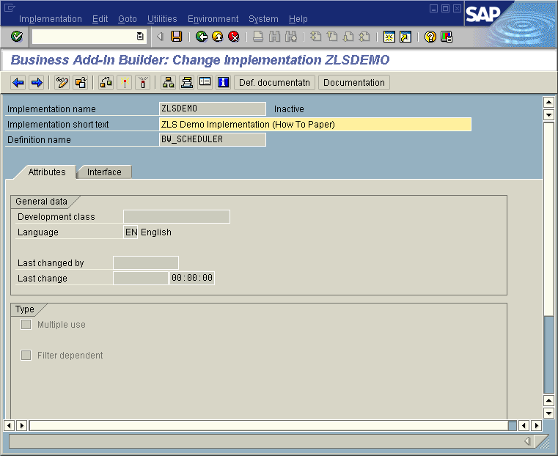
- Once you save your new Implementation, you will be prompted for a development class (as well as for a development request). Follow here the usual procedure for development class / request input. | 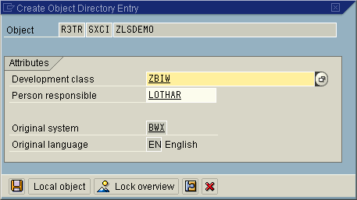
- Also, you will be required to register as a developer, if you have not done so yet. Again, here follow the usual standard procedure. | 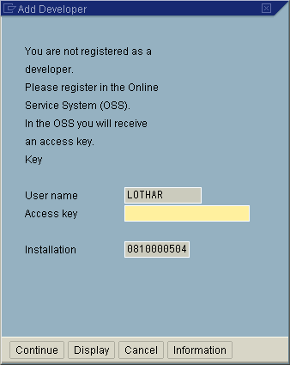
- Once you have saved your Implementation, you are back to the properties screen. Double-click on the method “User_EXIT”. | 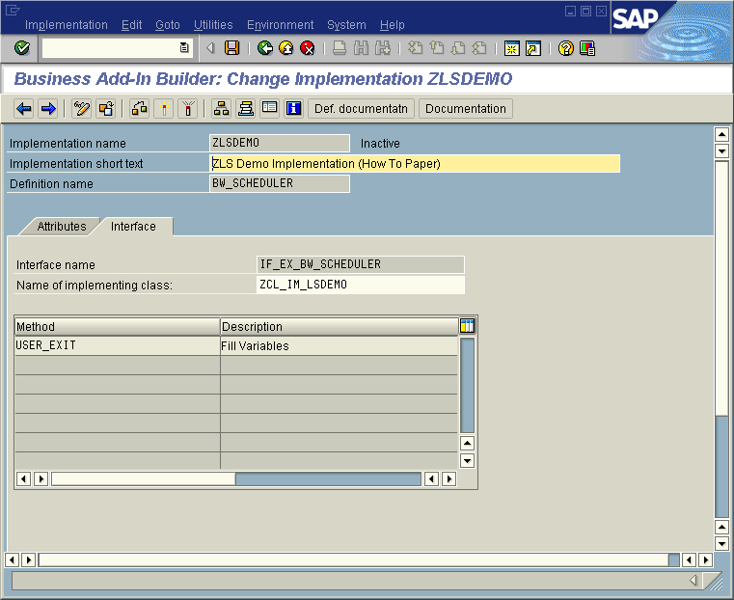
- Double-click will take you to the ABAP Objects Editor. Here, enter your custom coding (see next screens, and appendix, for examples). | 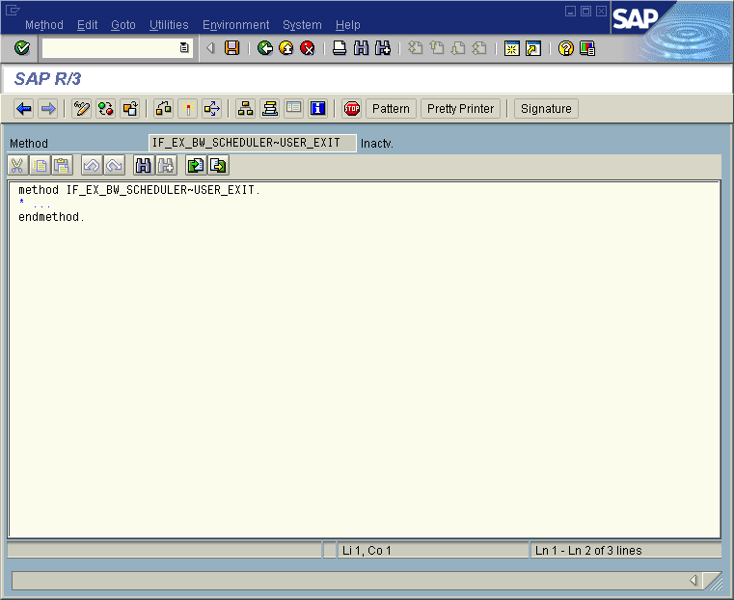
- By pushing the button “Signature”, you will get a listing of the interface parameters, as described above. | 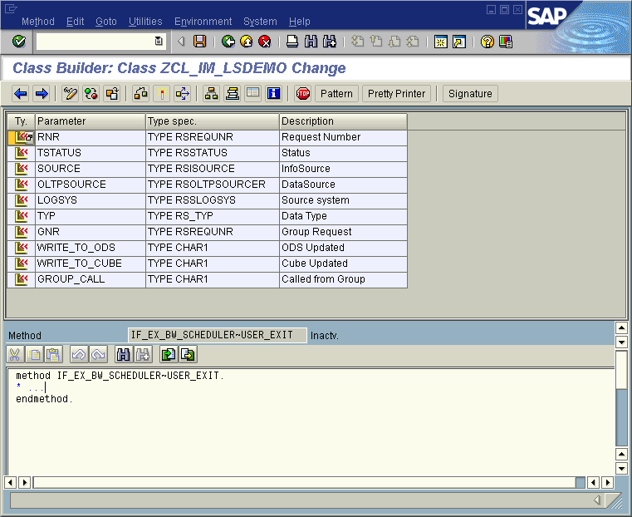
- Please see on the right, for a coding example. This sample coding is not much of practical use – however it’s a great coding for getting started.  Basically, first it discriminates on your User-ID (to make sure that no other user is affected). Then, an endless loop is programmed, which will help you to debug (and further understand) the coding. | 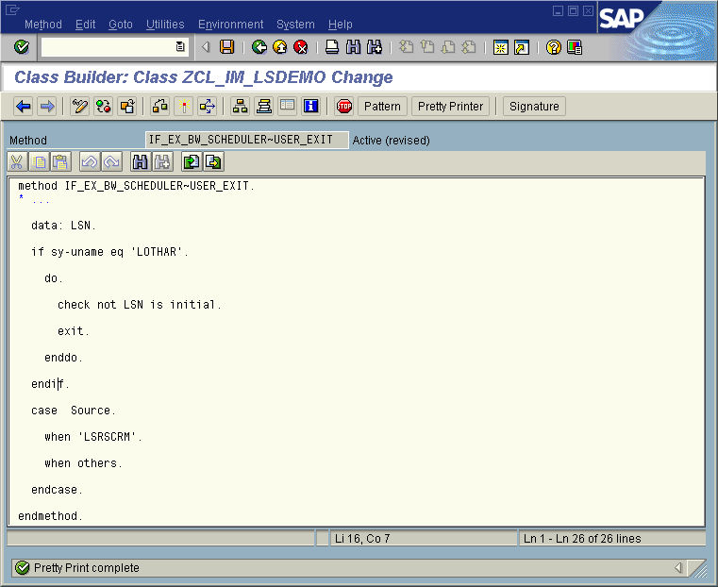
- Activate your coding, using the activation icon; make sure to select all the relevant objects. | 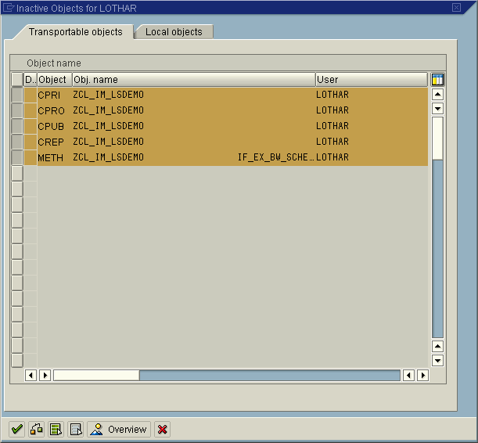
- Once you are back to the BADI definition screen… | 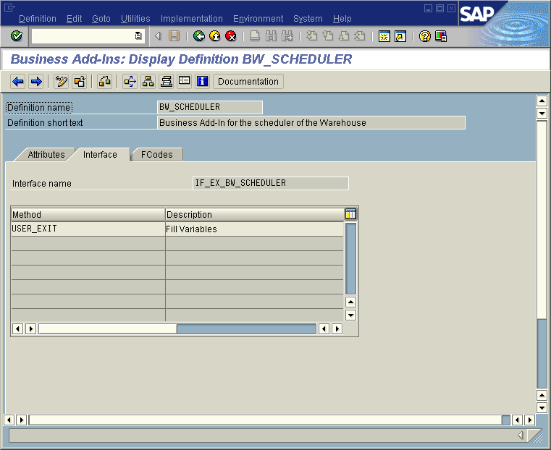
- … you can select your new Implementation, from the menu via “Implementation >> Change”. | 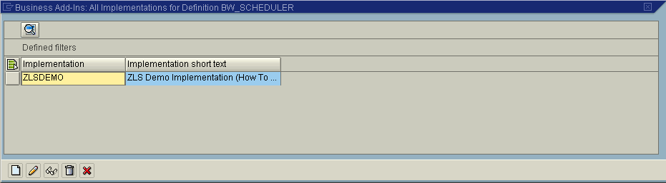
- Now you need to activate the Implementation itself, via the Activation Icon. (In case that you already have a competing Implementation for this BADI active, you will get the message on the right. In this case, make sure to first de-activate the competing Implementation, as there can be only one Implementation active at a time). | 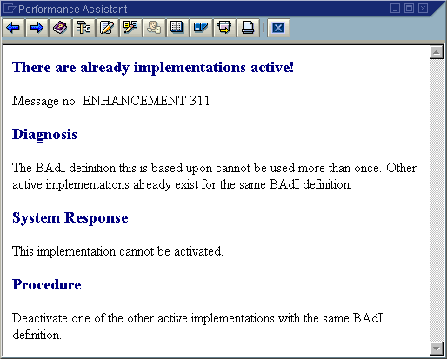
- Once you have activated the Implementation, this will be indicated via the status message “Active” on the right of the technical name. | 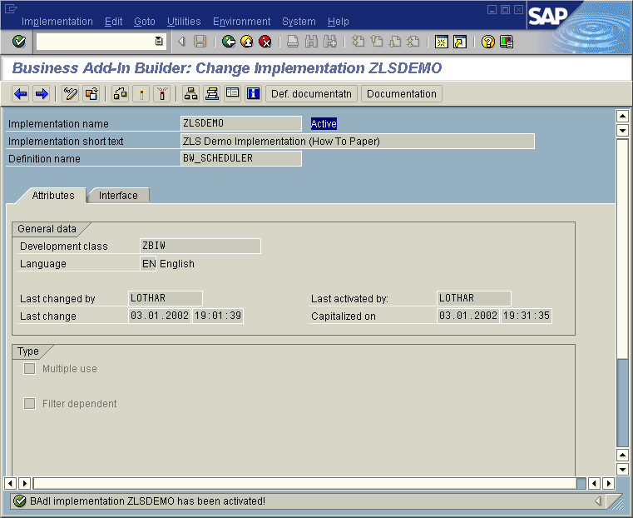

Execute and debug the BADI

- Now it is the time to test your developments. Go back to the scheduler (InfoPackage), and execute the relevant extraction (of course, with option “Subsequent Process” still activated). | 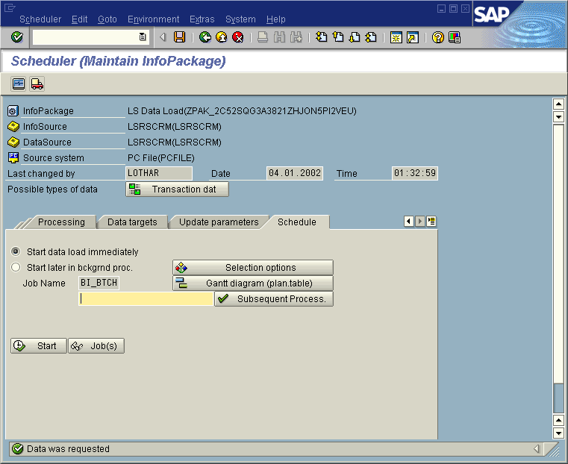
- In transaction ‘SM50’ (Process Overview) you can monitor the extraction load. Specifically, you will recognize when the data extract has entered your custom logic (in form of an endless loop), in program ZCL_IM_LSD. | 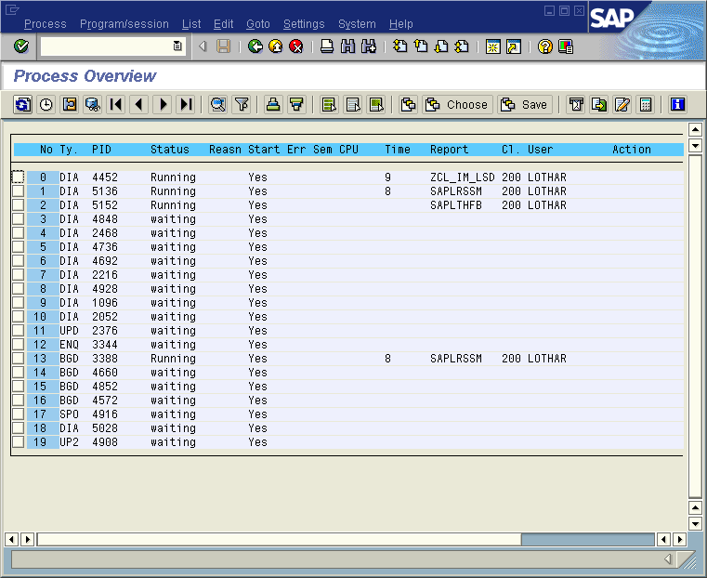
- Click on the relevant work-process, then choose from the menu ‘Program/session >> Program >> Debugging’. There will be a pop-up, and you will have to confirm that you really want to debug. | 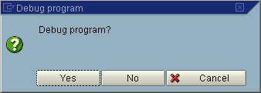
- The debugger will take you to the endless-loop that you programmed before. | 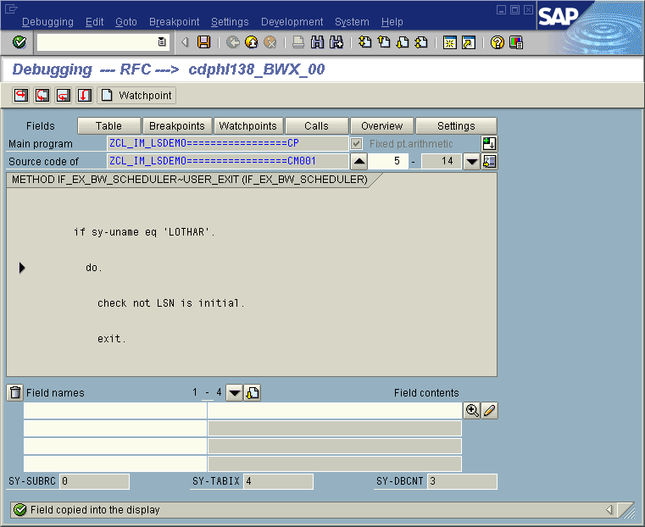
- Now in the debugger, change the field value of the variable “LSN’ to ‘X’. This will allow you to leave the endless-loop. From there, you may keep on debugging. | 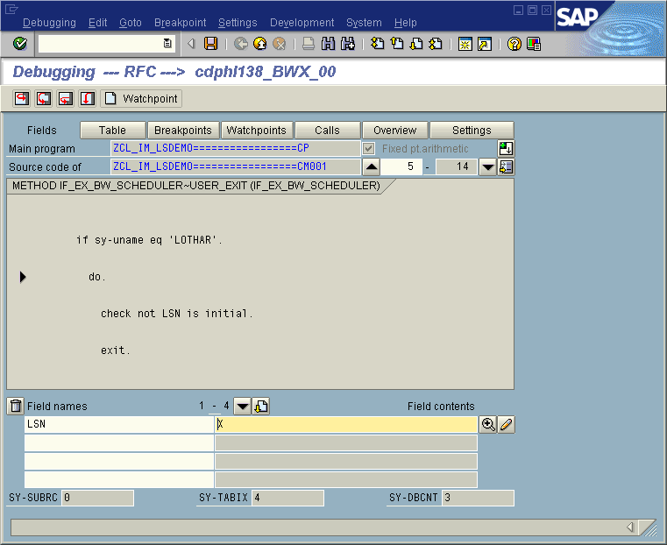
- A few steps further down, you will be taken to the interface of the user-exit of the BADI. Here you can check the interface values of the BADI. | 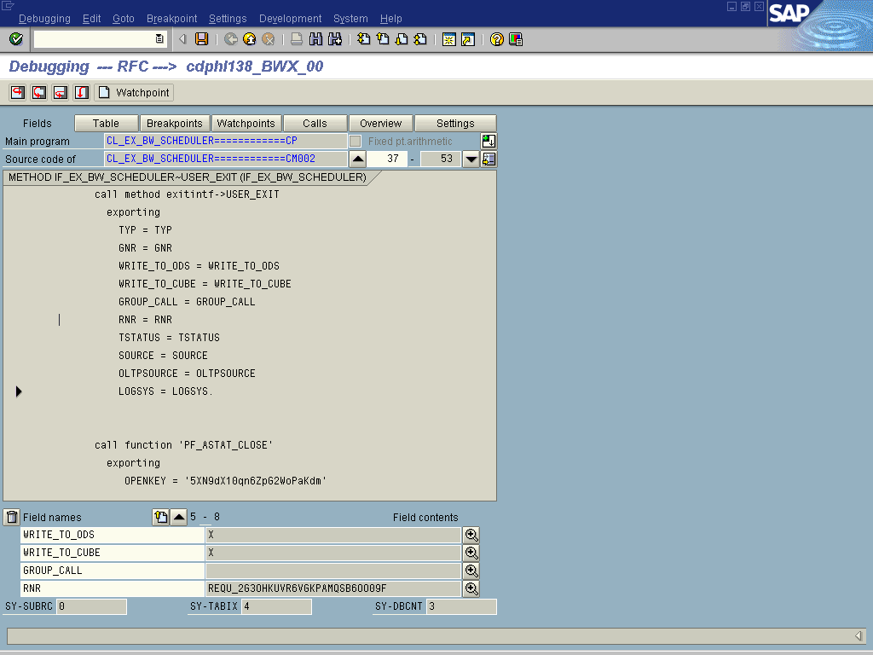

Appendix (Sample ABAP Coding)
The ABAP Objects coding below is a fully functioning, practical application of the BW BADIs. The coding triggers an Express SAP Office Mail (for two users), based on the outcome of the loading process.

method IF_EX_BW_SCHEDULER~USER_EXIT.

* data: LSN.

data: document_data type sodocchgi1,

object_content type solisti1,
receivers type somlreci1,

i_object_content type standard table of solisti1,
i_receivers type standard table of somlreci1.

* if sy-uname eq 'LOTHAR'.

* do.

* check not LSN is initial.

* exit.

* enddo.

* endif.

case Source.

when 'LSRSCRM'.

concatenate tstatus 'Request' rnr 'uploaded'
into document_data-obj_descr
separated by space.

concatenate 'Request' rnr 'for Infosource' source 'uploaded'
into object_content-line separated by space.
append object_content to i_object_content.

concatenate 'from sourcesystem' logsys into object_content-line
separated by space.
append object_content to i_object_content.

move 'METTEJ' to receivers-receiver.
move 'X' to receivers-express.
append receivers to i_receivers.

move 'LOTHAR' to receivers-receiver.
move 'X' to receivers-express.
append receivers to i_receivers.

call function 'SO_NEW_DOCUMENT_SEND_API1'
exporting
document_data = document_data
document_type = 'RAW'
* put_in_outbox = ' '
* IMPORTING
* SENT_TO_ALL =
* NEW_OBJECT_ID =
tables
* OBJECT_HEADER =
object_content = i_object_content
* OBJECT_PARA =
* OBJECT_PARB =
receivers = i_receivers
EXCEPTIONS
TOO_MANY_RECEIVERS = 1
DOCUMENT_NOT_SENT = 2
DOCUMENT_TYPE_NOT_EXIST = 3
OPERATION_NO_AUTHORIZATION = 4
PARAMETER_ERROR = 5
X_ERROR = 6
ENQUEUE_ERROR = 7
OTHERS = 8.

if sy-subrc <> 0.
* MESSAGE ID SY-MSGID TYPE SY-MSGTY NUMBER SY-MSGNO
* WITH SY-MSGV1 SY-MSGV2 SY-MSGV3 SY-MSGV4.
endif.

when others.

endcase.

