How to…

grant authorizations for query components by creator
Business Information Warehouse
ASAP “How to…” Paper
Applicable Releases: BW 3.0A
January 2002

Business Scenario
You have development teams (projects) working on query components in the same system. You want to grant the users authorizations for (creating, changing, deleting etc.) query components by team.

The Result
Your developers are authorized to work only with the query components that members of the same team have created but not with those that members of other teams have created.

The Step-By-Step Solution
- Preliminary remarks | For BW 3.0A a new authorization object S_RS_COMP1 -“Business Explorer - Components: Enhancements to the Owner” was created enabling you to grant authorizations for query components that are dependent on the creator of the query components. The authorization object S_RS_COMP “Business Explorer – Components” is still used, i.e. both objects are checked for sufficient authorization when working with query components.  If you have upgraded your system from BW 2.0B / 2.1C and you want to enable your users to go on working as they used to before the upgrade (without any change in authorizations), you can add the new authorization object S_RS_COMP1 to a standard role / profile every user is assigned to and grant full authorizations for this authorization object.  For adjustments necessary after an upgrade please also refer to “How to Customize BW 3.0A after an Upgrade from 2.0B/2.1C“
- Assume you have a role for the “Sales” team. The team consists of the users Stein, Forester, Hamid and Brehme. They have full authorizations for the authorization object S_RS_COMP | 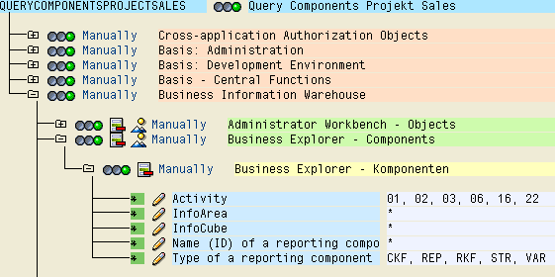
- Add the authorization object S_RS_COMP1 either manually by pressing the “Manually” button and typing the object name into the dialog box or by using “Selection criteria”. | 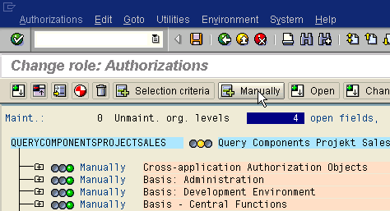  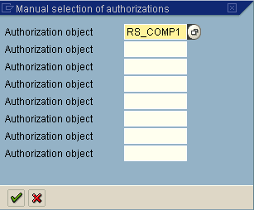
- Assign the same values as for S_RS_COMP if applicable (e.g. activity 01, “create or generate” doesn’t make sense for S_RS_COMP1). In the “Owner” field enter the name of all the sales team users. Generate the profile (and assign users if it is a new role). | 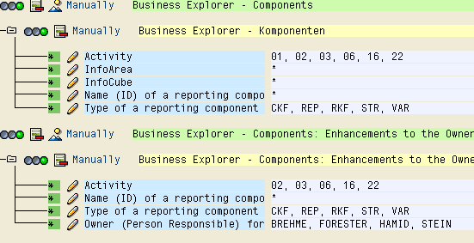
- If you want to ensure that all users are authorized to work with queries they have created themselves, you can add the value “$USER” to the “Owner” field in a standard role / profile. “$USER” is replaced with the current user name in the authorization check. (This feature is enabled with support package 3, BW 3.0A.) | 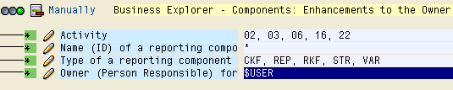

Summary
Granting authorizations for working with query components depending on the component creator is possible with the authorization object S_RS_COMP1 (new with BW 3.0A). You can either grant those authorizations for a team or grant authorizations for self-created queries with low maintenance effort by entering a variable ($USER).

Top of Form

