How to…

Realize an ABC Analysis

Business Information Warehouse
ASAP How to Paper
Applicable Releases: BW 2.0B, 2.1C, 3.0A
October 20 2001

Business Scenario
You have an InfoCube with Orders on a header and item level, customers and ordered quantity. In a reporting szenario you want to create a web application where you graphically answer the question "Do I make 80% of my ordered quantity with only 30% of my customers?"

The Result
The result is a web report with a chart and a table. The chart immediately shows, that in this example 30% of your customers account for almost 80% of your order quantity.
In the data table you get detailed information about your customers. The column "Customer %" shows that one customer is about 5% of your total customers, i.e. you have 22 customers altogether. In the "Quantity %" column you can see how much of your ordered quantity this specific customer is responsible for. Both columns show accumulated values (running totals).

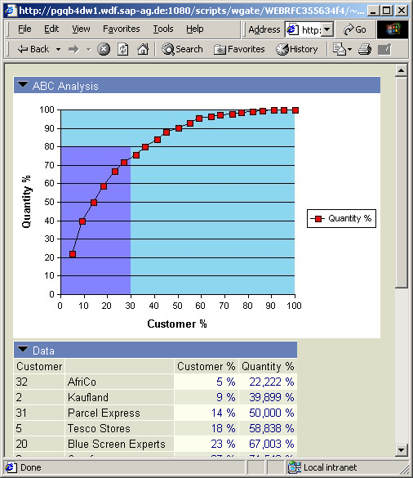

The Step By Step Solution
In this step you learn how to create a query that shows the necessary result and how to show the result in a web appliaction. The query can be realized with BEx Analyzer features only. It is not necessary to change the data model of the InfoCube, create virtual key figures, etc.

- Create a new Query. Place characteristic 'Customer' in the rows | 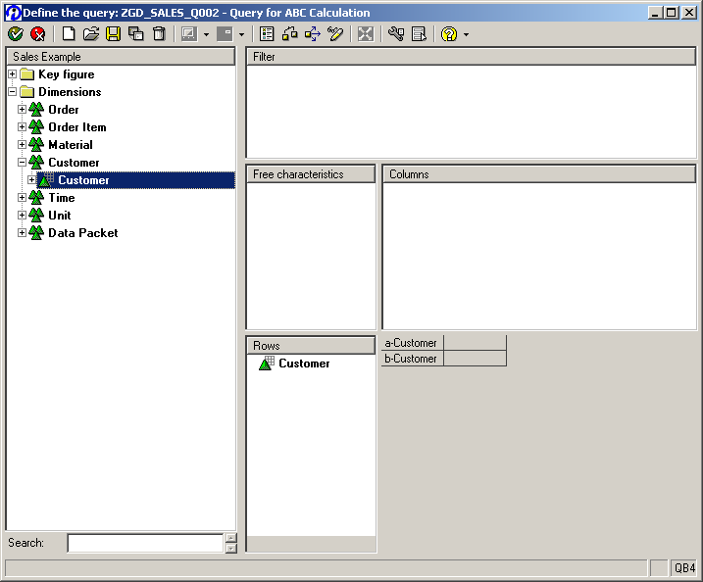
- Create a new calculated key figure. Define the formula by simply dragging ' Quantity' into the formula area. | 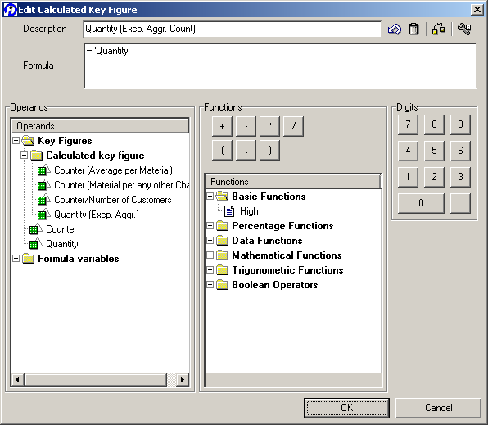
- When you save the calculated key figure you have to specify its 'Enhanced' properties. Press the button 'Enhance >>>' . | 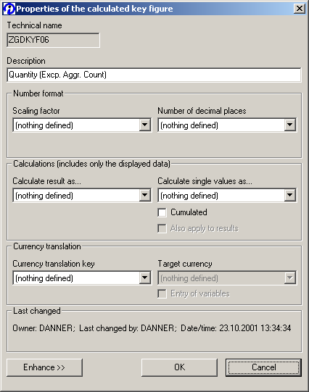
- New fields will appear. Here you have to specify the 'Exception Aggregation'. Set this parameter to 'Counting all values' with reference characteristic being 'Customer'. Press the 'Ok' button | 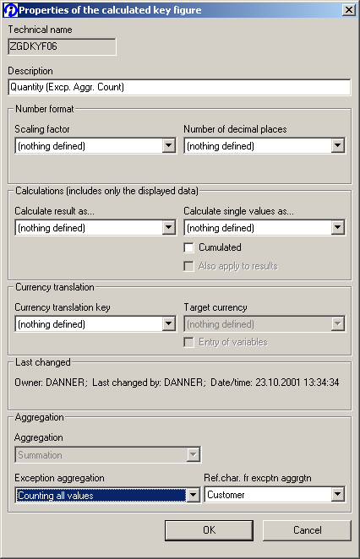
- Now insert the newly defined calculated key figure into your rows. | 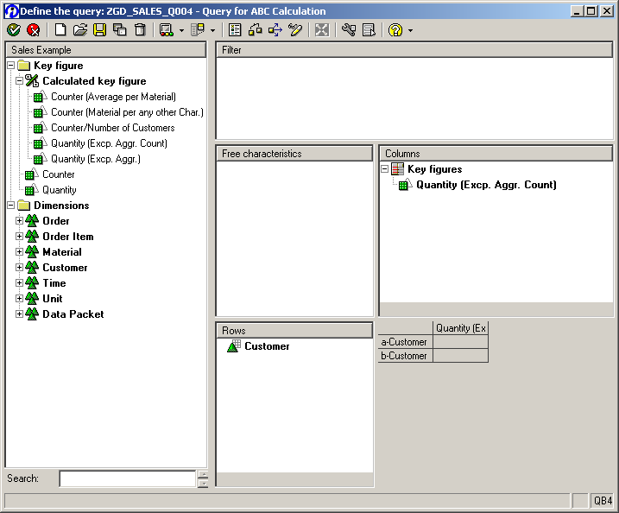
- Create a new formula in the rows. The formula should be '1 %A SUMGT Quantity (Excp. Aggr. Count) '. This formula calculates the percentage share of one customer to the total number of customers. | 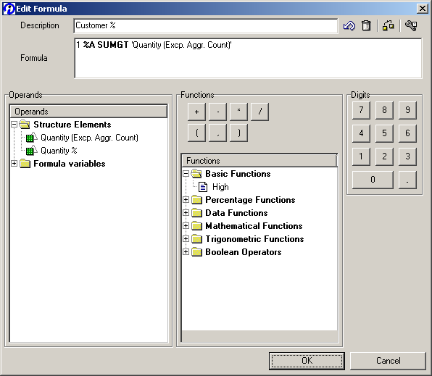
- Insert 'Quantity' into your rows. Change the title of the selection to 'Quantity %'. | 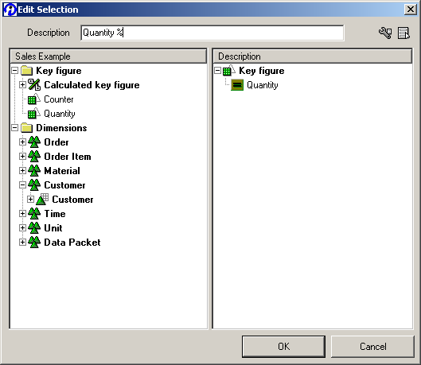
- The query should now look like this. | 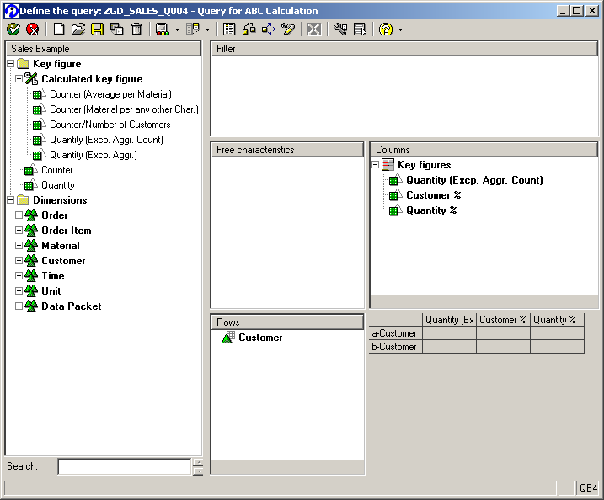
- Now hide the first column. From the context menu of the column element choose the properties dialogue. There you have to set the check box 'Hide'. | 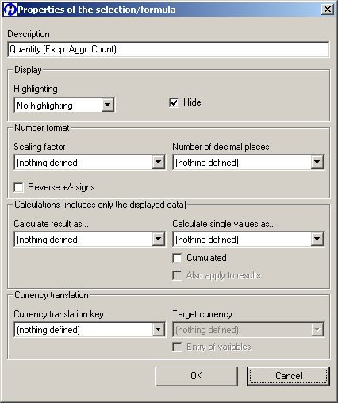
- In the properties dialogue of the fourth row set the number of decimal places to zero. Additionally, set the 'Cumulated' check box and choose 'Calculate result as...' 'Summation'. | 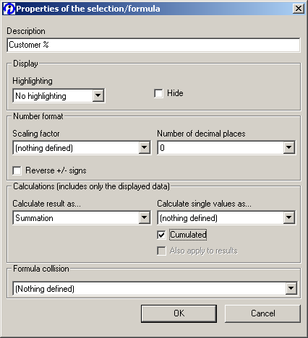
- In the properties dialogue of the fifth row set the number of decimal places to zero. Set the 'Cumulated' check box and choose 'Calculate single values as normalization of result (incl. Filter)' | 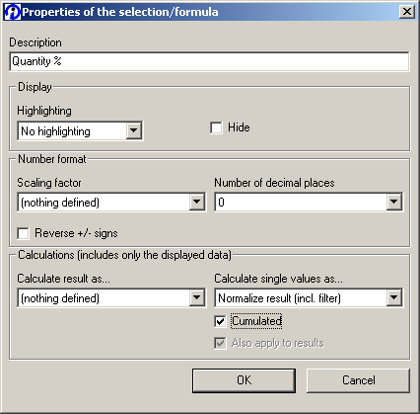
- Save and run the query. In the 'Quantity %' column from the context menu choose 'Sort in descending order --> Quantity'. | 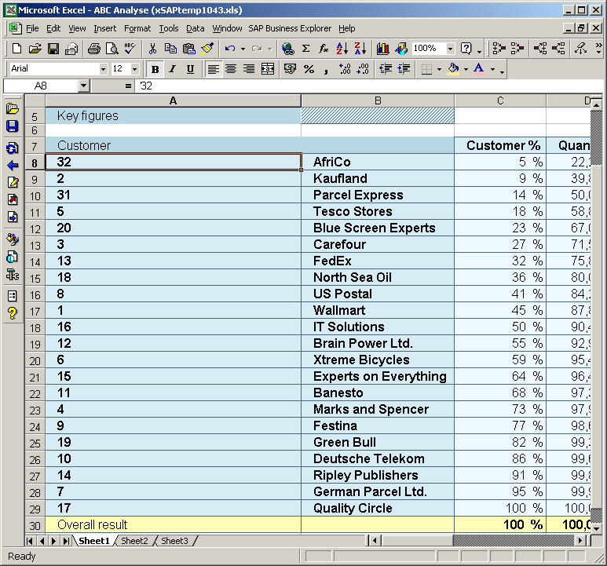
- Save the workbook and the query view.
- Publish the query view to the web. Create a template with a table item and a chart item. When you parameterize the chart, choose an XY (Scatter) chart type with connected value points. | 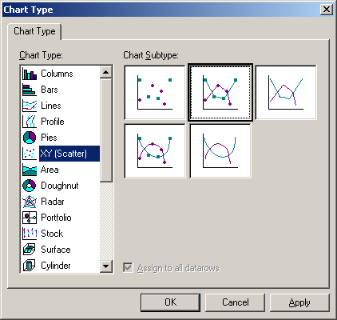
- In the chart options set the title for the X- and Y-axis | 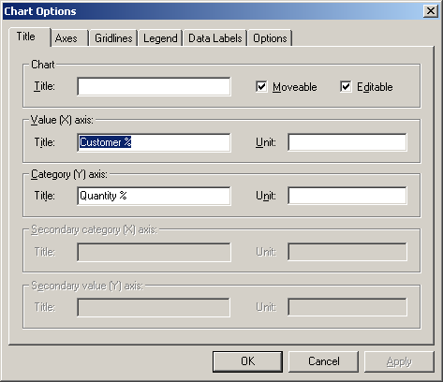
- Choose 'Format Plot area' to define the quadrant that should be highlighted. | 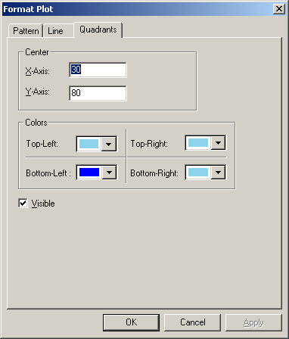
- For both axes choose 'Format Axis'. Set the scaling parameters for the axis: minimum = 0 and maximum = 100. If you want to you can specify minor and major units that are going to be displayed. | 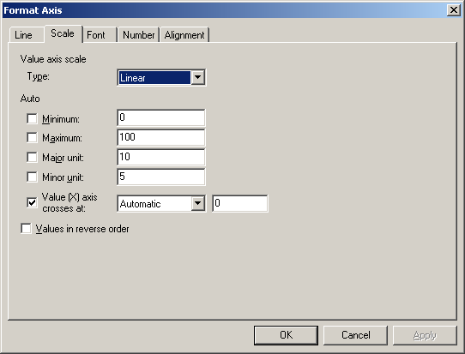
- Run the web application in a browser to inspect the result

